## Image 01 (driveway)

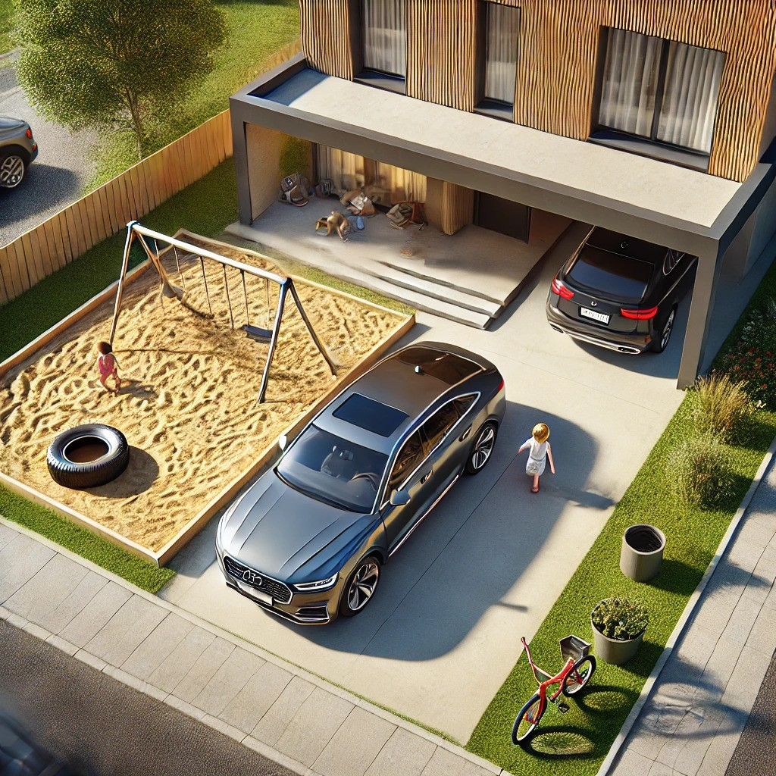

1. How many vehicles are present? 2 (taxonomic) (cars)

2. How many objects with wheels are visible? 3 (structural) (cars and bicycle)

3. If the sandbox was filled with water instead of sand, how many objects would be floating? 1 (physical) (tire)

## Image 02 (construction)

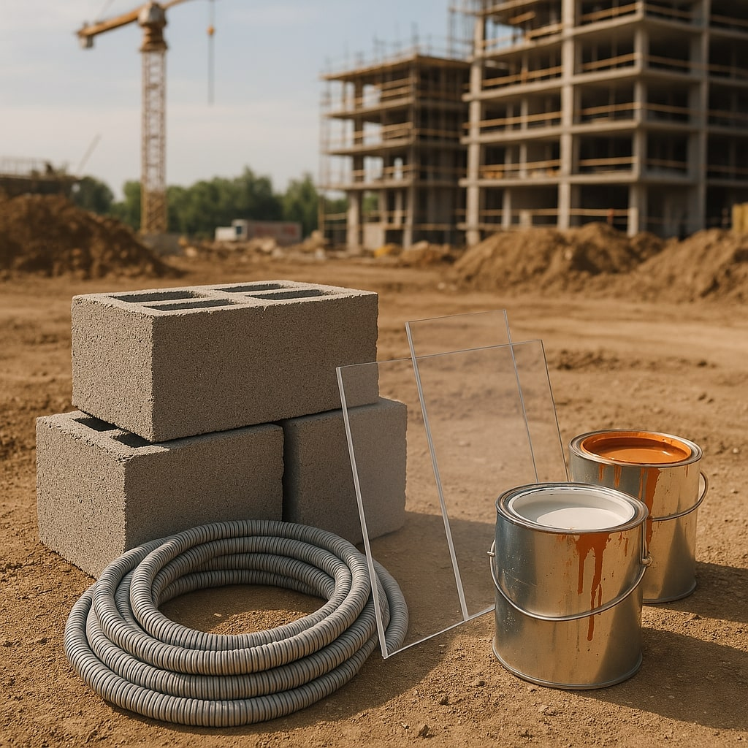

1. How many objects made of metal are present? 3 (physical) (paint cans)

2. How many objects are stacked on top of each other? 3 (relational) (concrete blocks)

3. If the hose was straightened into a line, would there be more or fewer objects visible? 1 (functional) (hose)

## Image 03 (farm)

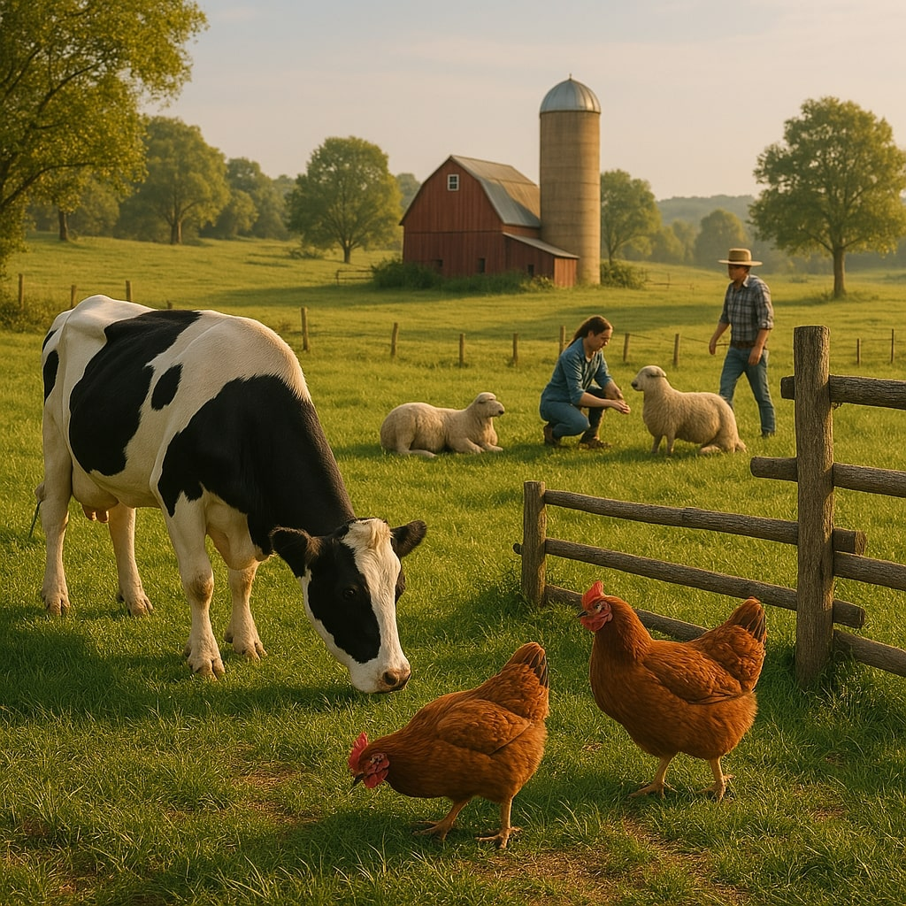

1. How many mammals are visible? 3 (taxonomic) (cow, sheep, person)

2. How many animals are in a flock? 3 (relational) (sheep)

3. If the chickens were the same color as the cow, how many black and white animals would be visible? 4 (taxonomic) (cow, sheep, person)

## Image 04 (library)



1. How many objects made of wood are present? 1 (physical) (bookshelf)

2. How many items are stacked on top of other items? 4 (relational) (stacks of books/boxes)

3. If the books were replaced with plants, how many living things would be visible? 2 (taxonomic) (people)

## Image 05 (picnic)

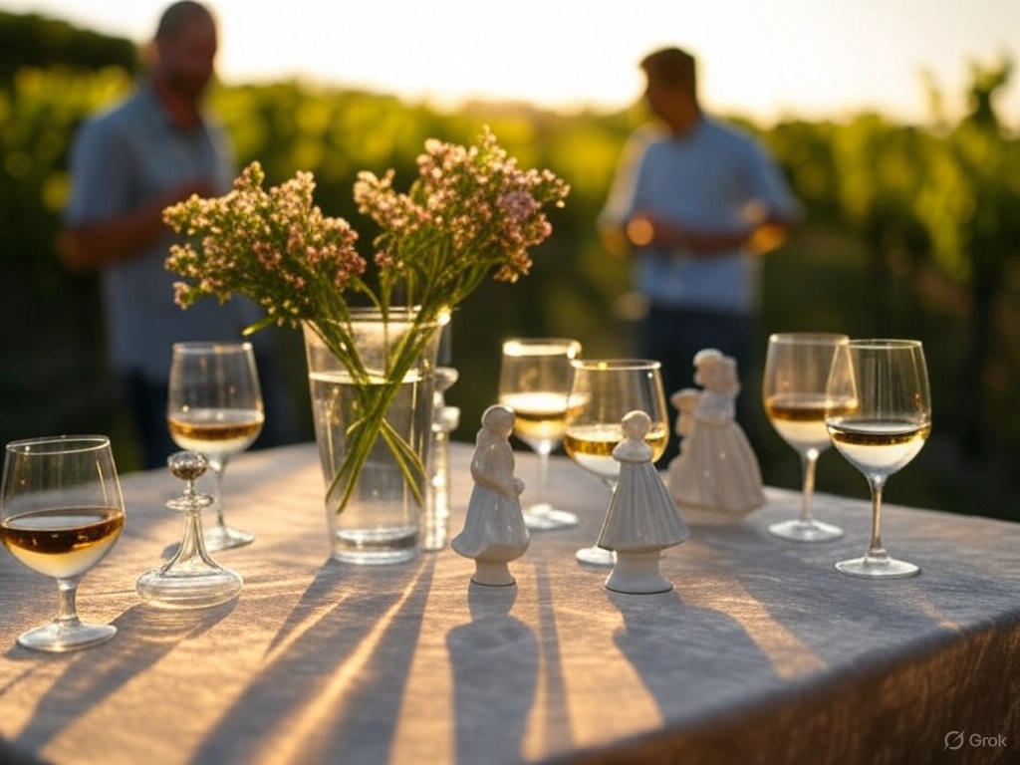

1. How many objects made of glass are present? 5 (physical) (wine glasses)

2. How many objects are on top of the table cloth? 8 (relational) (objects)

3. If the flowers were replaced with fruit, how many food items would be visible? 10 (taxonomic) (fruits)

## Image 06 (beach cleanup)

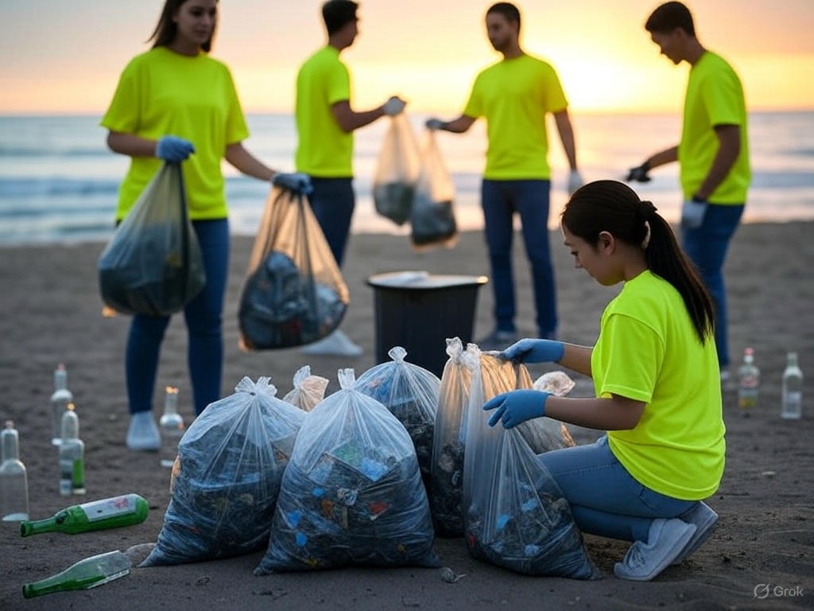

1. How many objects made of glass are present? 6 (physical) (bottles)

2. How many people are holding bags? 4 (relational) (people)

3. If all the trash bags were empty, how many bags would be visible? 5 (physical) (trash bags)

## Image 07 (camping)

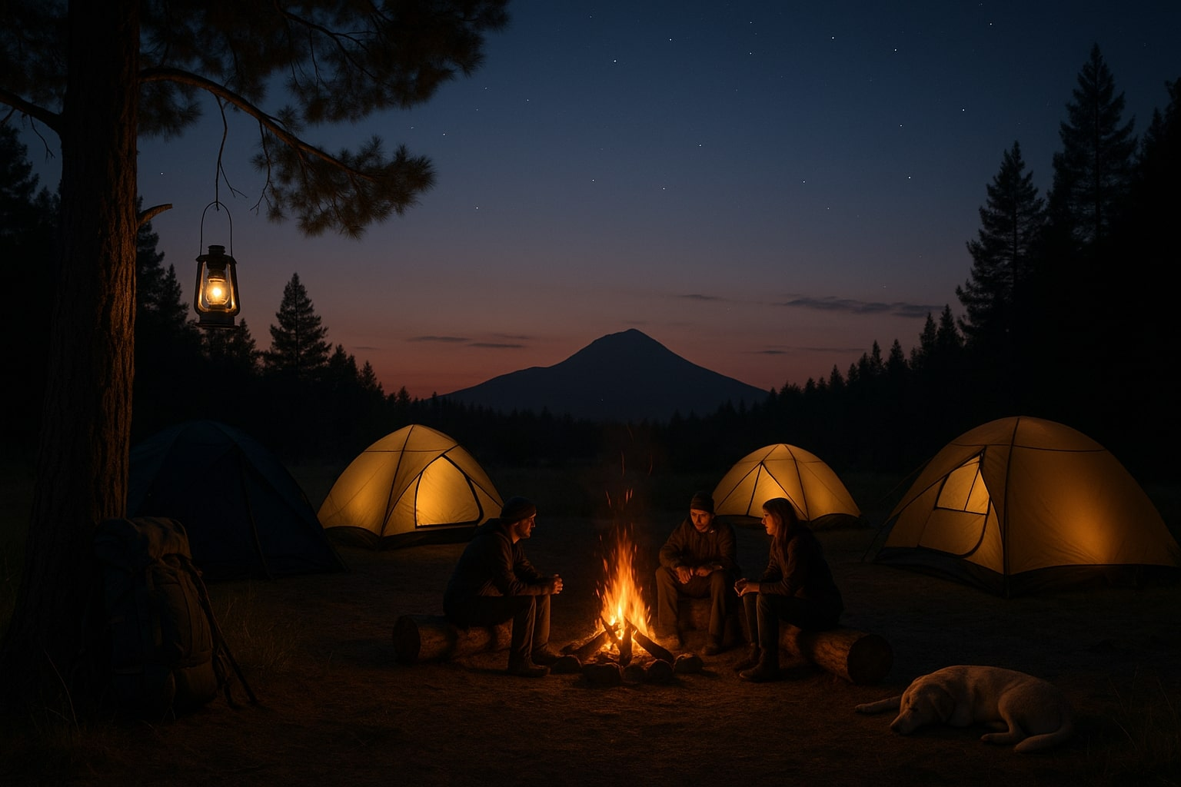

1. How many tents are visible? 4 (taxonomic) (tents)

2. How many people are sitting around the fire? 3 (relational) (people)

3. If the dog was replaced with another dog, how many dogs would be present? 2 (taxonomic) (dogs)

## Image 08 (gym)

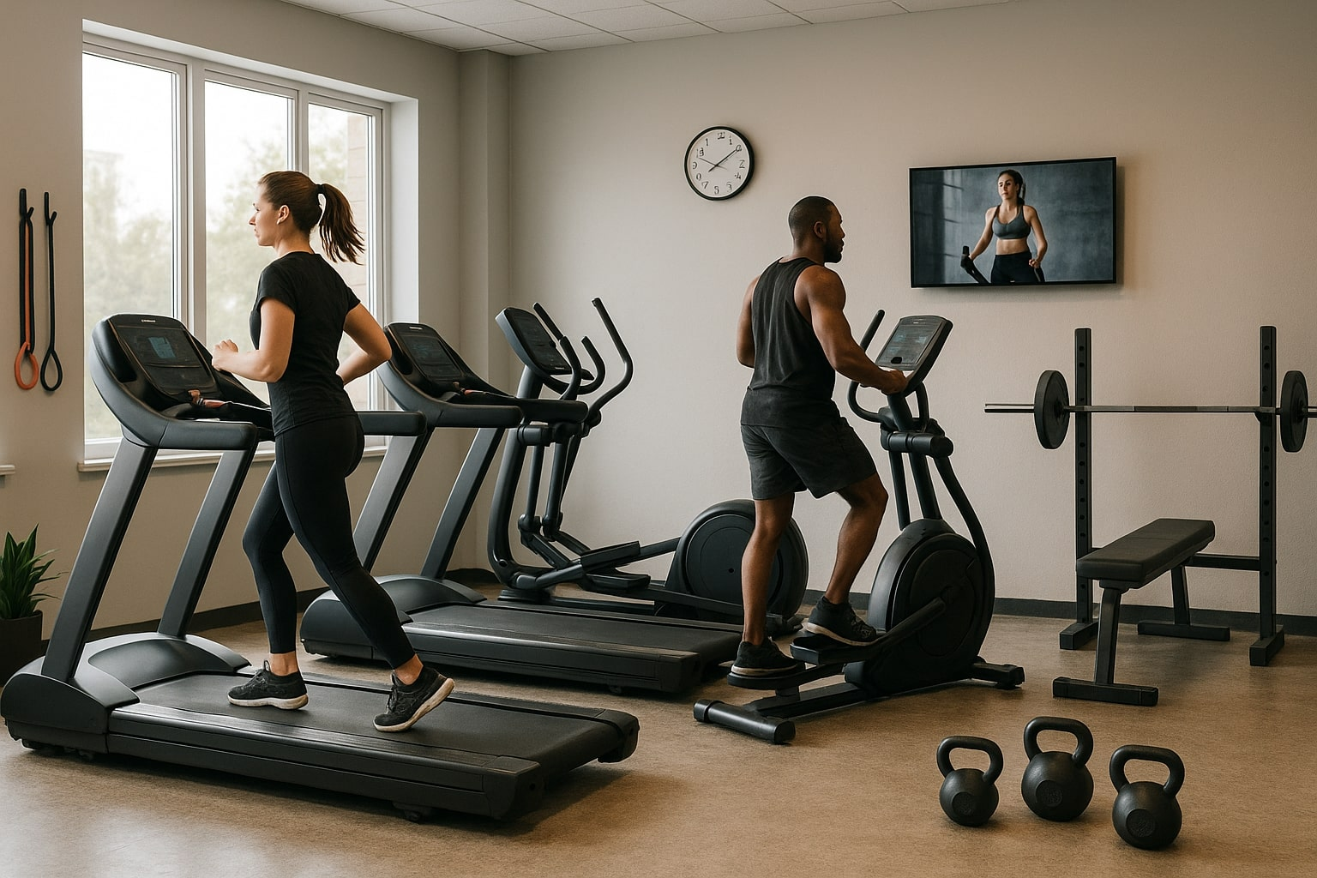

1. How many pieces of exercise equipment are visible? 4 (taxonomic) (treadmill, elliptical trainers)

2. How many items are designed to be grasped? 6 (functional) (dumbbells)

3. If the television was not mounted on the wall, how many wall-mounted objects would be visible? 1 (relational) (clock)

## Image 09 (garage)

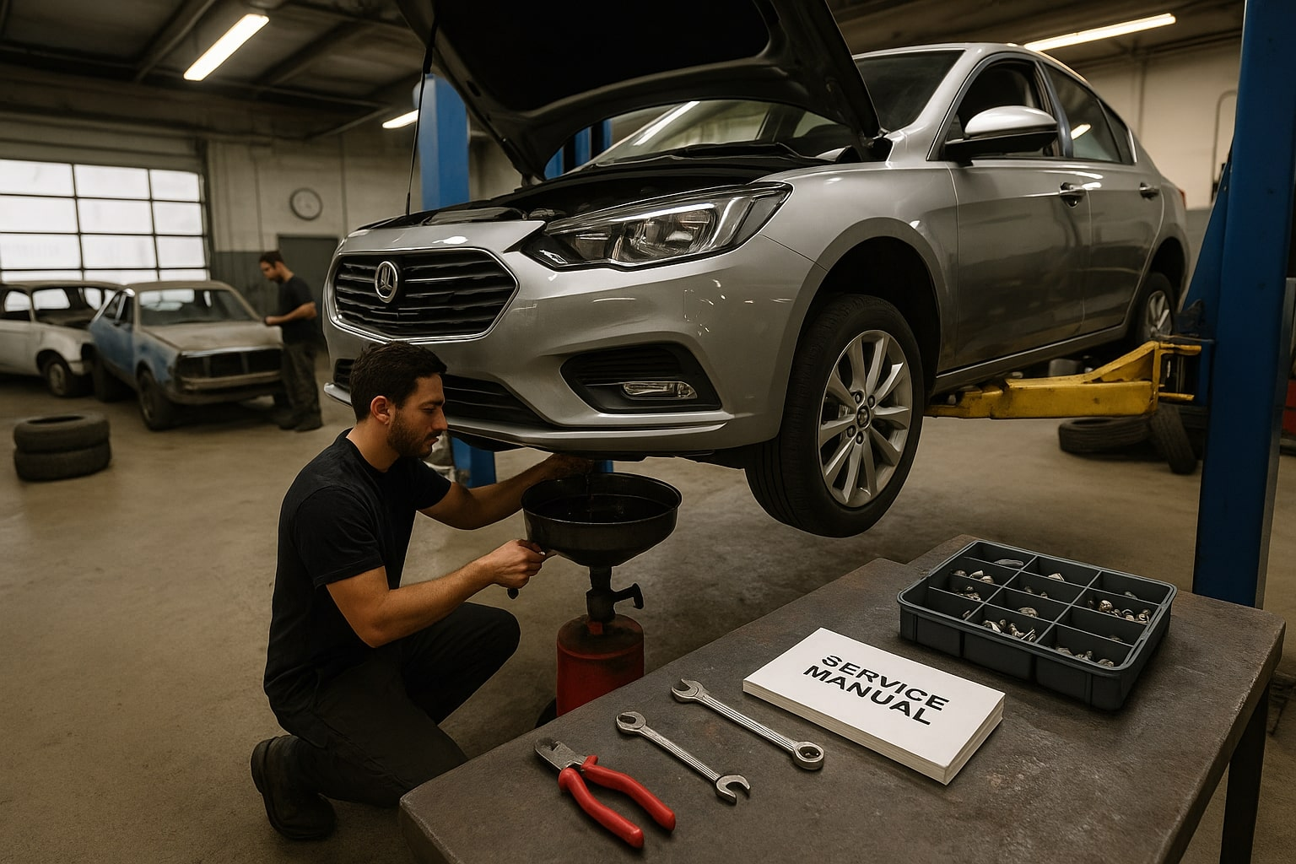

1. How many vehicles are visible? 3 (taxonomic) (cars)

2. How many tools are lying on top of the service manual? 3 (relational) (tools)

3. If the car was not lifted, how many tires would be touching the ground? 4 (physical) (tires)

## Image 10 (kitchen)

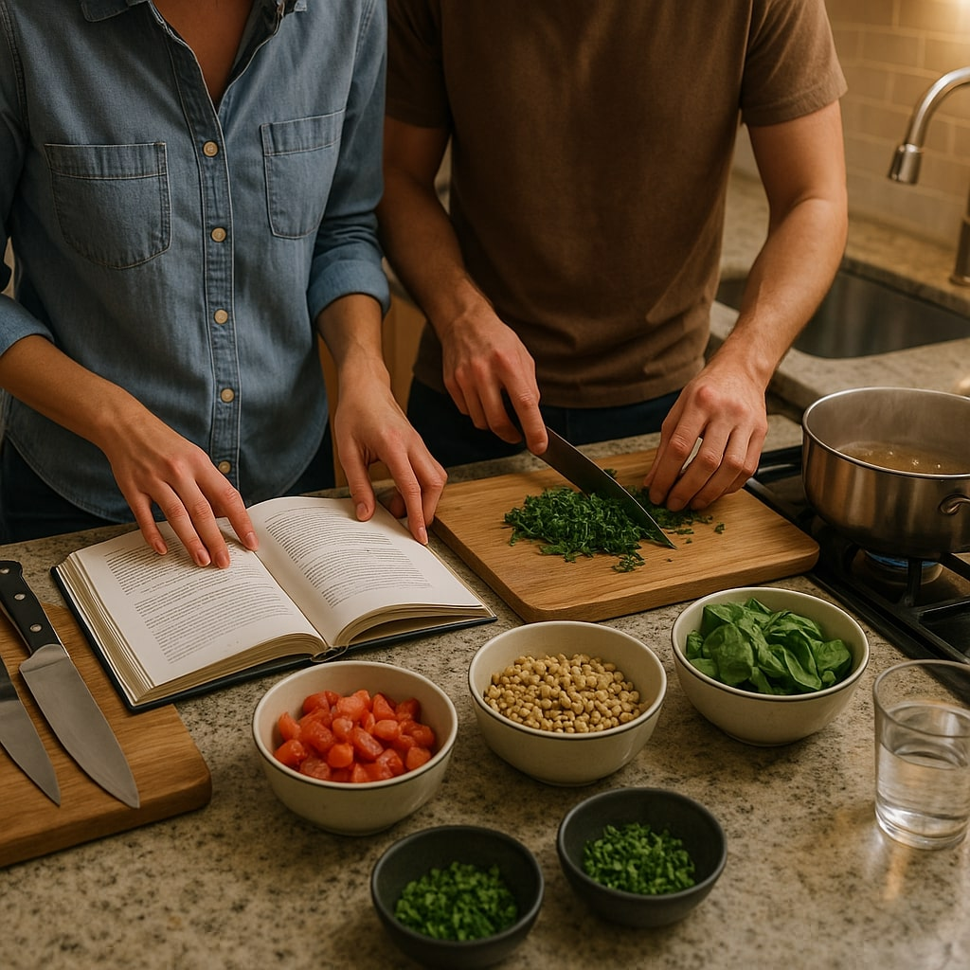

1. How many bowls containing food are visible? 5 (taxonomic) (bowls)

2. How many items are on top of the cutting boards? 2 (relational) (knives)

3. If the pot on the stove was empty, how many containers with ingredients would be visible? 5 (functional) (bowls)

## Image 11 (bedroom)

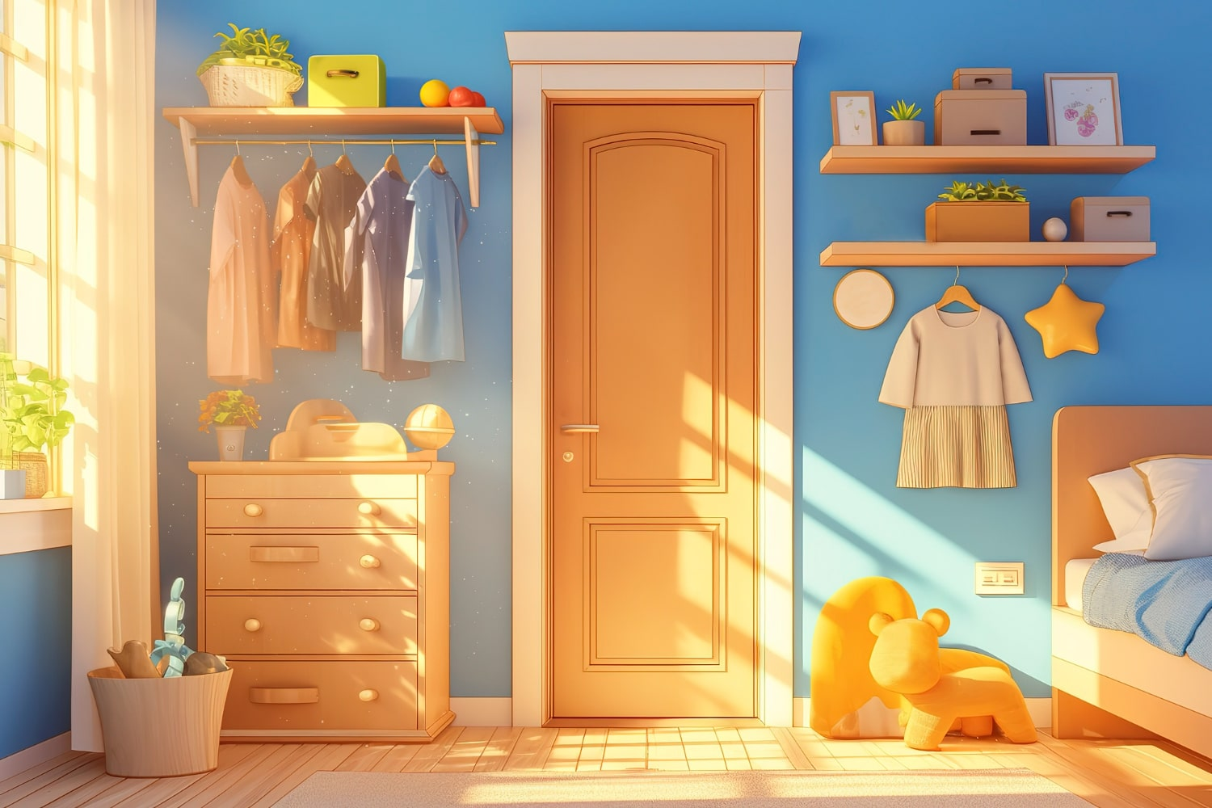

1. How many items of furniture are present? 5 (taxonomic) (dresser, shelves, bed, rocking horse, wardrobe)

2. How many items are hanging? 7 (relational) (clothes)

3. If the dresser drawers were open, how many drawers would be visible? 6 (physical) (drawers)

## Image 12 (classroom)



1. How many chairs are visible? 4 (taxonomic) (furniture)

2. How many students are looking away from the viewer? 2 (relational) (students)

3. If the clocks on the wall were removed, how many clocks would be visible? 0 (physical) (clocks)

## Image 13 (kitchen)

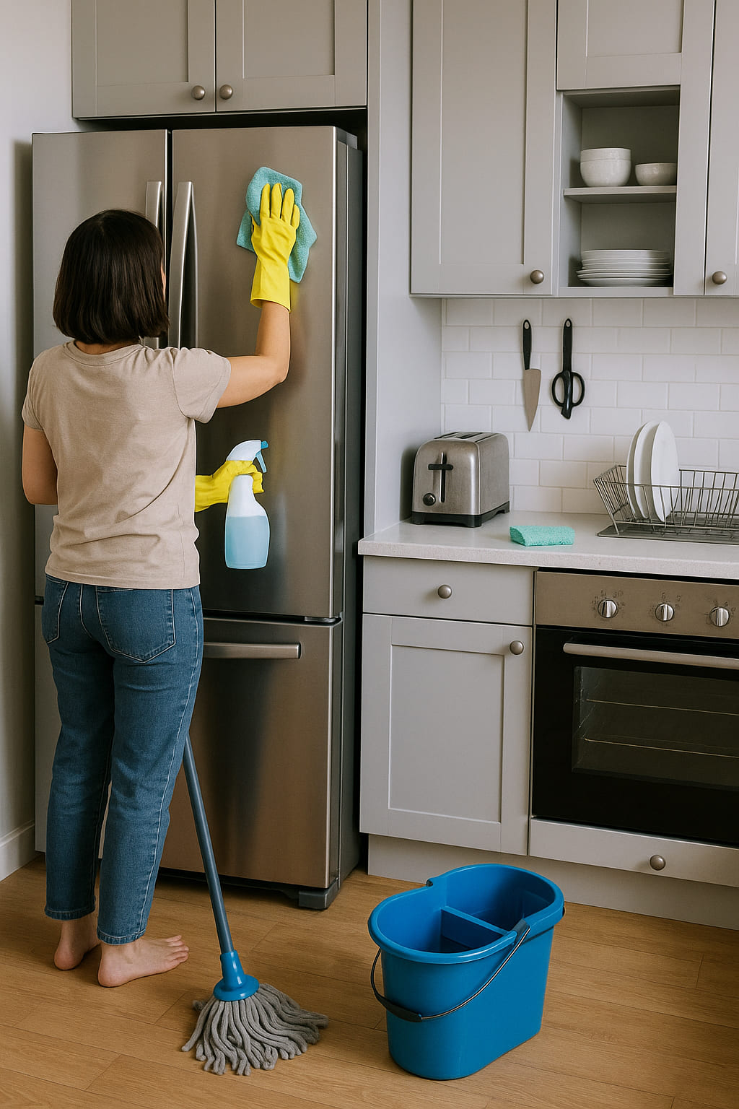

1. How many items made of metal are present? 6 (physical) (appliances/tools)

2. How many items can hold something? 5 (functional) (bucket, spray bottle, cabinets, oven, sink)

3. If the bucket was full of water, how many liquid-holding objects would be visible? 2 (functional) (bucket, spray bottle)

## Image 14 (kitchen)

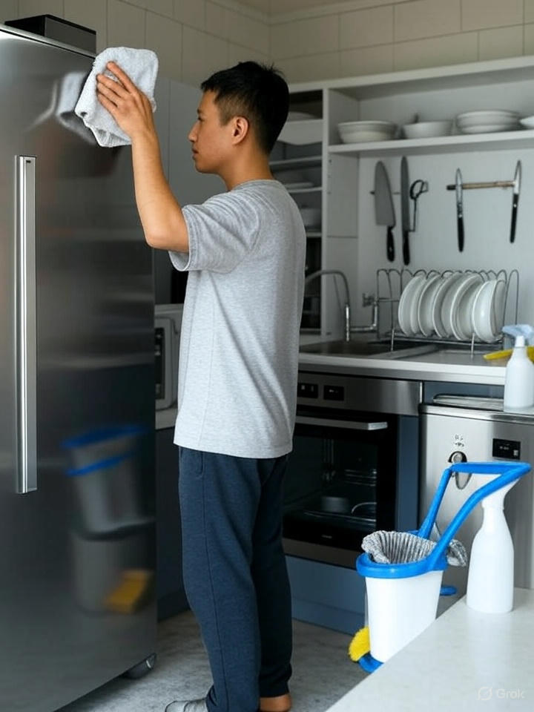

1. How many items made of metal are present? 8 (physical) (knives, utensils, oven handle, fridge handle, bucket handle, cleaning spray can, sink faucet, oven buttons)

2. How many items are used for holding things? 4 (functional) (bucket, sink, plates rack, oven)

3. If the man wasn't cleaning, how many cleaning supplies would be visible? 3 (relational) (cleaning spray, bucket, cloth)

## Image 15 (kitchen)

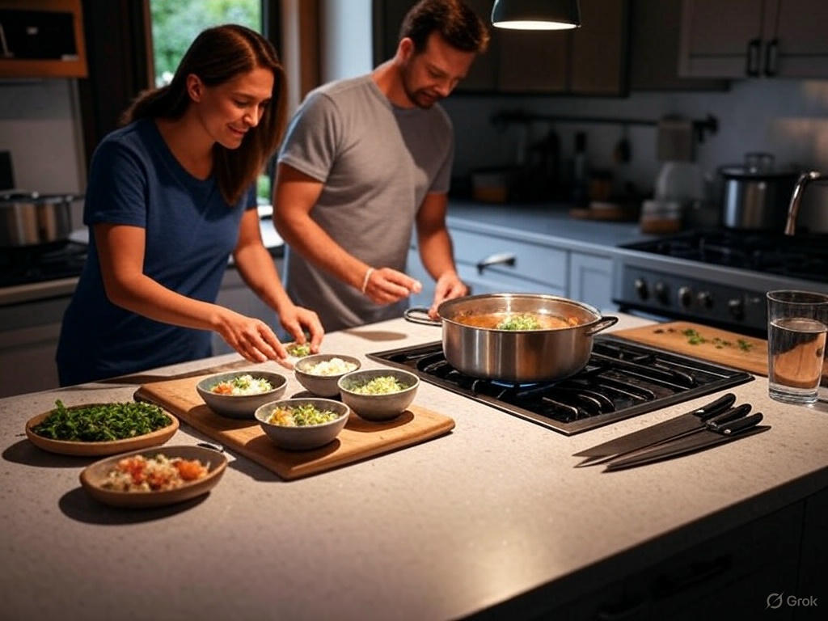

1. How many bowls are present? 4 (taxonomic) (bowls)

2. How many items can hold liquid are visible? 2 (functional) (pot, glass)

3. If the people in the image were not present, how many cooking tools would be visible? 7 (relational) (pot, cutting board, knives, bowls)

## Image 16 (kitchen)

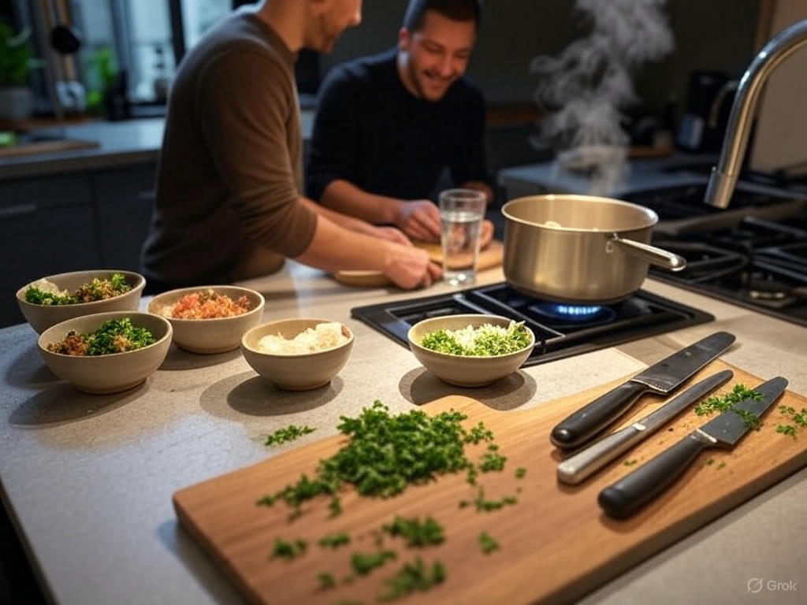

1. How many bowls are present? 5 (taxonomic) (bowls)

2. How many items are on top of the wooden cutting board? 3 (relational) (knives and herbs)

3. If the two people in the image were not present, how many cooking tools would be visible? 7 (functional) (pot, bowls, knives, cutting board)

## Image 17 (beach cleanup)

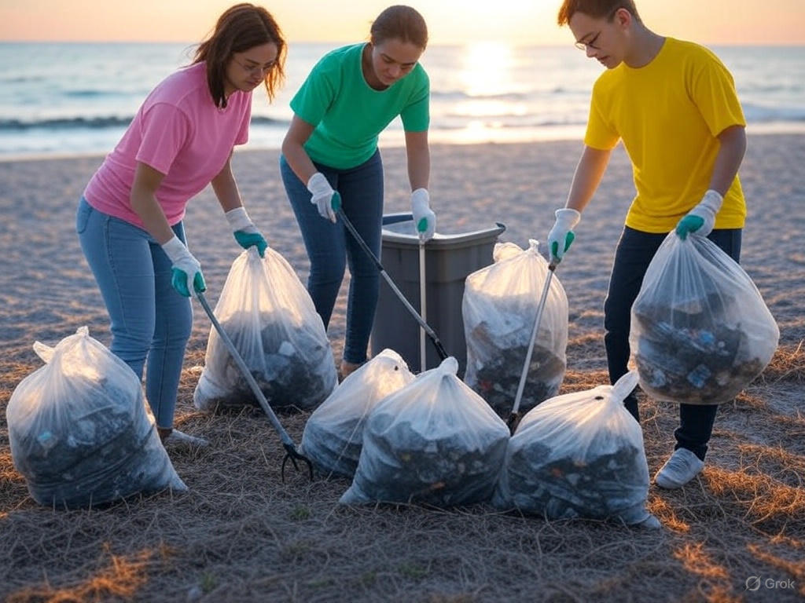

1. How many people are wearing gloves? 3 (physical) (people)

2. How many bags appear to be full of collected items? 6 (relational) (trash bags)

3. If the trash pickers had used metal buckets instead of plastic bags, how many buckets would be visible? 6 (functional) (containers)

## Image 18 (construction)

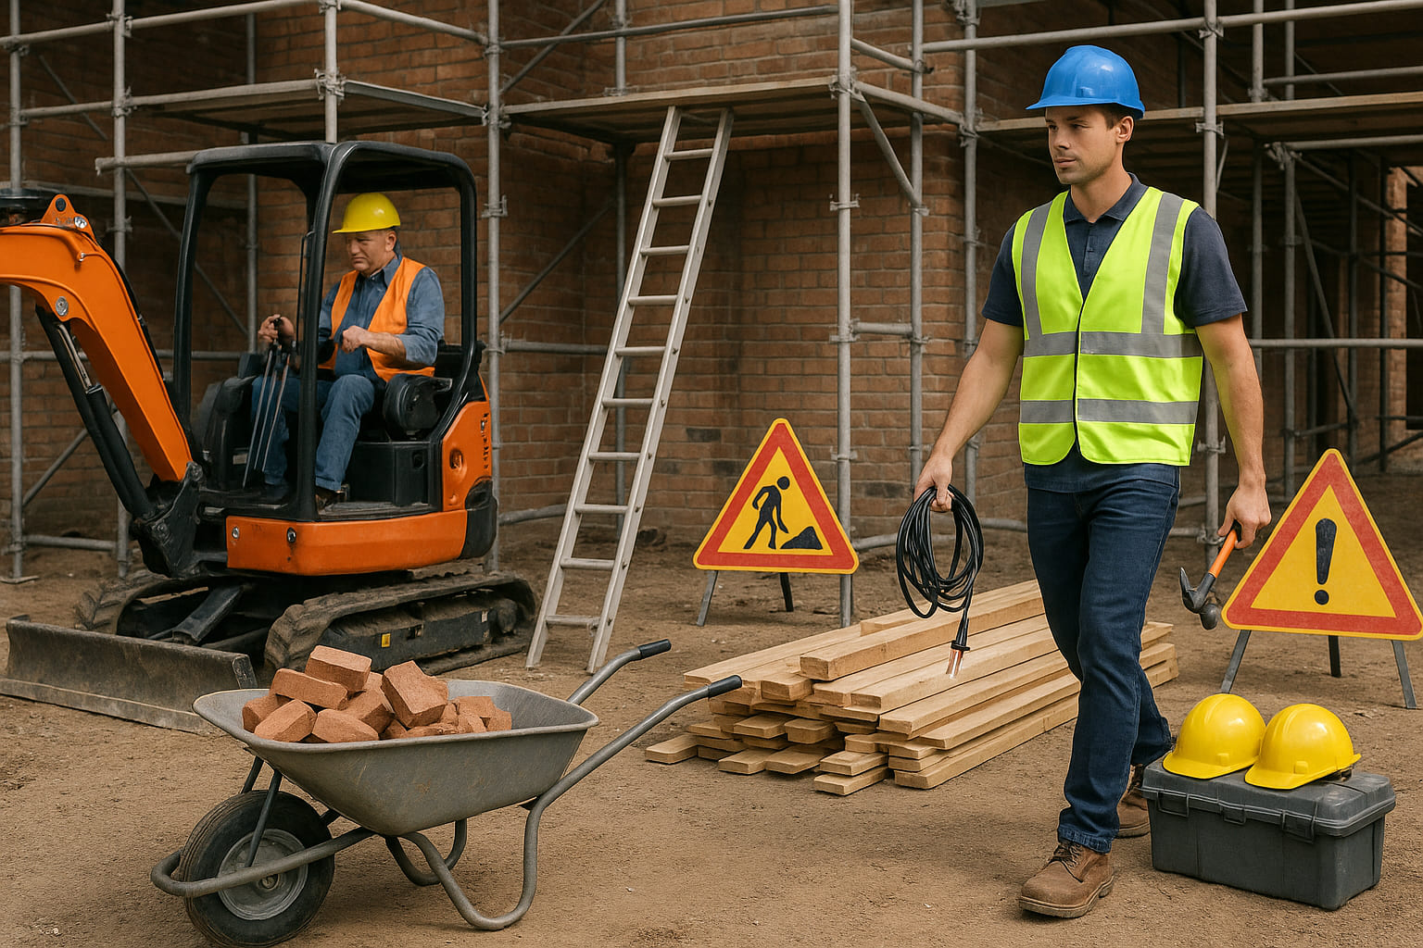

1. How many workers wearing helmets are visible? 2 (taxonomic) (people)

2. How many warning signs are standing upright? 2 (relational) (signs)

3. If the wheelbarrow was empty, how many bricks would be visible inside it? 0 (physical) (bricks)

## Image 19 (garage)

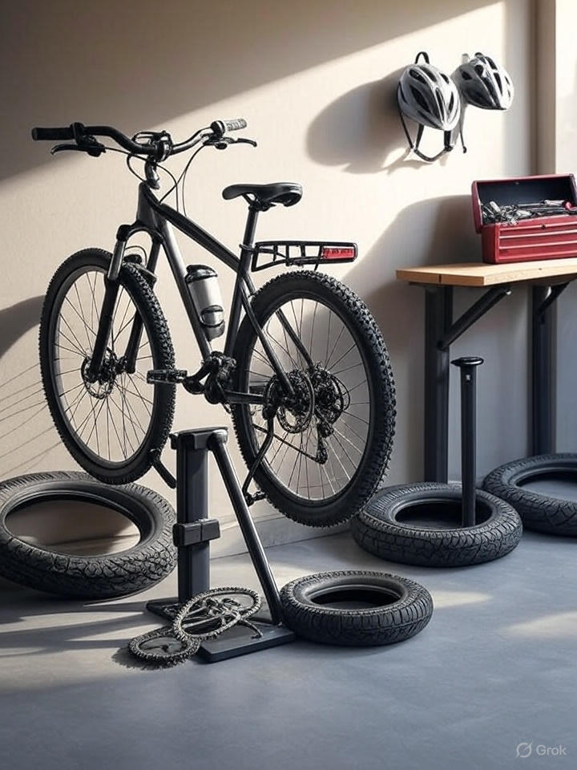

1. How many vehicles are present? 1 (taxonomic) (bicycle)

2. How many items are stacked on top of each other? 4 (relational) (tires)

3. If the helmets were red instead of white, how many red helmets would be visible? 2 (physical) (helmets)

## Image 20 (biking)

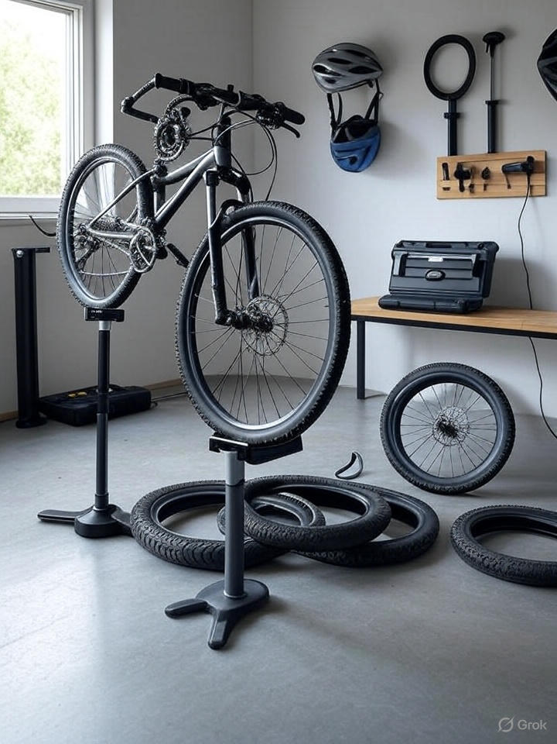

1. How many tires are present? 5 (taxonomic) (bicycle tires)

2. How many items are on top of the wooden table? 2 (relational) (items)

3. If the bicycle was not being repaired, how many bicycles would be fully assembled? 1 (taxonomic) (bicycle)

## Image 21 (park)

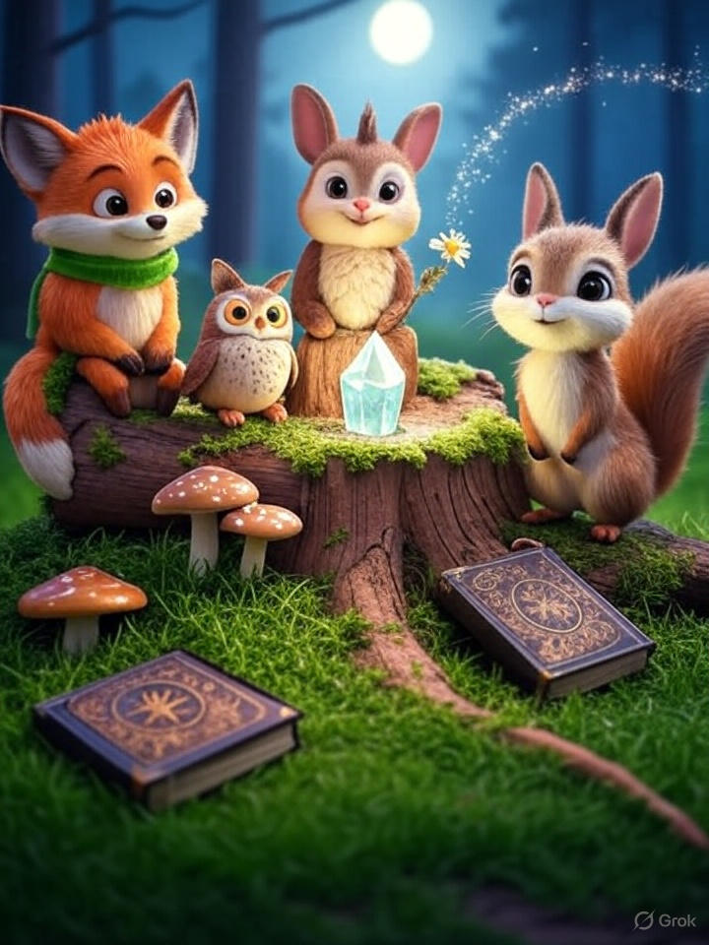

1. How many mammals are present? 3 (taxonomic) (fox, groundhog, squirrel)

2. How many items are on top of the log? 4 (relational) (crystal, books, mushrooms)

3. If the owl had wings spread, how many wings would be visible? 2 (physical) (wings)

## Image 22 (park)

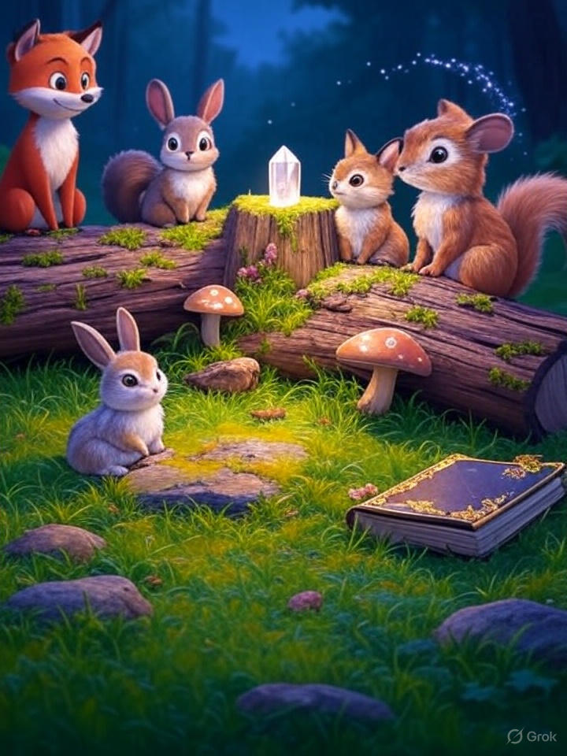

1. How many mammals are visible? 5 (taxonomic) (fox, rabbits, squirrel)

2. How many objects are on top of other objects? 3 (relational) (rabbits, crystal, book)

3. If the mushrooms were all the same color as the crystal, how many red objects would there be? 1 (taxonomic) (fox)

## Image 23 (biking)

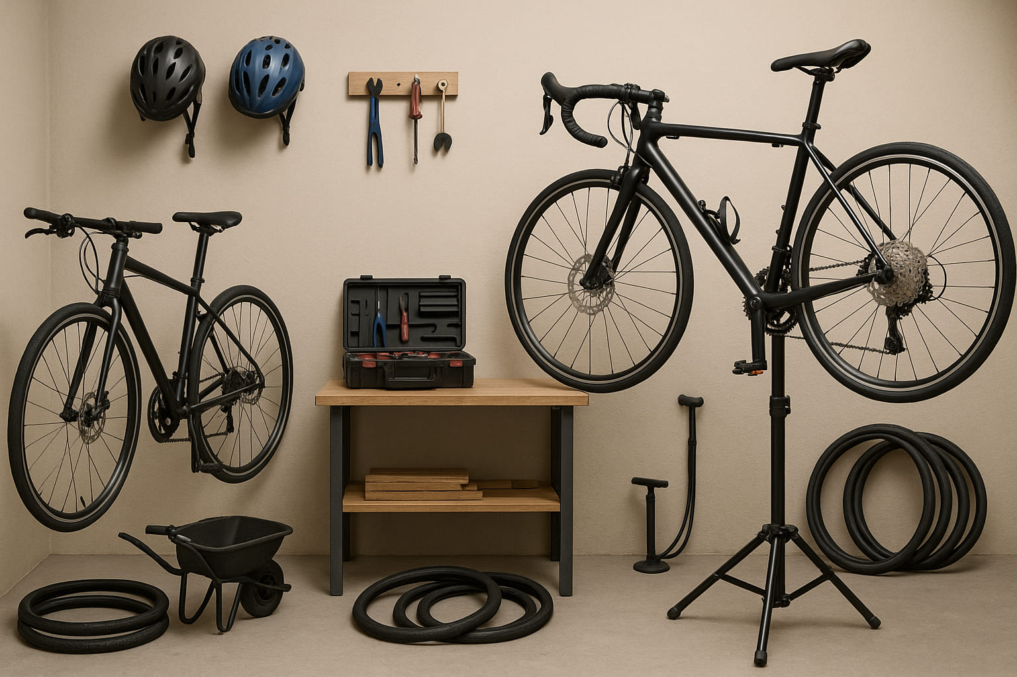

1. How many vehicles are present? 2 (taxonomic) (bicycles)

2. How many items are on top of the wooden shelf? 1 (relational) (toolbox)

3. If the helmets were a different color, how many blue items would be visible? 1 (physical) (helmet)

## Image 24 (laboratory)

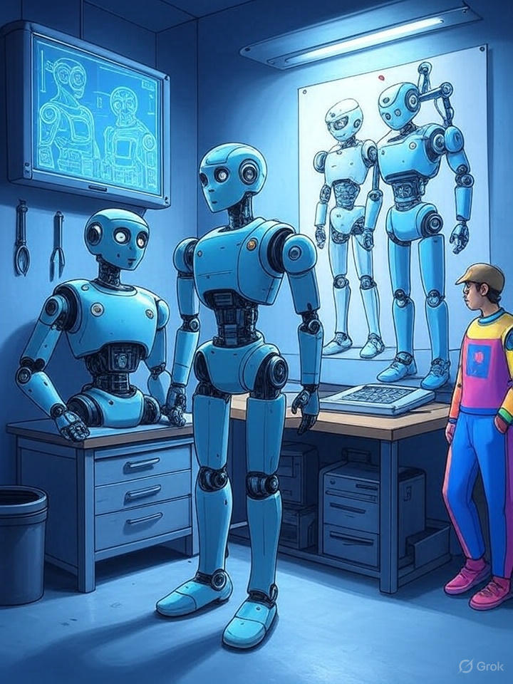

1. How many robots are present? 4 (taxonomic) (robots)

2. How many items are on top of the table? 5 (relational) (items)

3. If the robots were made of glass instead of metal, how many fragile objects would there be? 4 (physical) (robots)

## Image 25 (laboratory)

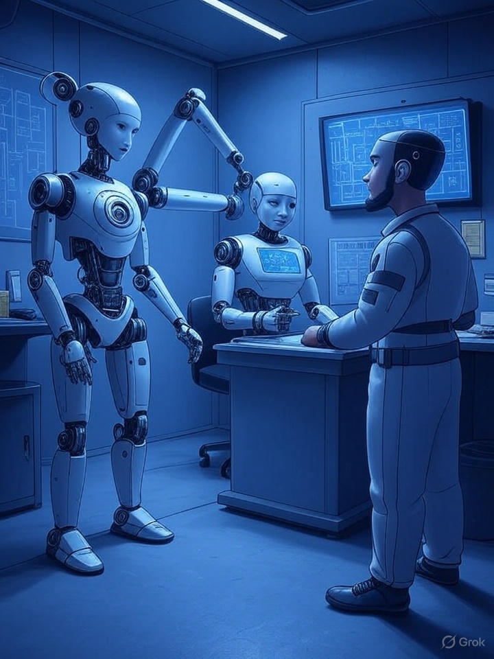

1. How many robots are visible? 2 (taxonomic) (robots)

2. How many items are on top of the desk? 2 (relational) (items)

3. If the man was replaced with another robot, how many robots would be present? 3 (taxonomic) (robots)

## Image 26 (classroom)

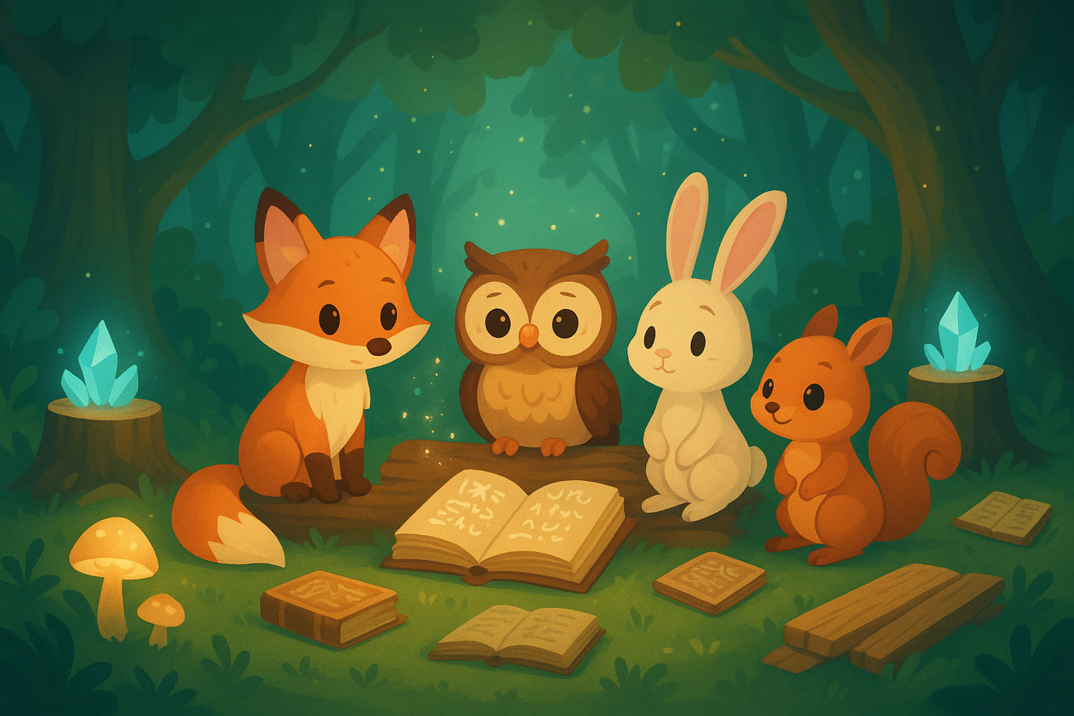

1. How many mammals are present? 3 (taxonomic) (fox, rabbit, squirrel)

2. How many open books are visible? 2 (functional) (books)

3. If the crystals were replaced with mushrooms, how many glowing objects would there be? 0 (physical) (crystals)

## Image 27 (park)

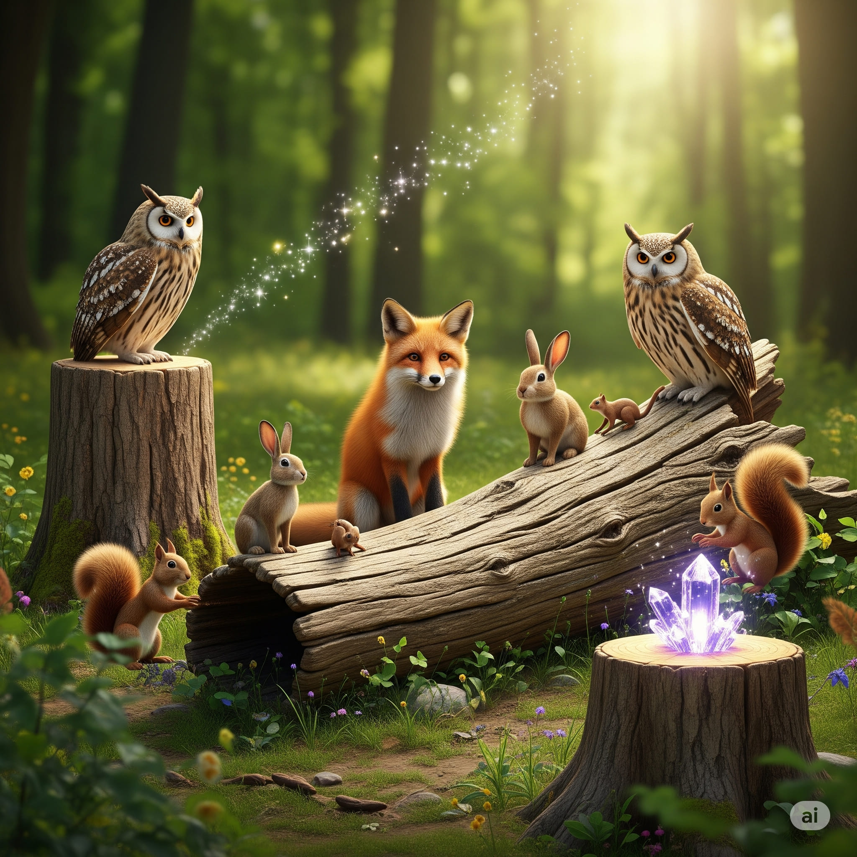

1. How many mammals are visible? 6 (taxonomic) (fox, rabbits, squirrels)

2. How many animals are sitting on top of the log? 5 (relational) (fox, rabbits, squirrels)

3. If the owls were replaced with bluebirds, how many birds would be visible? 2 (taxonomic) (bluebirds)

## Image 28 (market)

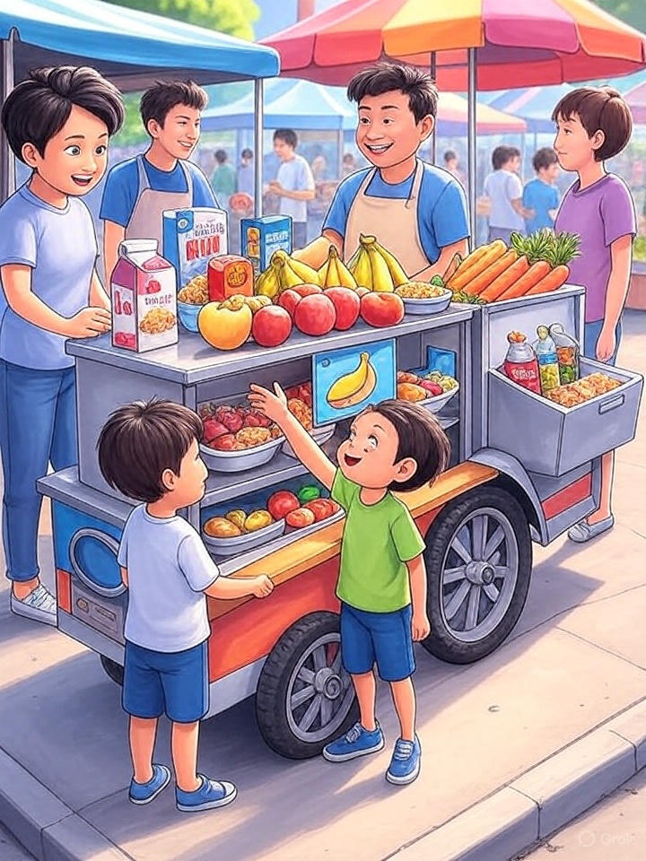

1. How many fruits are visible? 11 (taxonomic) (apples, bananas, oranges)

2. How many people are interacting with the cart? 4 (relational) (people)

3. If the cart had no wheels, how many legs would it have? 0 (physical) (legs)

## Image 29 (tools)

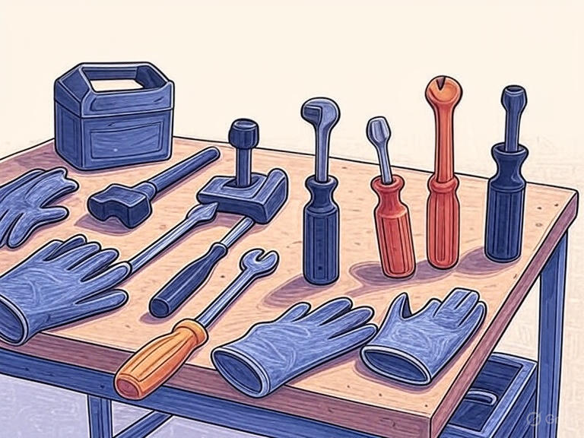

1. How many tools are present? 10 (taxonomic) (tools)

2. How many items are used for gripping are visible? 3 (functional) (gloves)

3. If the toolbox was empty, how many tools would be lying on the table? 9 (relational) (tools)

## Image 30 (tools)

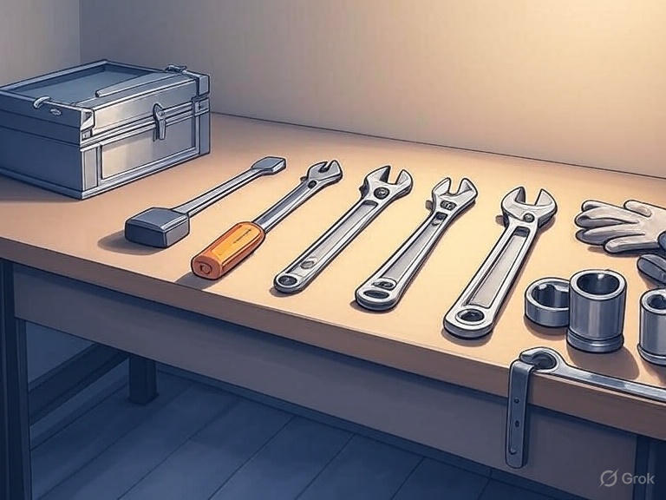

1. How many metal tools are present? 7 (taxonomic) (tools)

2. How many items are used for gripping or turning? 5 (functional) (wrenches)

3. If the toolbox was empty, how many tools would be lying on the table? 7 (relational) (tools)

## Image 31 (library)

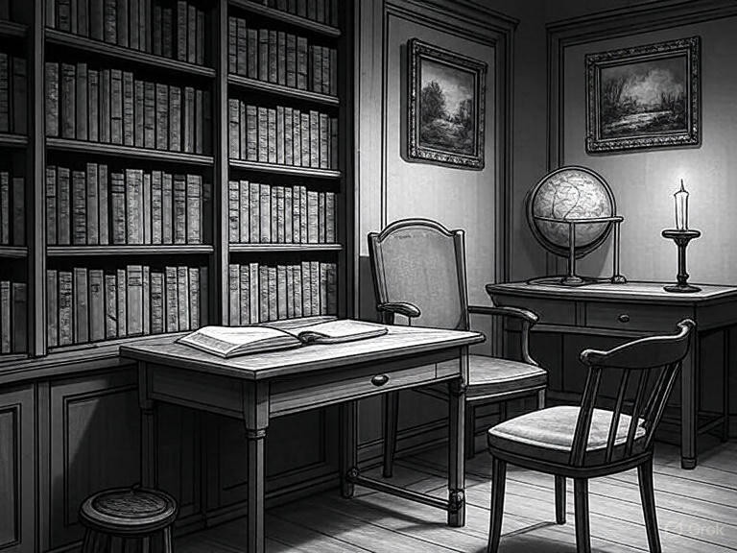

1. How many pieces of furniture are present? 5 (taxonomic) (desks, chairs, stool, dresser)

2. How many objects are on top of other objects? 2 (relational) (book on desk, globe on dresser)

3. If all the books were removed from the bookshelf, how many empty shelves would be visible? 5 (physical) (shelves)

## Image 32 (library)

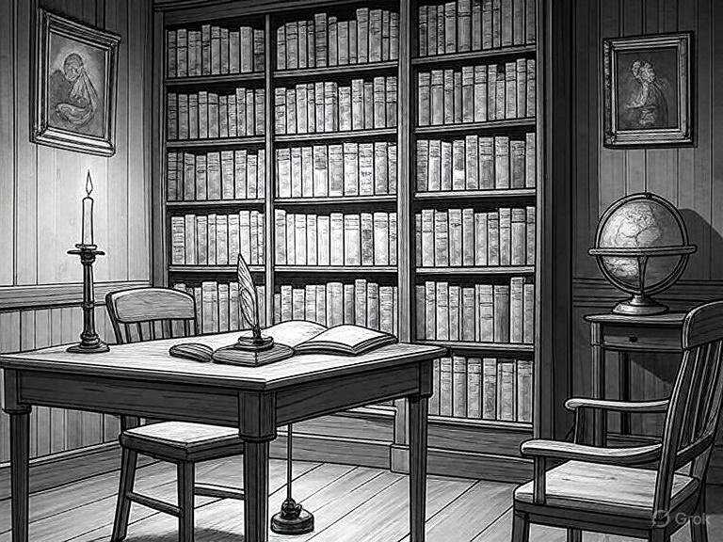

1. How many pieces of furniture are present? 4 (taxonomic) (tables and chairs)

2. How many items are on top of other items? 2 (relational) (books on shelves)

3. If all the books were removed from the shelves, how many empty shelves would be visible? 6 (physical) (shelves)

## Image 33 (kitchen)

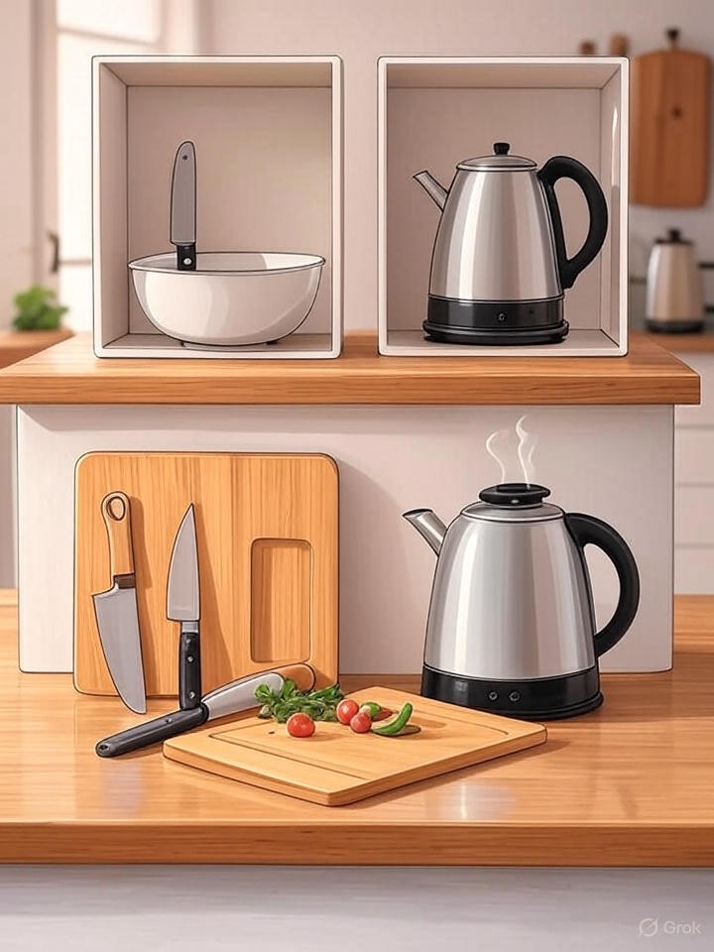

1. How many objects made of metal are present? 4 (physical) (kettles)

2. How many objects are on top of cutting boards? 3 (relational) (knives and tomatoes)

3. If the kettles were made of glass instead of metal, how many glass objects would be visible? 2 (physical) (kettles)

## Image 34 (kitchen)

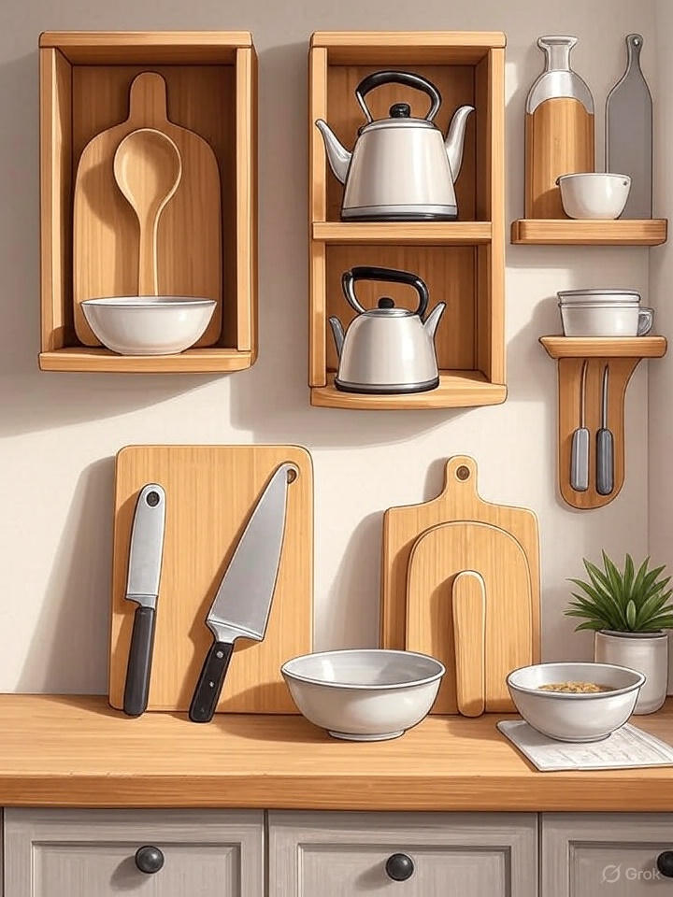

1. How many objects made of metal are present? 4 (physical) (kettles)

2. How many objects are on top of the counter? 7 (relational) (kitchen items)

3. If all the wooden cutting boards were painted blue, how many wooden objects would be visible? 5 (physical) (shelves)

## Image 35 (picnic)

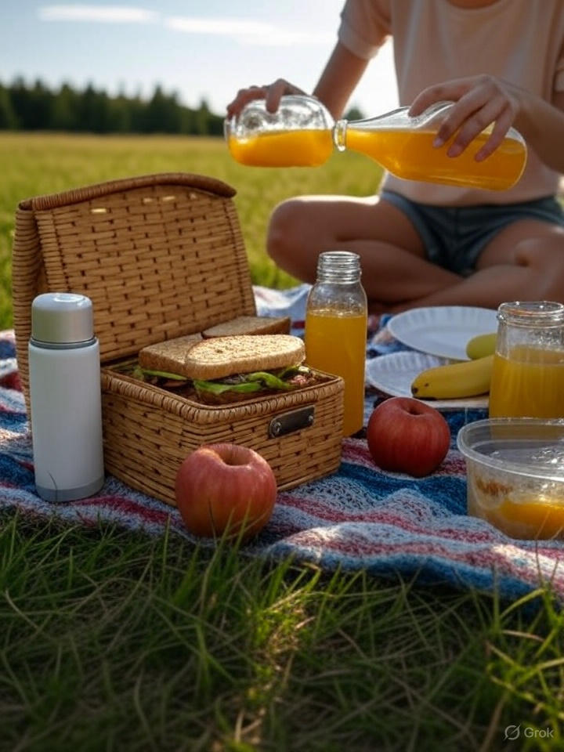

1. How many fruits are visible? 3 (taxonomic) (apples and bananas)

2. How many containers can hold liquid are present? 3 (functional) (bottles and jars)

3. If the picnic basket was empty, how many sandwiches would be visible? 0 (relational) (sandwiches)

## Image 36 (picnic)



1. How many fruits are visible? 3 (taxonomic) (apples)

2. How many containers that can hold liquid are present? 3 (functional) (bottles/glasses)

3. If the picnic basket were empty, how many woven objects would be visible? 1 (physical) (basket)

## Image 37 (picnic)

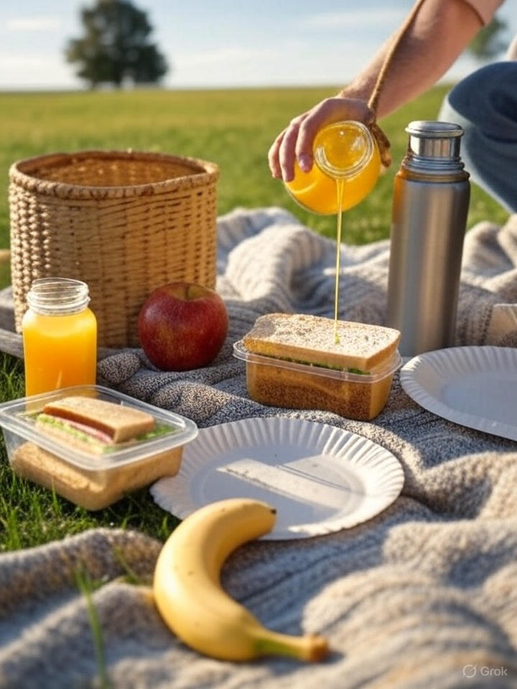

1. How many items are fruits? 2 (taxonomic) (apple, banana)

2. How many containers can hold liquid? 2 (functional) (juice bottles)

3. If the basket was empty, how many items would be directly on the blanket? 5 (relational) (sandwiches, apple, banana, water bottle, juice bottle)

## Image 38 (picnic)

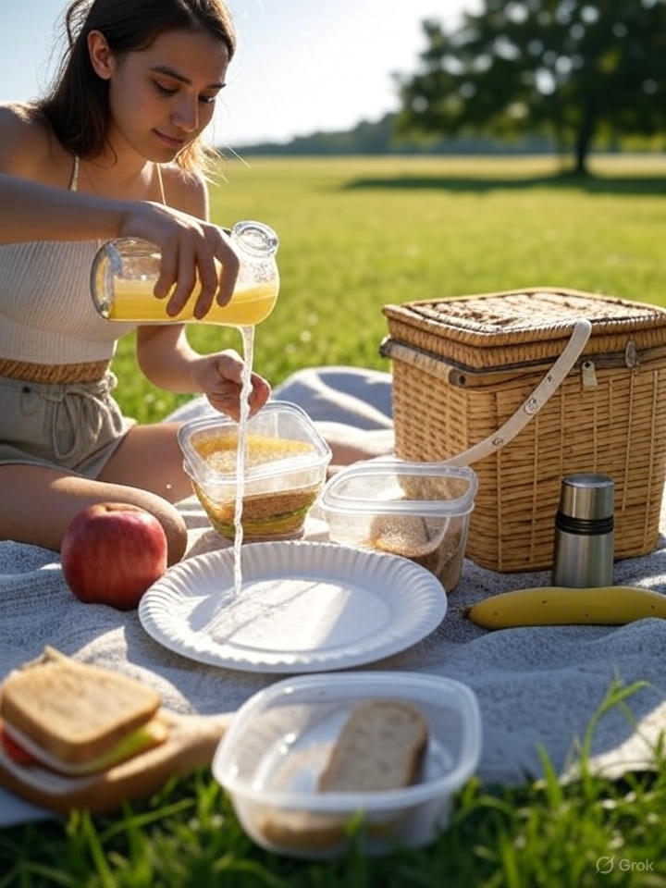

1. How many items are fruits? 2 (taxonomic) (apple, banana)

2. How many containers can hold food? 4 (functional) (plastic containers)

3. If the picnic basket were empty, how many items would be directly on the blanket? 6 (relational) (food items & thermos)

## Image 39 (laboratory)

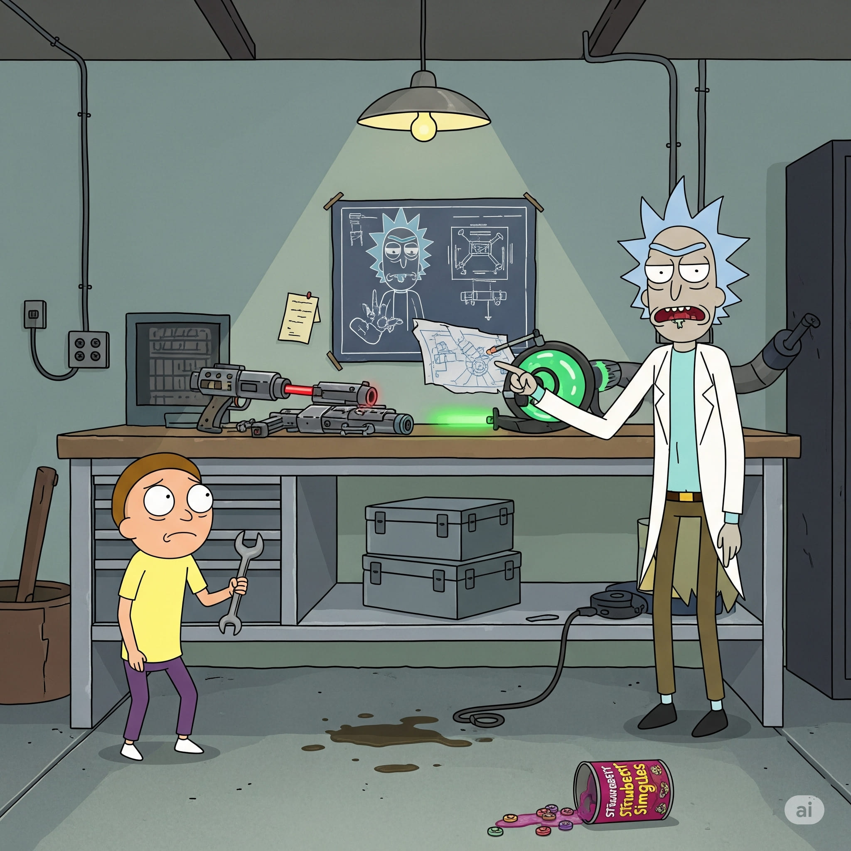

1. How many objects made of metal are present? 6 (physical) (gun, boxes, computer parts)

2. How many objects are on top of the wooden table? 8 (relational) (objects)

3. If the can of Strawberry Smiggles was not present, how many cans would be visible? 0 (taxonomic) (cans)

## Image 40 (bedroom)

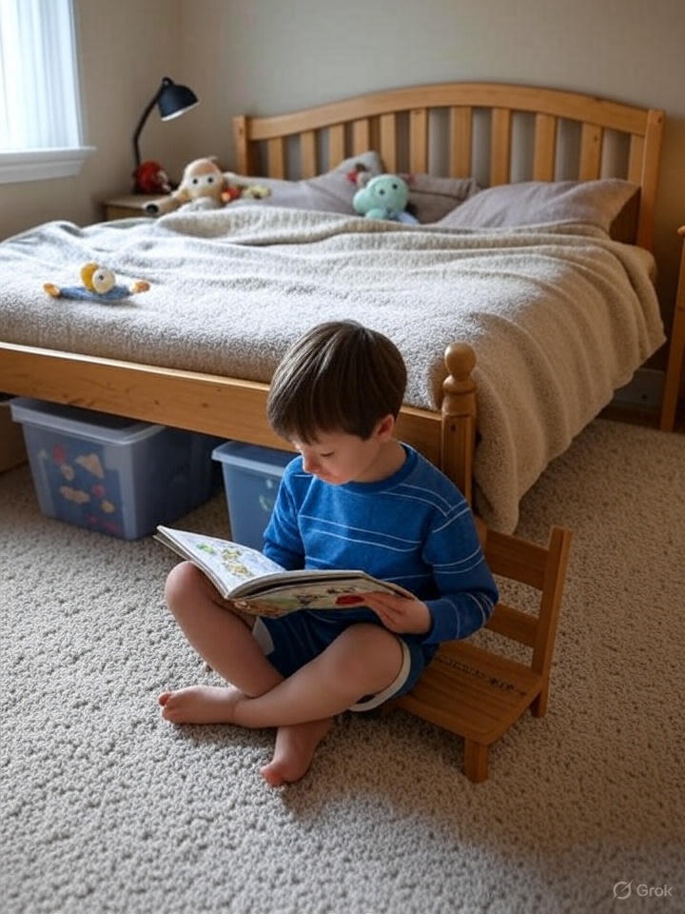

1. How many items made of wood are present? 3 (physical) (bed, stool, lamp base)

2. How many stuffed animals are on the bed? 3 (relational) (stuffed animals)

3. If the storage bins were removed from under the bed, how many storage bins would be visible? 0 (relational) (storage bins)

## Image 41 (bedroom)

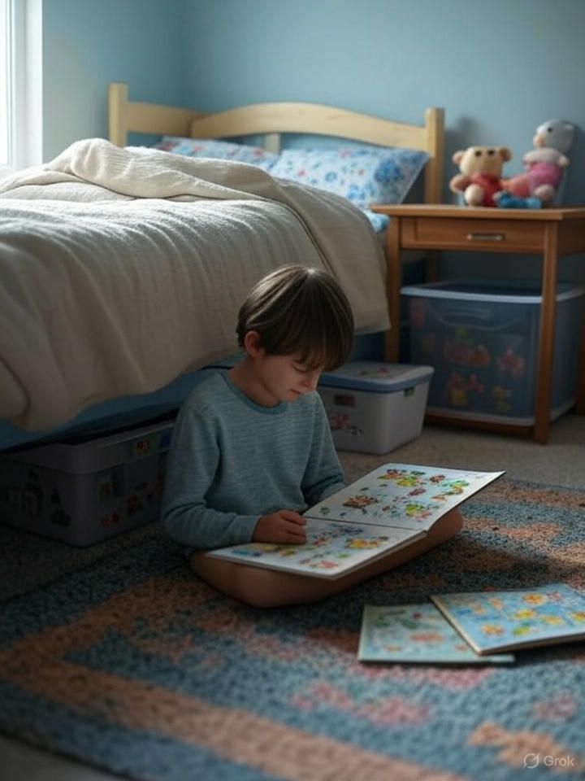

1. How many pieces of furniture are visible? 3 (taxonomic) (bed, nightstand, storage containers)

2. How many items are located under the bed? 2 (relational) (storage containers)

3. If the stuffed animals were removed from the nightstand, how many stuffed animals would be visible? 0 (taxonomic) (stuffed animals)

## Image 42 (bedroom)

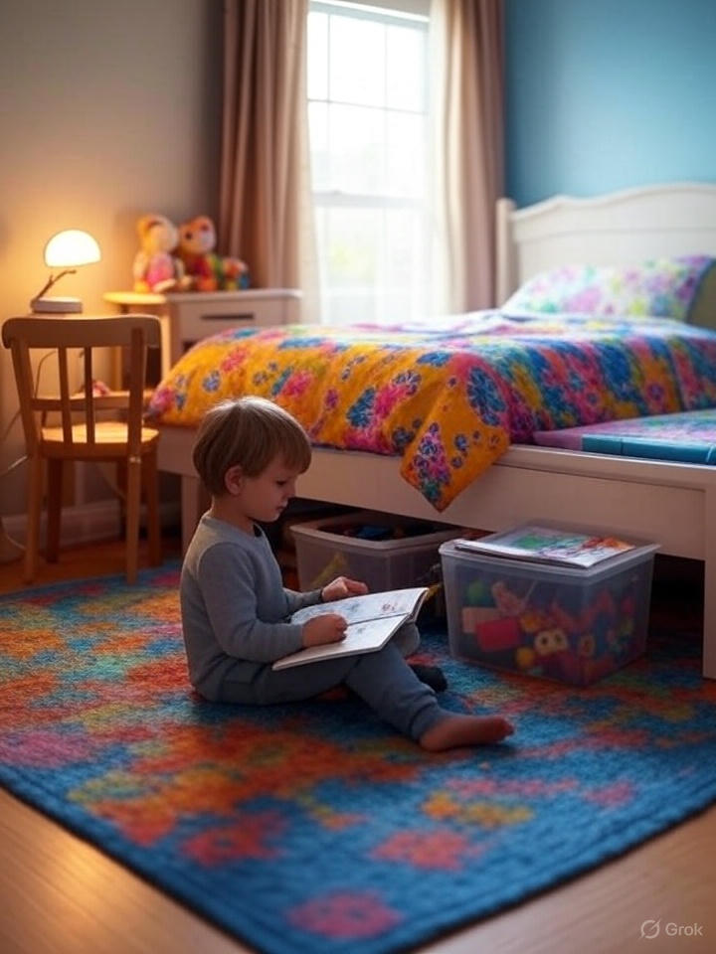

1. How many pieces of furniture are visible? 3 (taxonomic) (chair, bed, nightstand)

2. How many items are inside the clear plastic container? 8 (relational) (toys)

3. If the rug was a solid color, how many distinct colors would be visible in the room? 6 (physical) (colors)

## Image 43 (home setup)



1. How many monitors are visible? 2 (taxonomic) (computer monitors)

2. How many items are on top of the desk? 6 (relational) (laptop, keyboard, mouse, notebook, mug, picture frame)

3. If the lamp was not present, how many light sources would be visible? 0 (functional) (lamps)

## Image 44 (home setup)

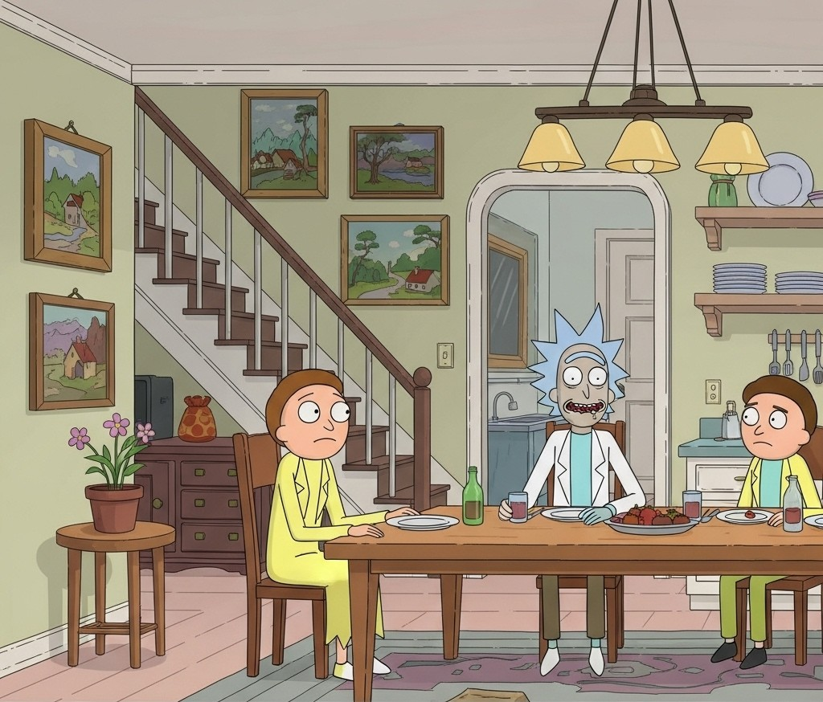

1. How many framed pictures are visible? 4 (taxonomic) (paintings)

2. How many chairs are positioned around the table? 3 (relational) (chairs)

3. If the plant on the side table had 5 flowers instead of 3, how many flowers would be visible? 5 (physical) (flowers)

## Image 45 (zoo)

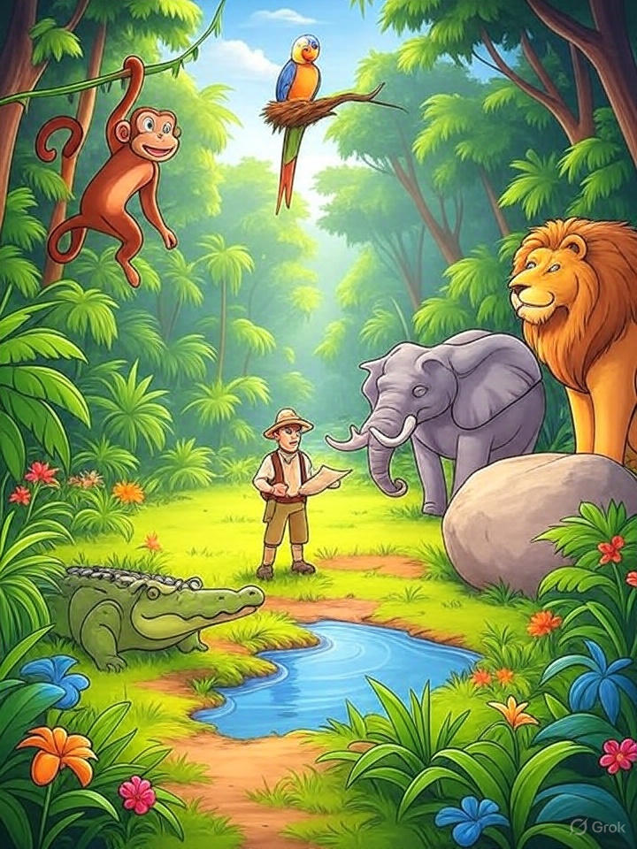

1. How many mammals are visible? 4 (taxonomic) (monkey, elephant, lion, person)

2. How many animals are looking at the person? 3 (relational) (elephant, lion, crocodile)

3. If the parrot flew away, how many birds would be visible? 0 (taxonomic) (birds)

## Image 46 (zoo)

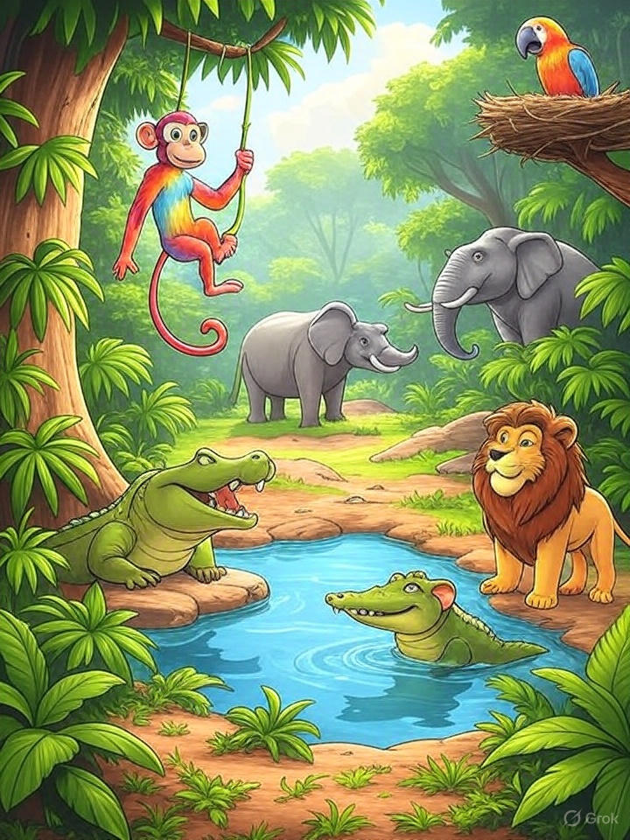

1. How many mammals are visible? 4 (taxonomic) (monkey, elephants, lion)

2. How many animals are near the water? 3 (relational) (crocodiles, lion)

3. If the parrot flew away, how many birds would be visible? 0 (taxonomic) (birds)

## Image 47 (kitchen)



1. How many loaves of bread are visible? 3 (taxonomic) (grains)

2. How many items that can hold liquid are present? 2 (functional) (glass/jugs)

3. If the jars on the shelf were filled with fruit instead of spices, how many jars would be filled? 4 (taxonomic) (fruits)

## Image 48 (kitchen)

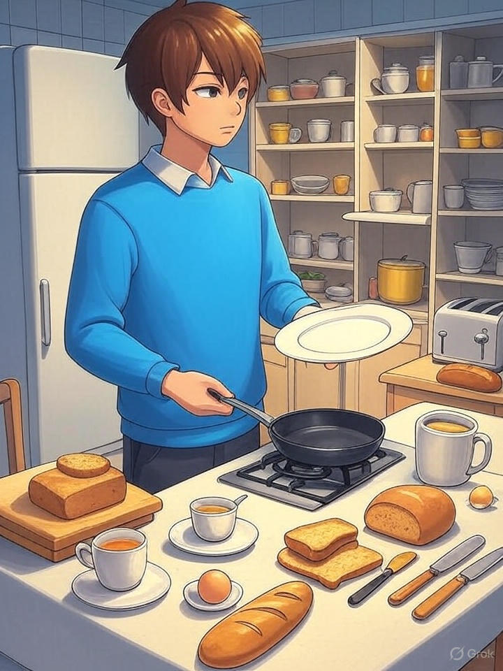

1. How many items categorized as grains are present? 5 (taxonomic) (bread slices/loaves/baguette)

2. How many items that can hold liquid are visible? 4 (functional) (cups/mugs)

3. If all the jars on the shelves were empty, how many containers would be visible? 10 (physical) (jars)

## Image 49 (garage)

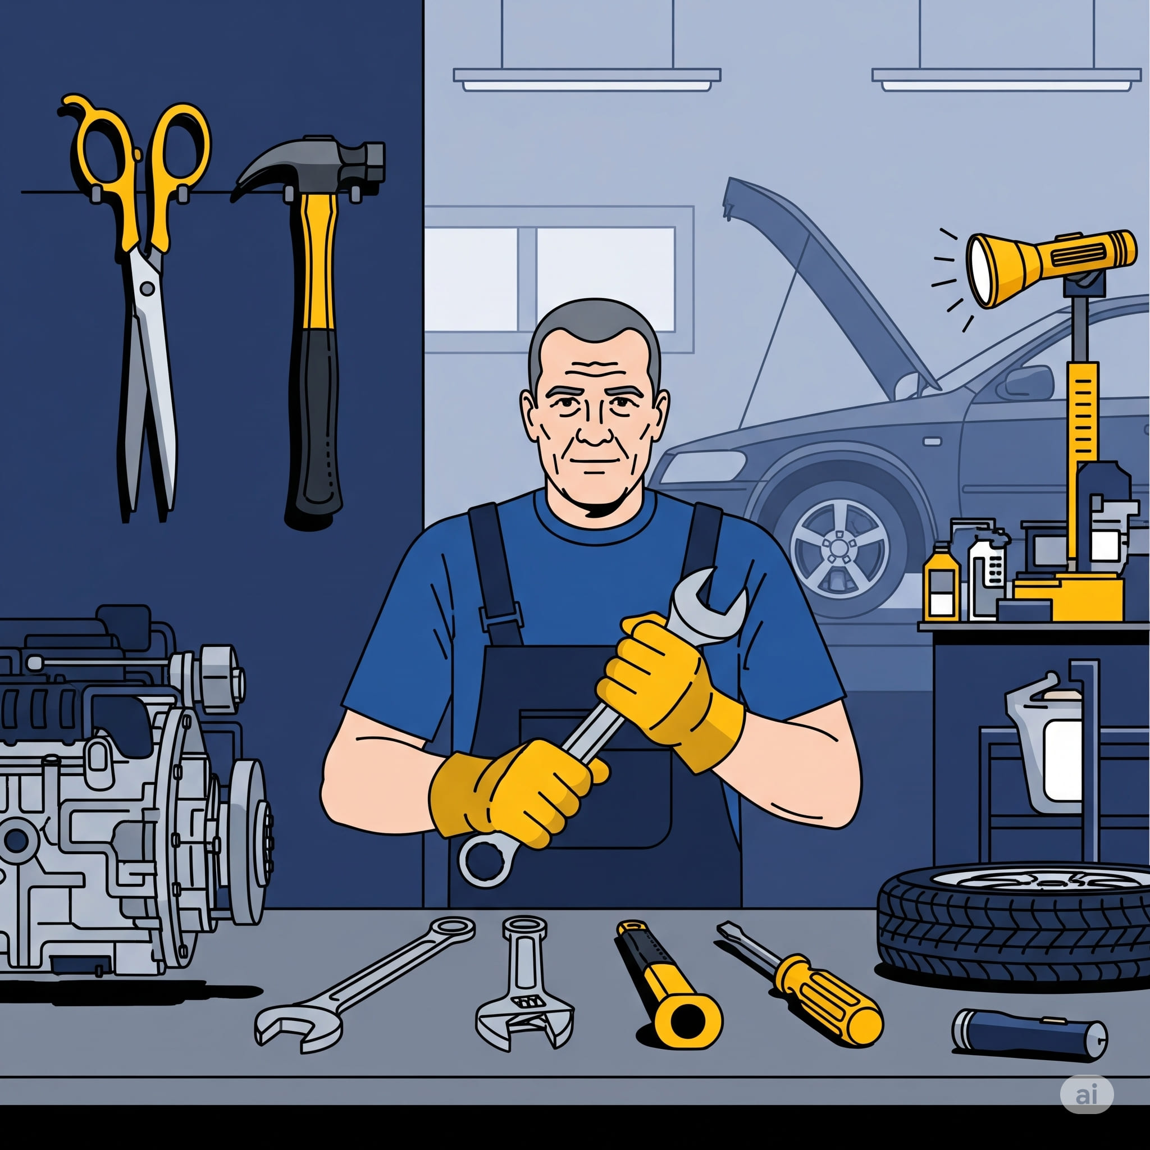

1. How many tools are visible? 7 (taxonomic) (scissors, hammer, wrench, screwdriver, wrench, ratchet, pliers)

2. How many items are lying on the workbench? 6 (relational) (tools)

3. If the car tire was replaced with a spare tire, how many tires would be visible? 2 (physical) (tires)

## Image 50 (camping)

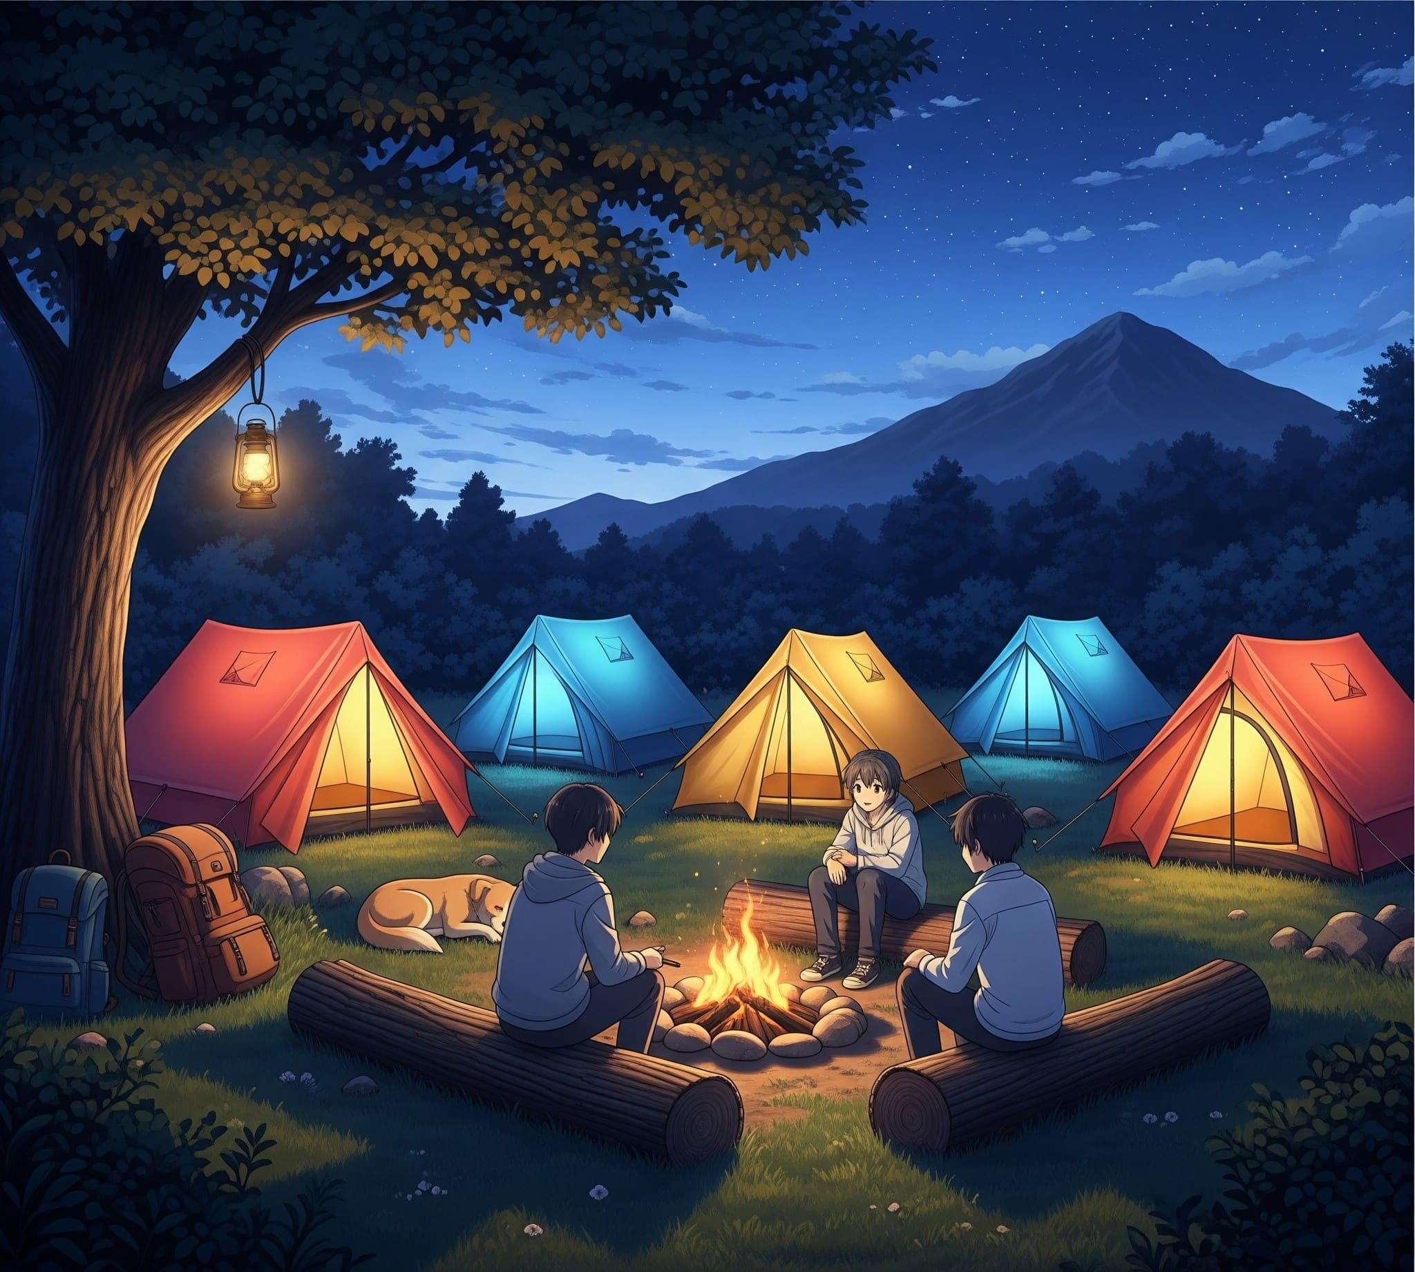

1. How many tents are visible? 5 (taxonomic) (tents)

2. How many people are sitting around the campfire? 3 (relational) (people)

3. If the backpacks were removed, how many backpacks would be visible? 0 (physical) (backpacks)

## Image 51 (gym)

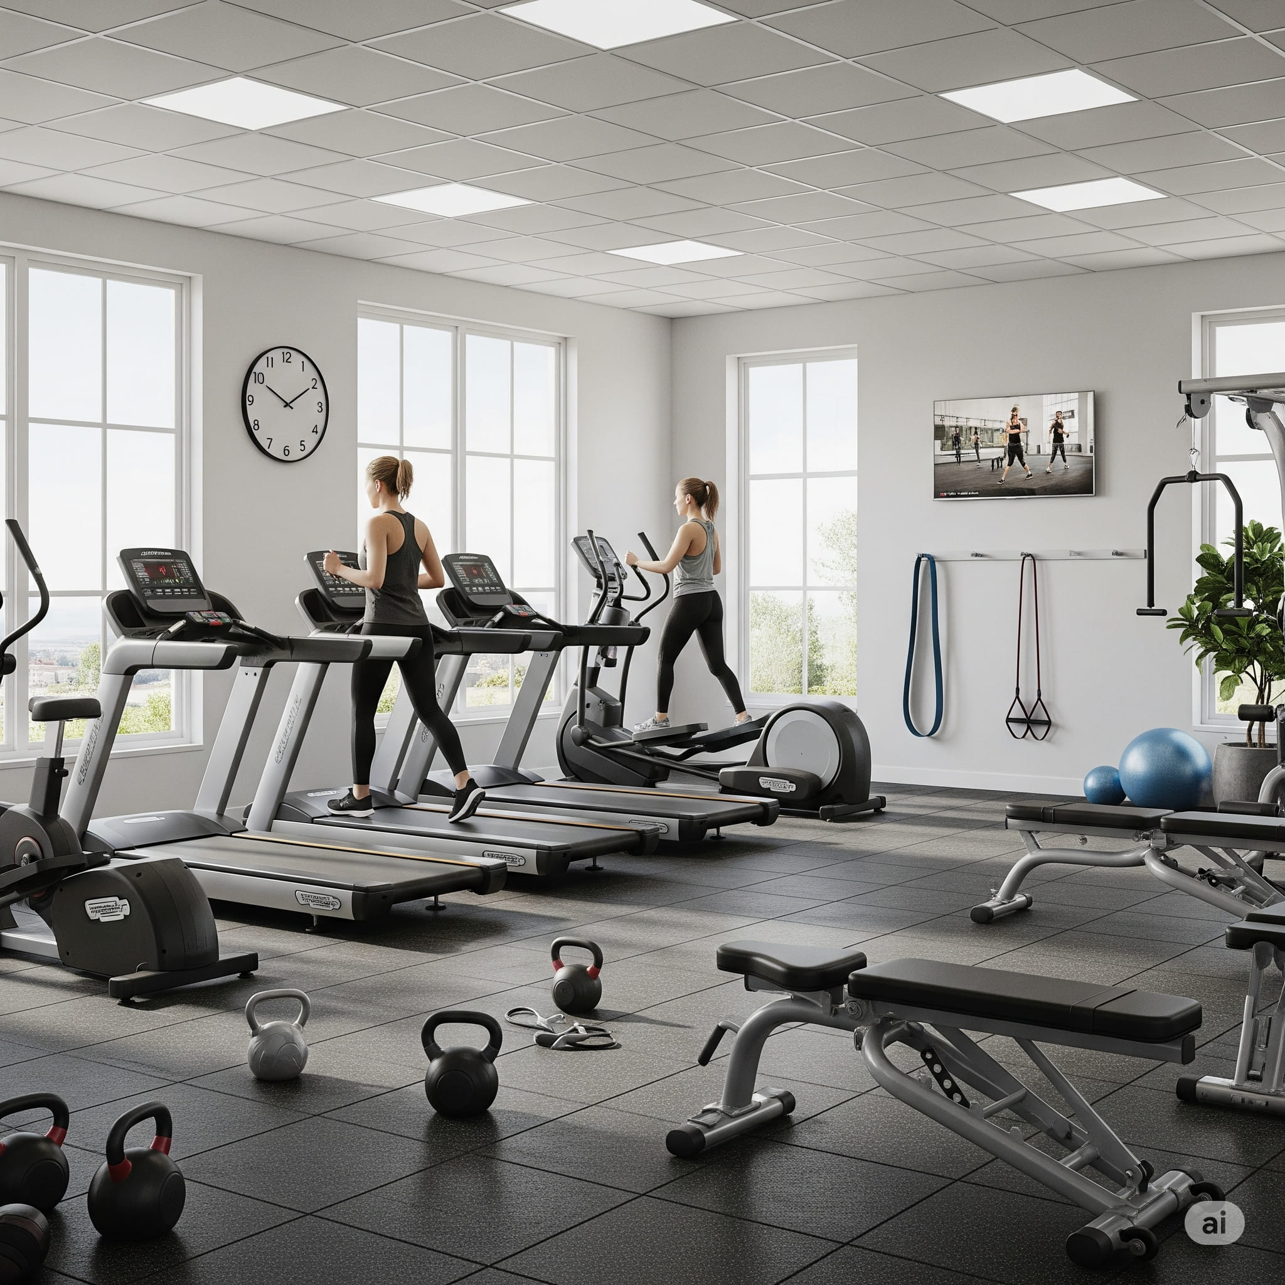

1. How many objects made of metal are present? 13 (physical) (treadmills, kettlebells, step platforms)

2. How many objects used for exercise are visible? 10 (functional) (treadmills, kettlebells, resistance bands, step platforms, exercise ball)

3. If all the treadmills were replaced with stationary bikes, how many objects with wheels would be visible? 8 (physical) (stationary bikes, step platforms)

## Image 52 (beach cleanup)

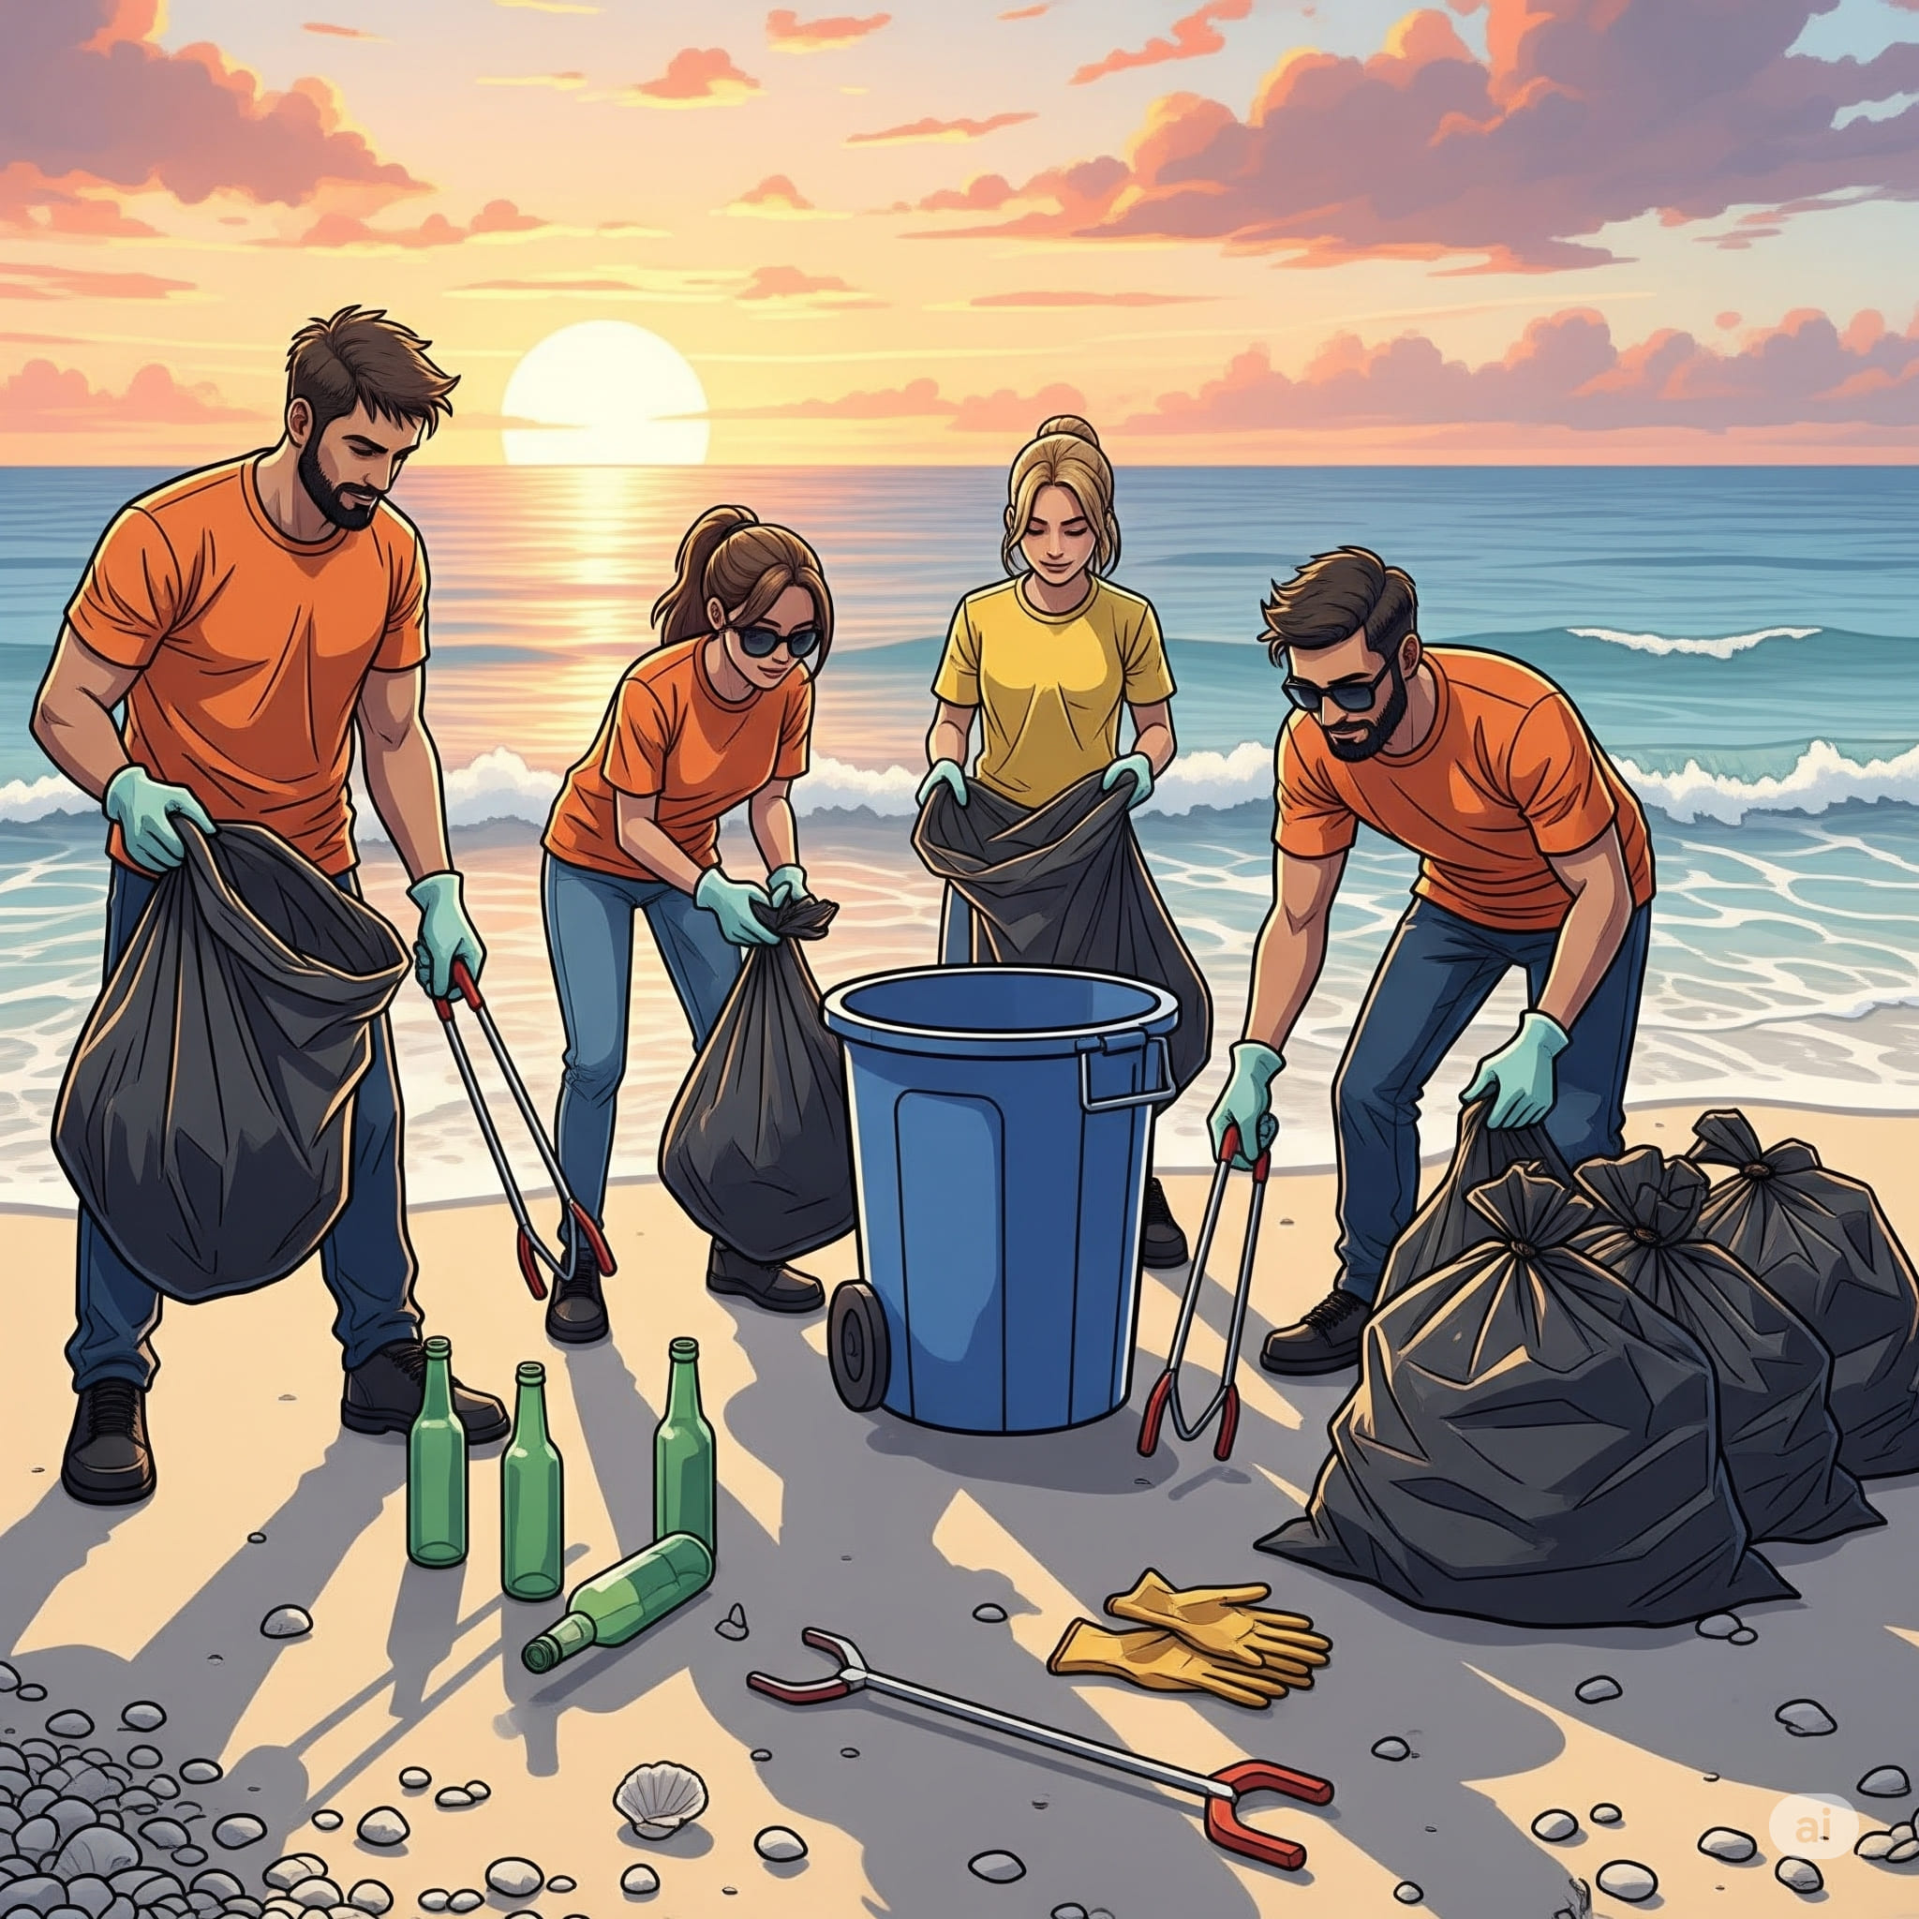

1. How many objects made of glass are present? 5 (physical) (bottles)

2. How many people are holding trash bags? 4 (relational) (volunteers)

3. If the blue trash can was not on wheels, how many objects with wheels are visible? 0 (physical) (wheeled trash can)

## Image 53 (garage)

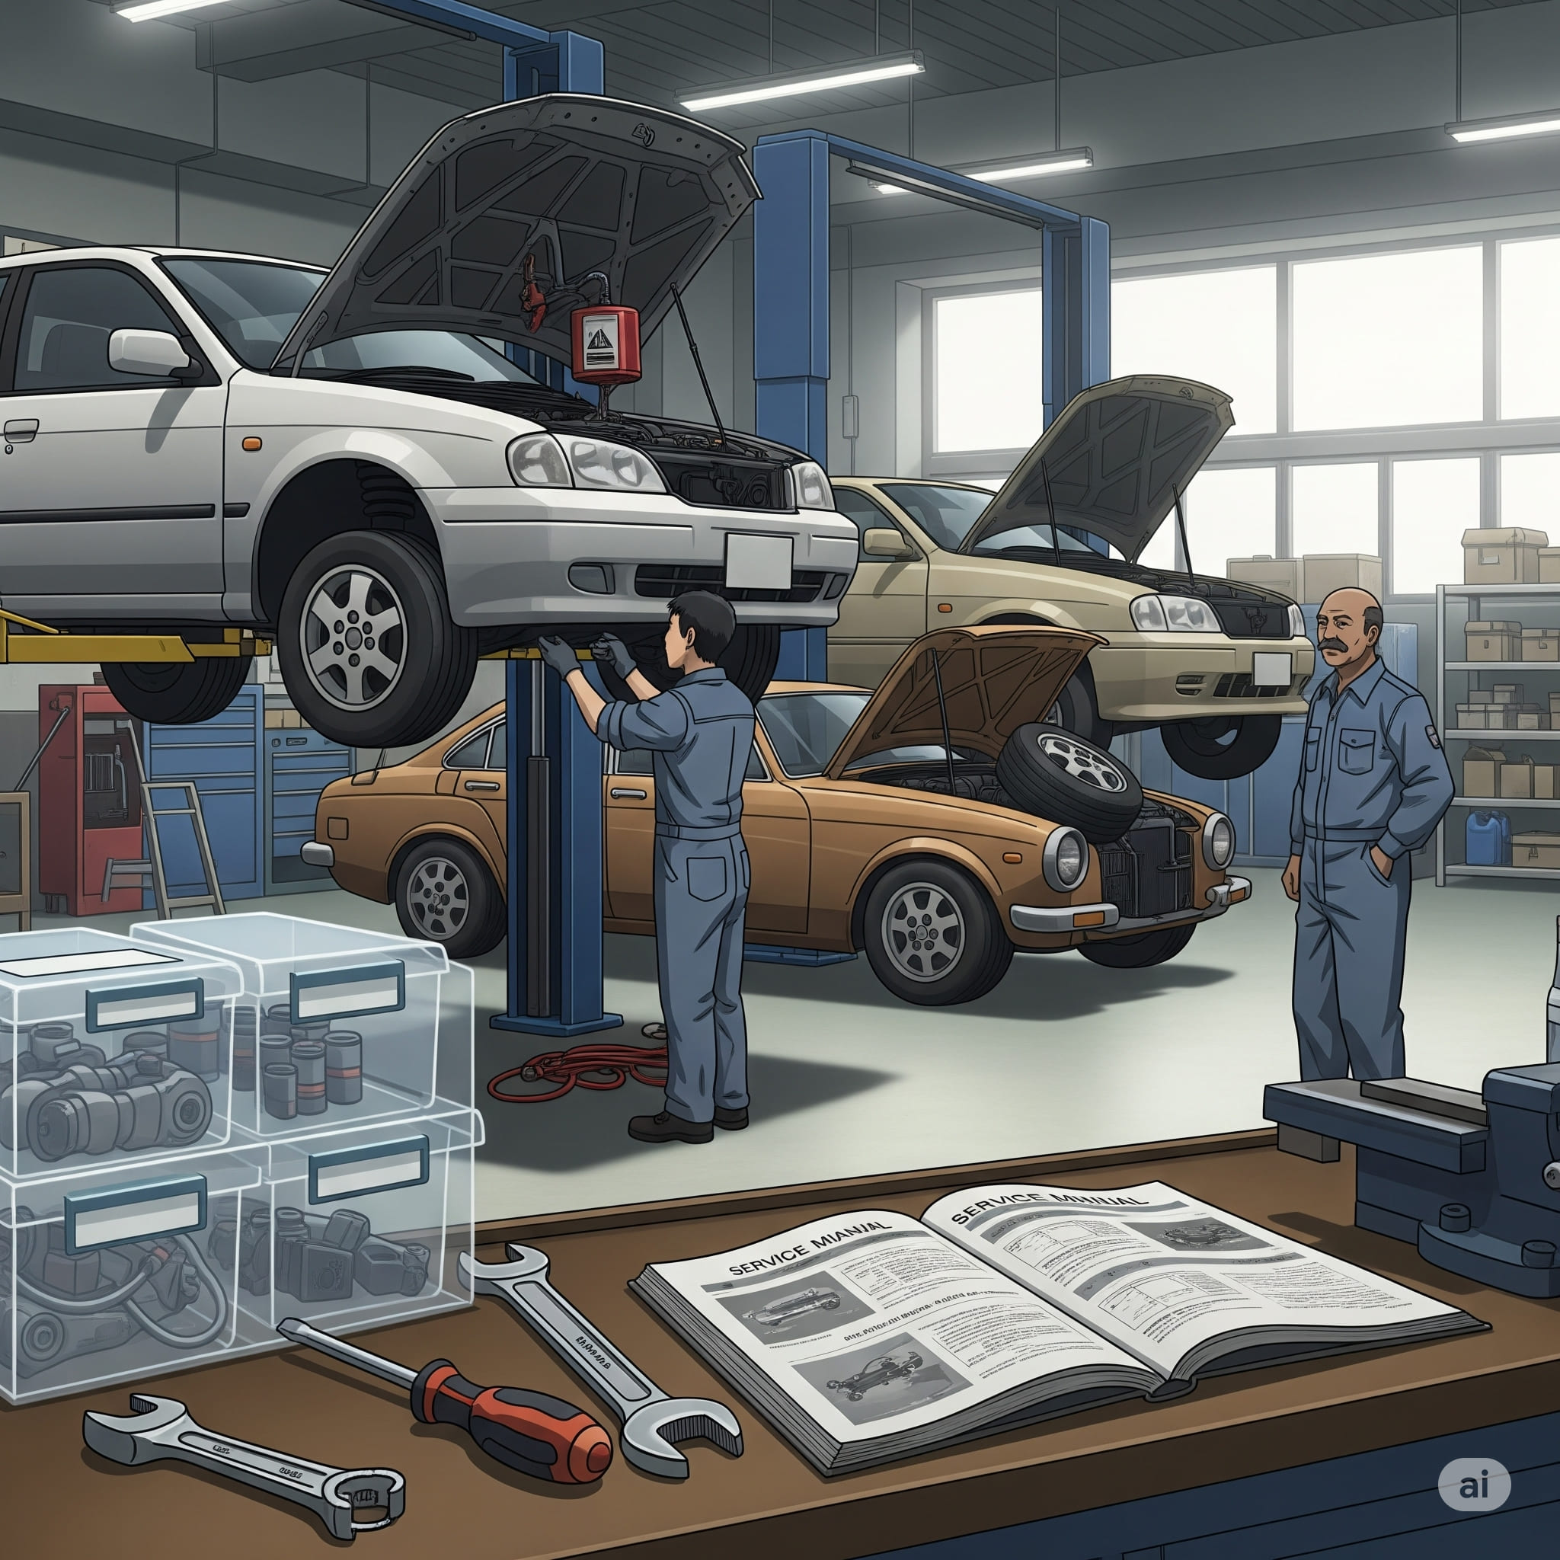

1. How many vehicles are present? 3 (taxonomic) (cars)

2. How many items are on top of other items? 4 (relational) (boxes, tools, manuals)

3. If the mechanic lifts were not present, how many vehicles would be on the ground? 3 (physical) (cars)

## Image 54 (kitchen)

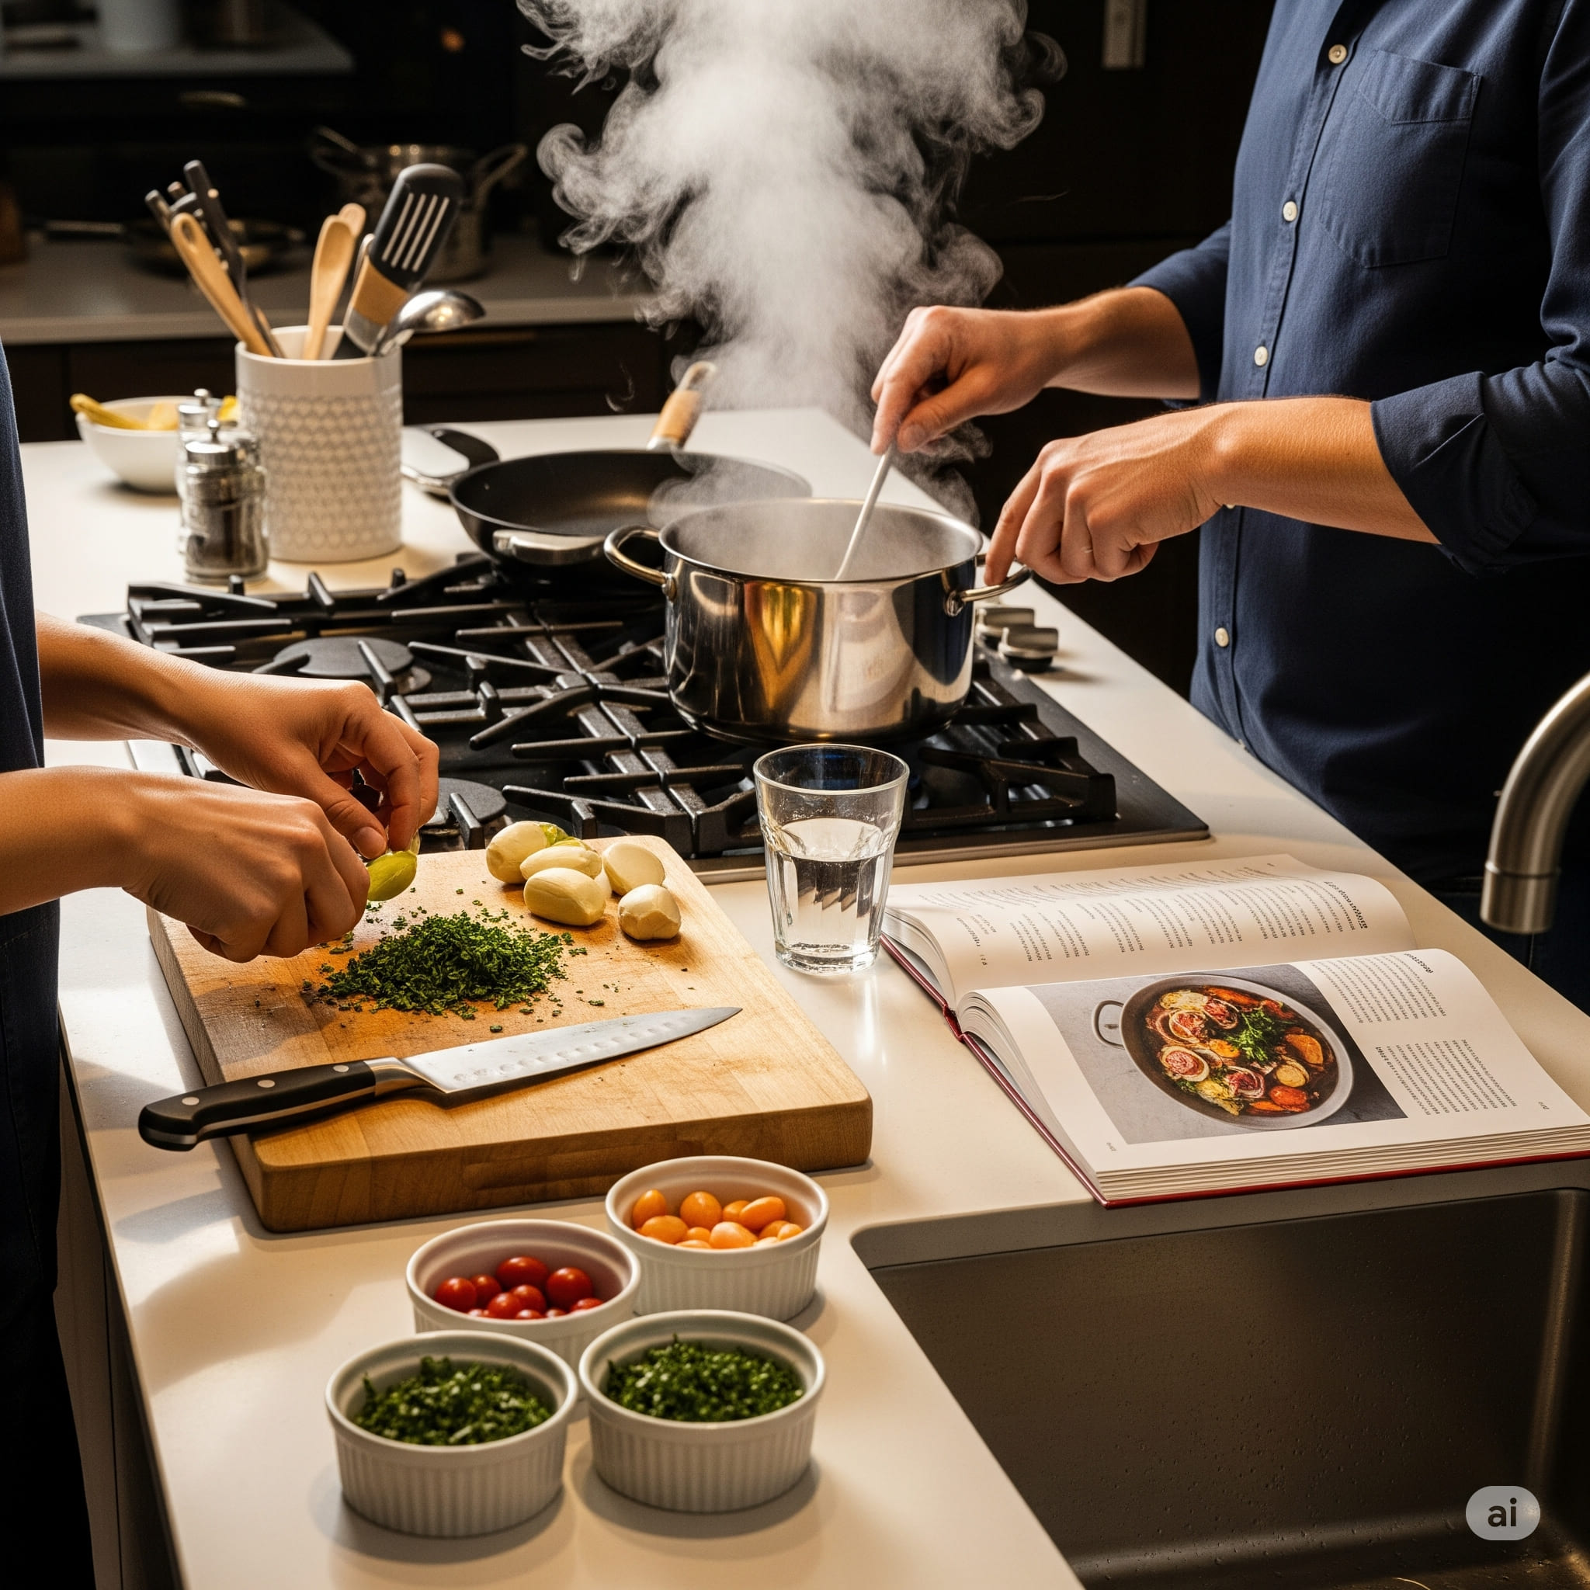

1. How many items are vegetables? 4 (taxonomic) (onions, limes, tomatoes, parsley)

2. How many containers can hold liquid? 4 (functional) (pot, glass, bowls)

3. If the cookbook was not open, how many pages would be visible? 0 (physical) (pages)

## Image 55 (classroom)

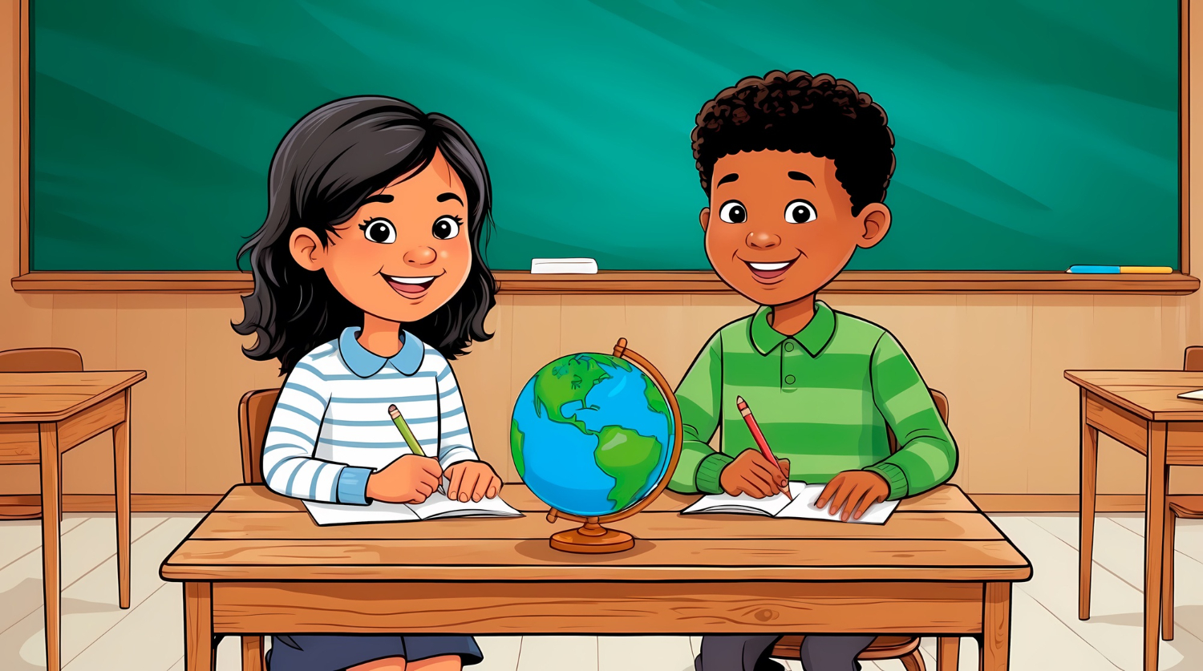

1. How many desks are visible? 3 (taxonomic) (furniture)

2. How many items are on top of the central desk? 3 (relational) (globe, papers, pencils)

3. If the globe was replaced with a book, how many spherical objects would be visible? 0 (physical) (spheres)

## Image 56 (classroom)

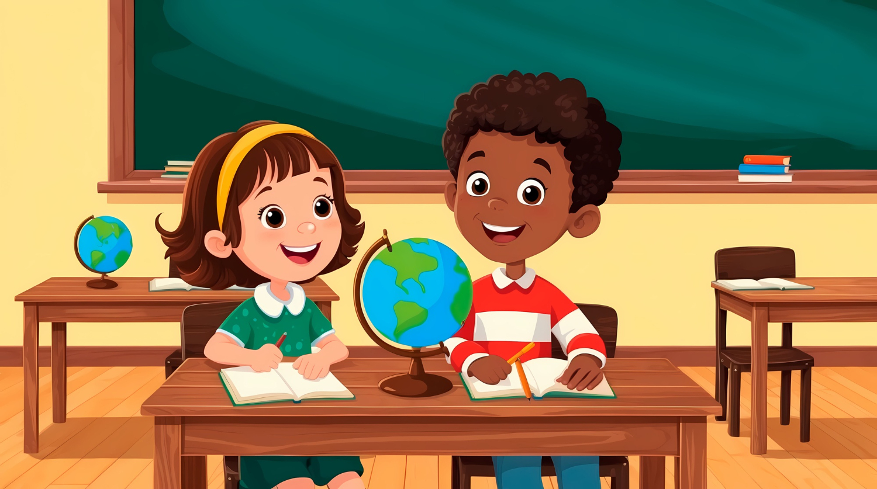

1. How many desks are present? 3 (taxonomic) (furniture)

2. How many globes are visible? 2 (functional) (educational tools)

3. If the books on the shelf were removed, how many objects would be on the shelf? 0 (relational) (books)

## Image 57 (classroom)

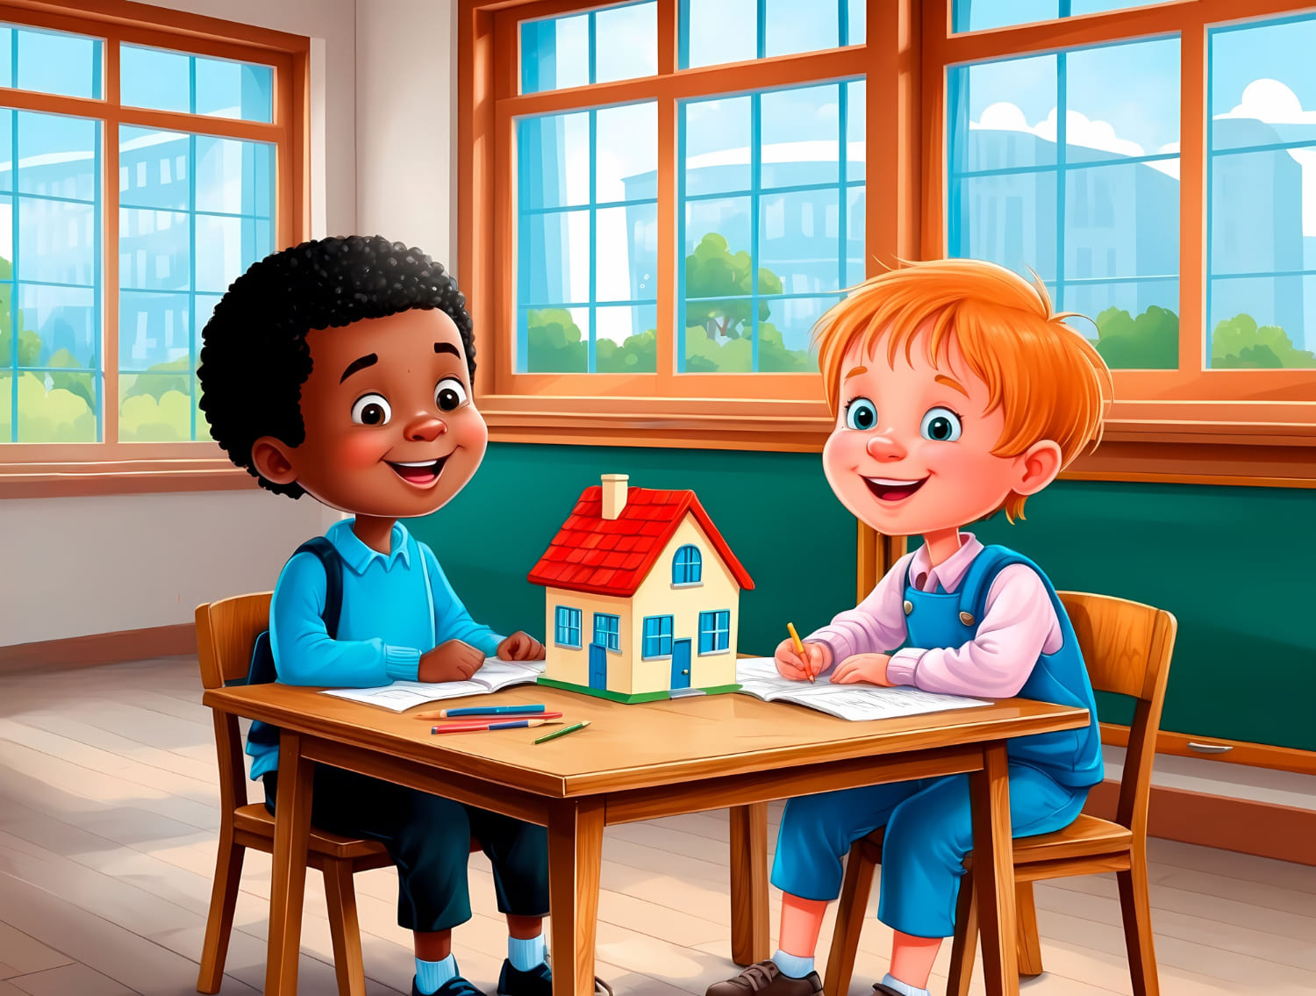

1. How many objects made of wood are present? 3 (physical) (chairs, table)

2. How many people are sitting at the table? 2 (relational) (children)

3. If the toy house was blue, how many red objects would be visible? 1 (taxonomic) (roof)

## Image 58 (kitchen)

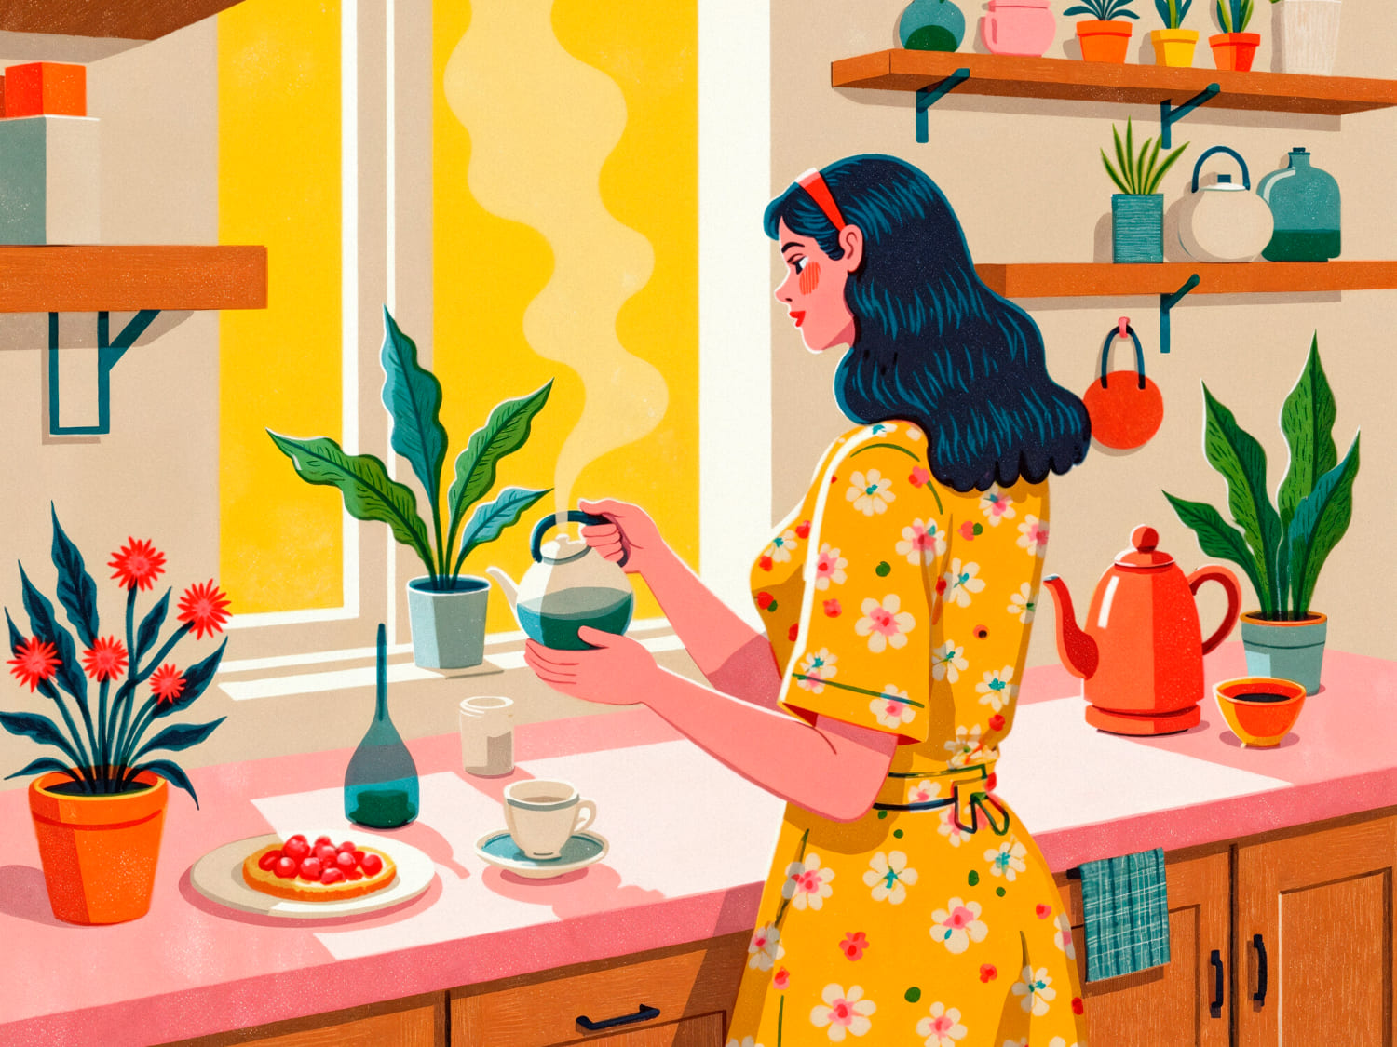

1. How many potted plants are visible? 4 (taxonomic) (plants)

2. How many items can hold liquid are present? 5 (functional) (tea pot, kettle, glasses, cup, pitcher)

3. If all the flowers were blue instead of red and orange, how many flowers would be visible? 7 (taxonomic) (flowers)

## Image 59 (kitchen)

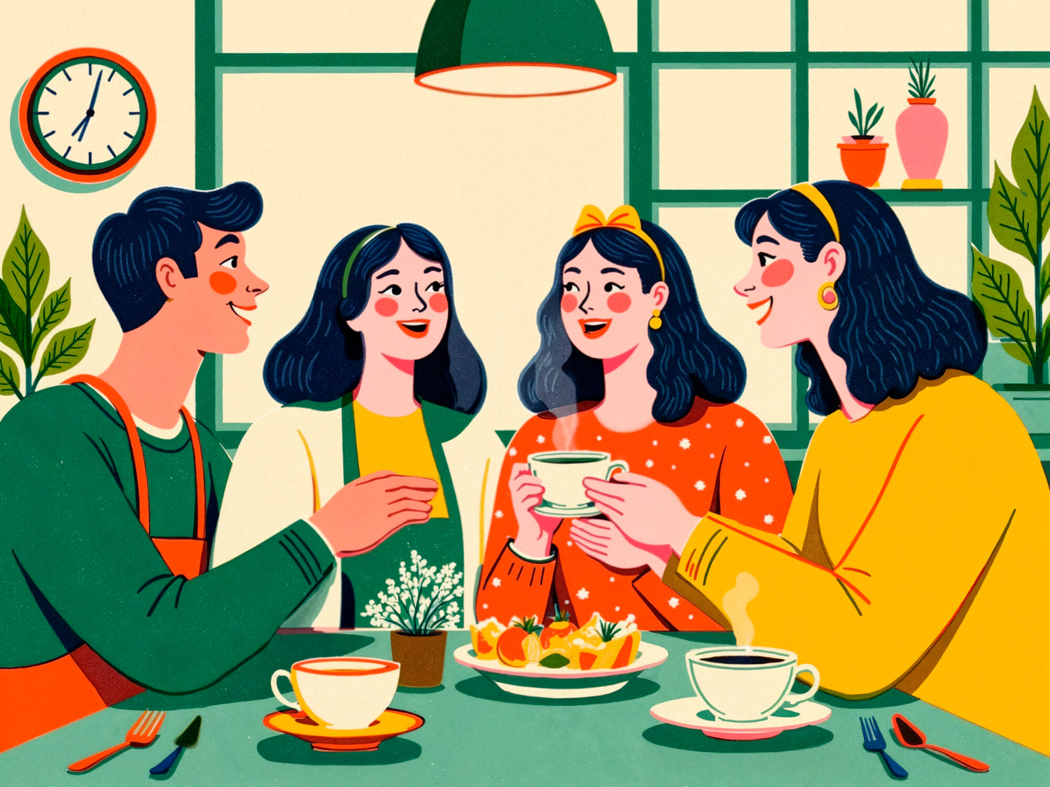

1. How many objects categorized as fruits are present? 5 (taxonomic) (orange slices)

2. How many objects that can hold liquid are visible? 3 (functional) (cups)

3. If the plants were removed from the windowsill, how many potted plants would be visible? 0 (taxonomic) (potted plants)

## Image 60 (home setup)



1. How many objects made of wood are present? 1 (physical) (tray)

2. How many objects that can hold liquid are visible? 3 (functional) (tea cups)

3. If the woman was holding a fourth tea cup, how many tea cups would be visible? 4 (taxonomic) (tea cups)

## Image 61 (kitchen)

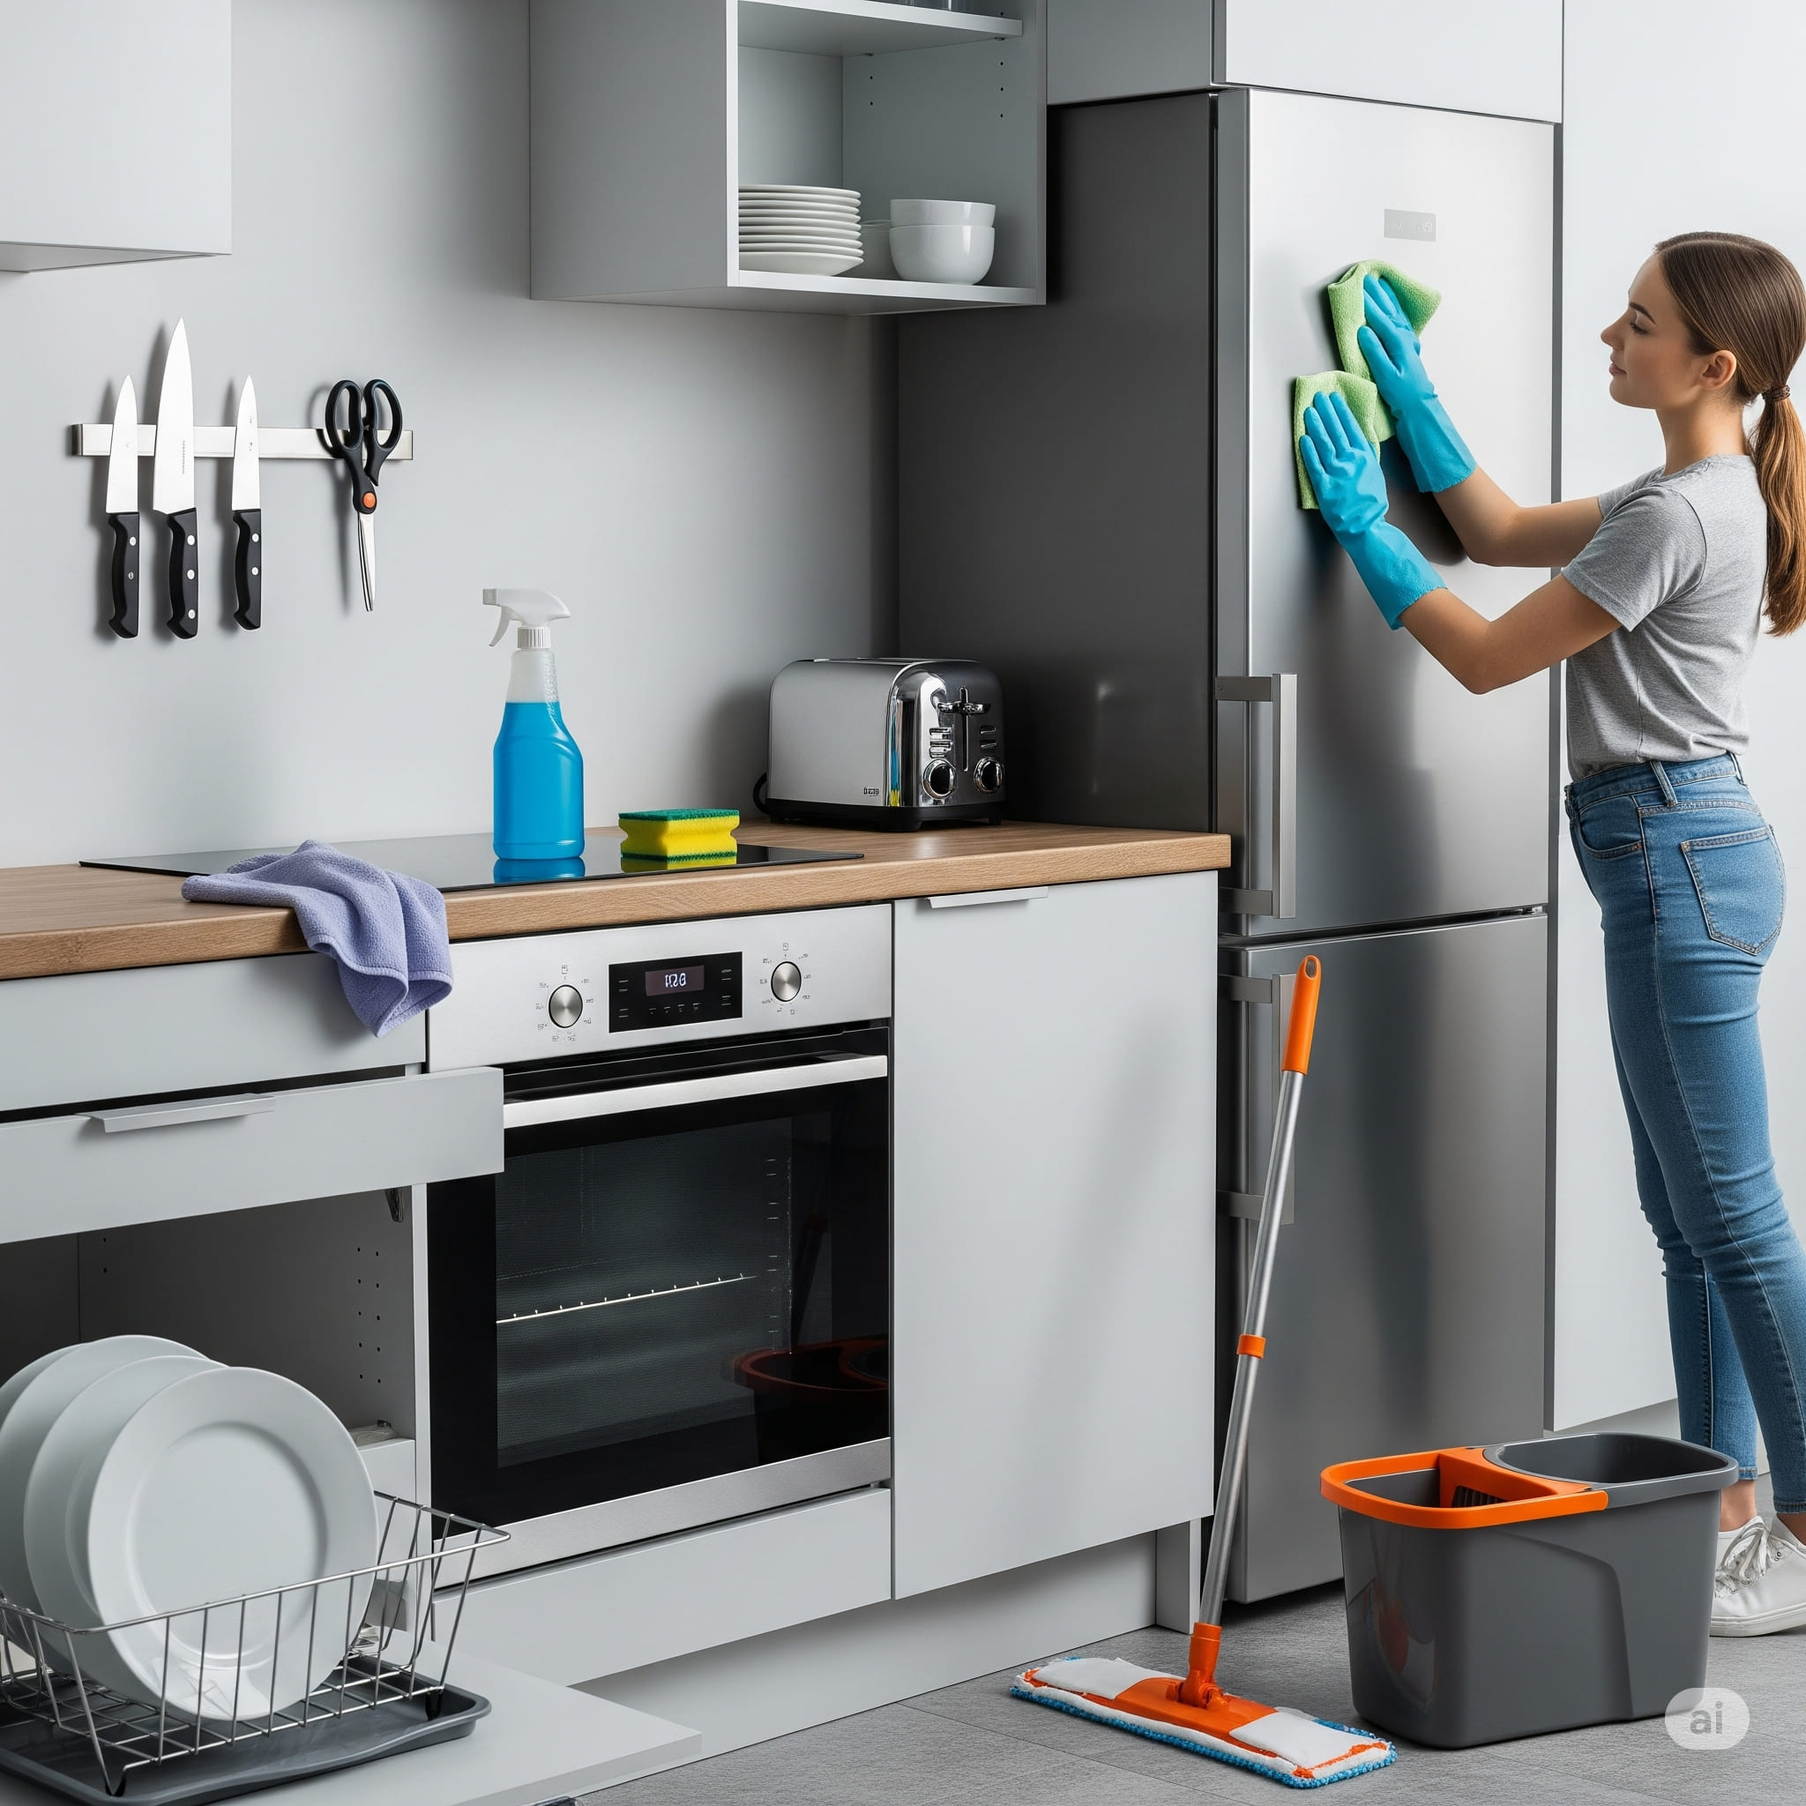

1. How many items made of metal are present? 7 (physical) (knives, toaster, oven dials, mop handle, trash can handle, mop head connector, oven handle)

2. How many items that can hold something are visible? 5 (functional) (cup, bowl, trash can, spray bottle, oven)

3. If the refrigerator was a different color, how many gray objects would be visible? 4 (physical) (cabinets, trash can, mop bucket, oven)

## Image 62 (picnic)

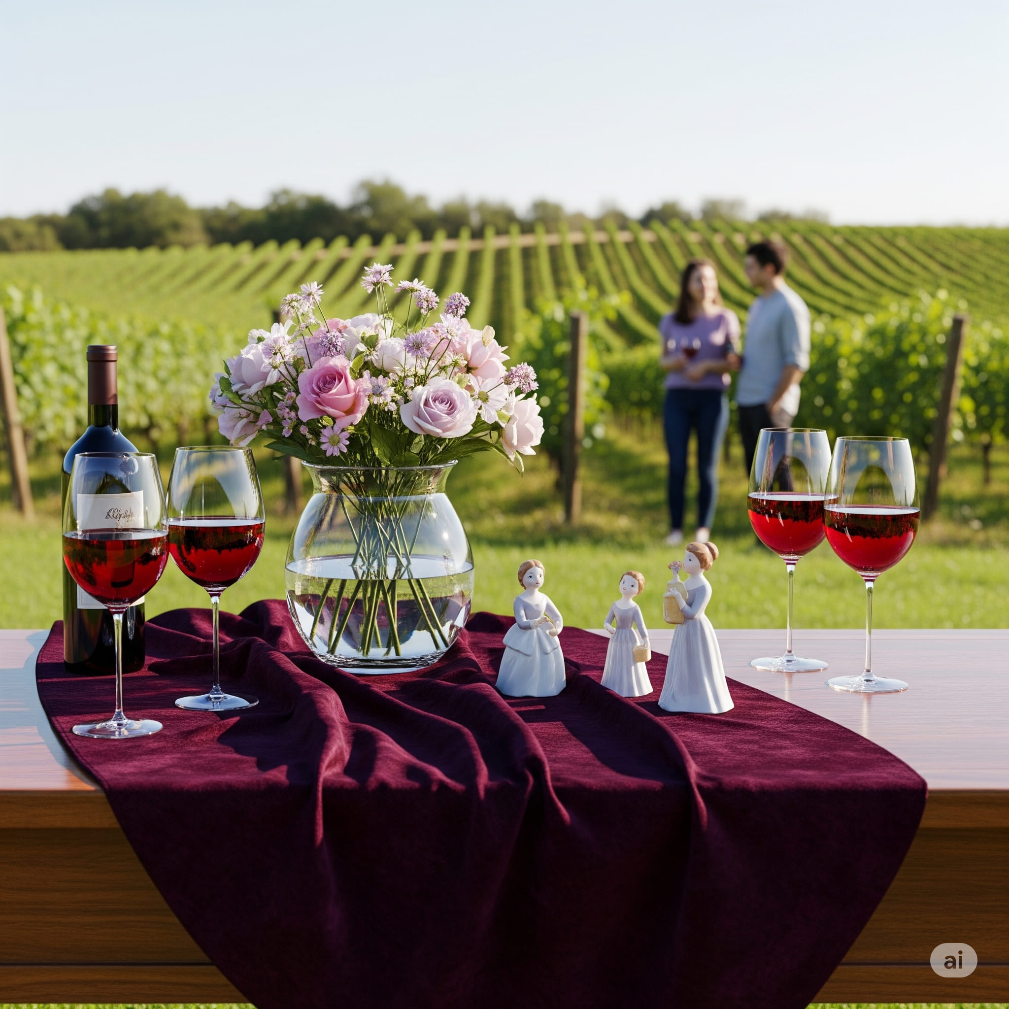

1. How many objects made of glass are present? 3 (physical) (wine glasses)

2. How many objects are on top of the table? 6 (relational) (objects)

3. If the two figurines were replaced with two bottles of wine, how many bottles of wine would be visible? 3 (taxonomic) (bottles of wine)

## Image 63 (construction)

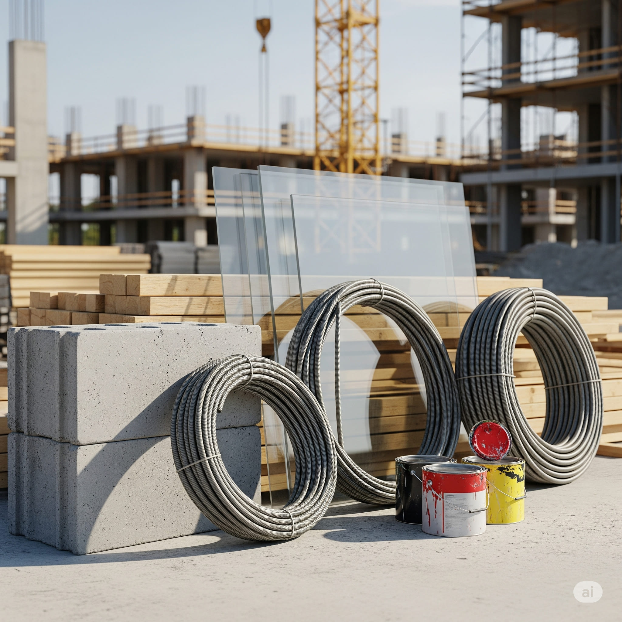

1. How many objects made of glass are present? 6 (physical) (glass panes)

2. How many objects are stacked on top of other objects? 8 (relational) (blocks and wood)

3. If the paint cans were full of water instead of paint, how many containers could hold liquid? 2 (functional) (paint cans)

## Image 64 (farm)

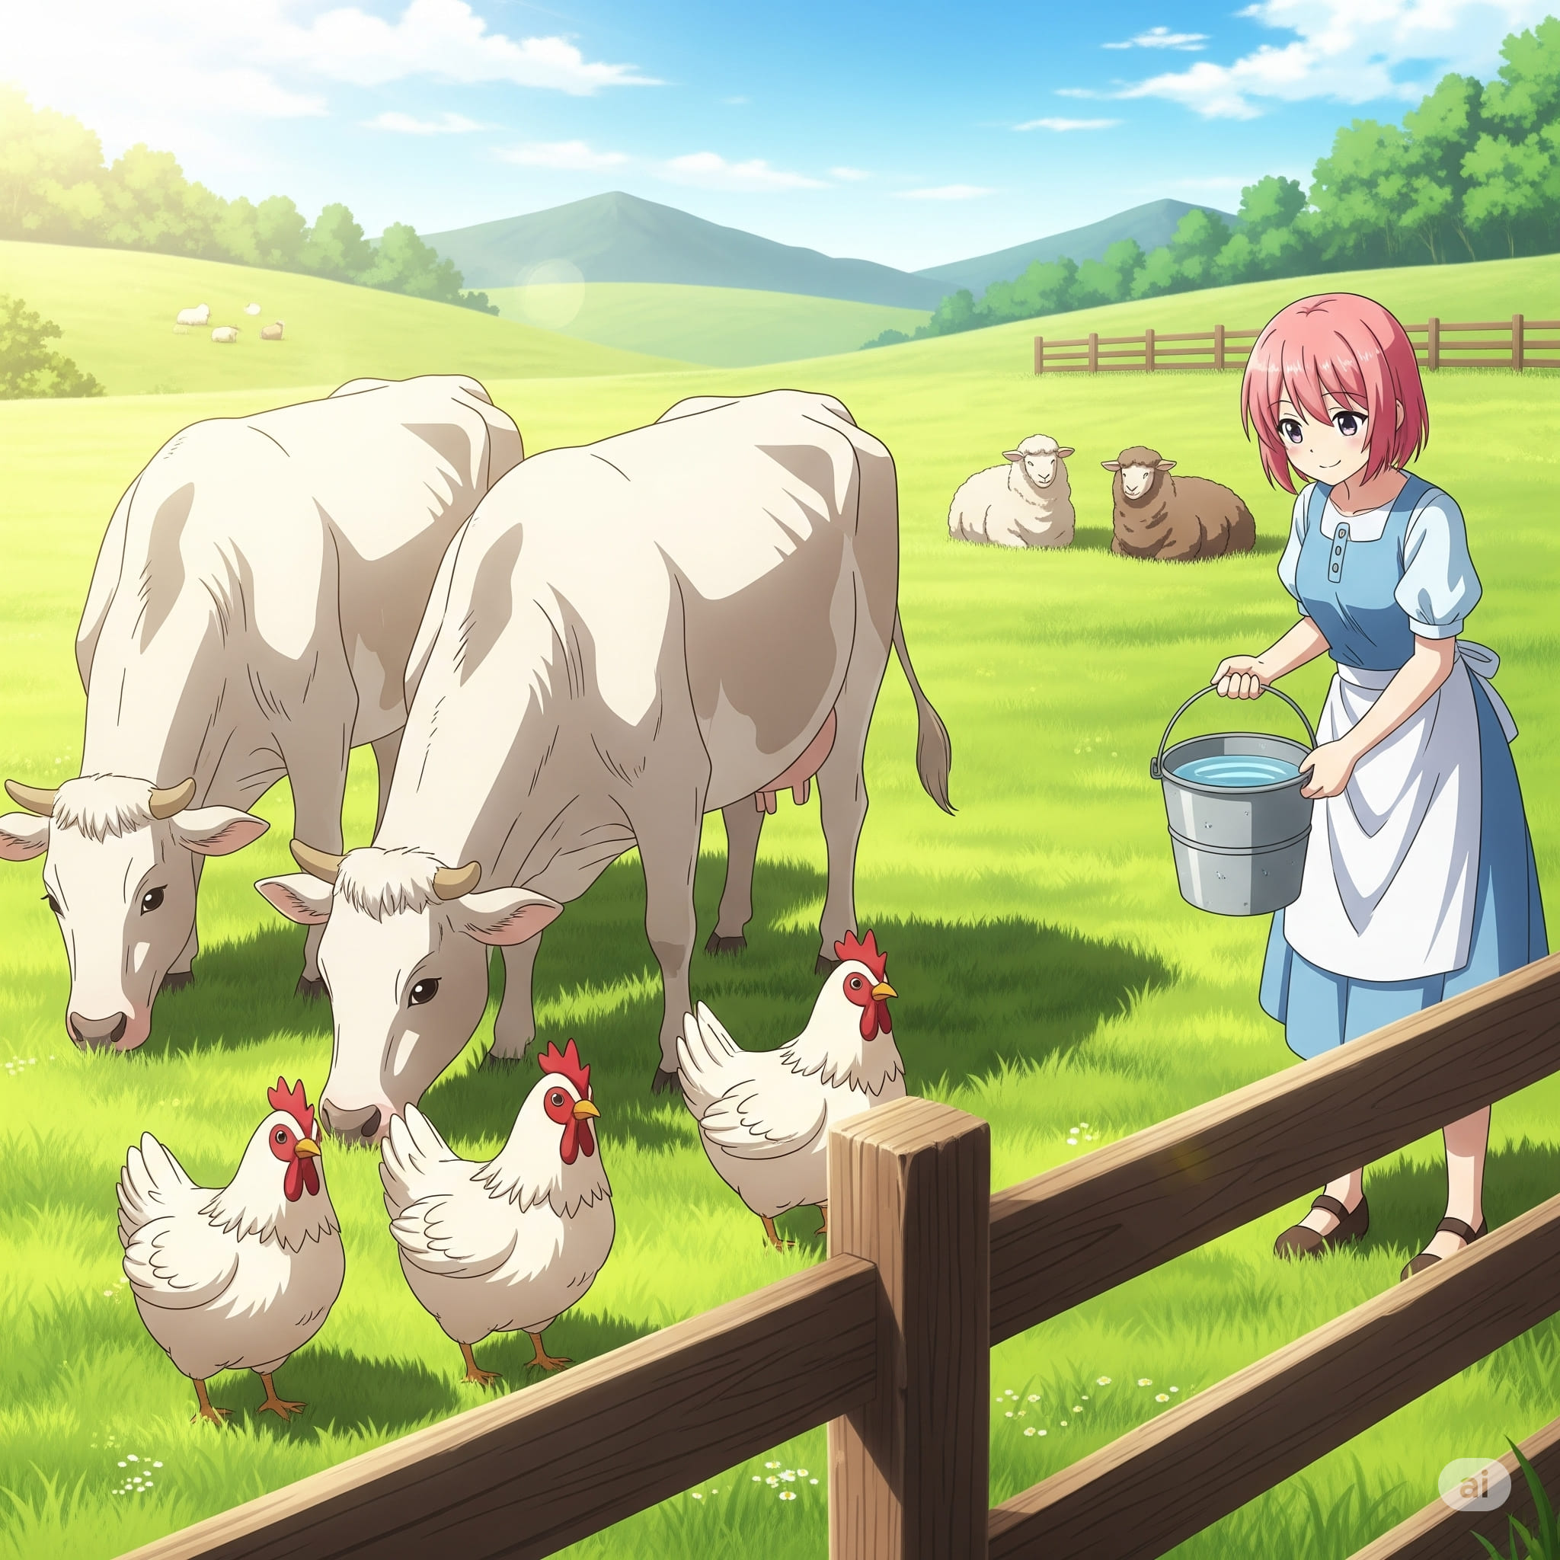

1. How many mammals are visible? 7 (taxonomic) (cows and sheep)

2. How many animals are in a flock? 4 (relational) (sheep)

3. If all the chickens were brown, how many white animals would be visible? 4 (taxonomic) (cows and sheep)

## Image 65 (farm)

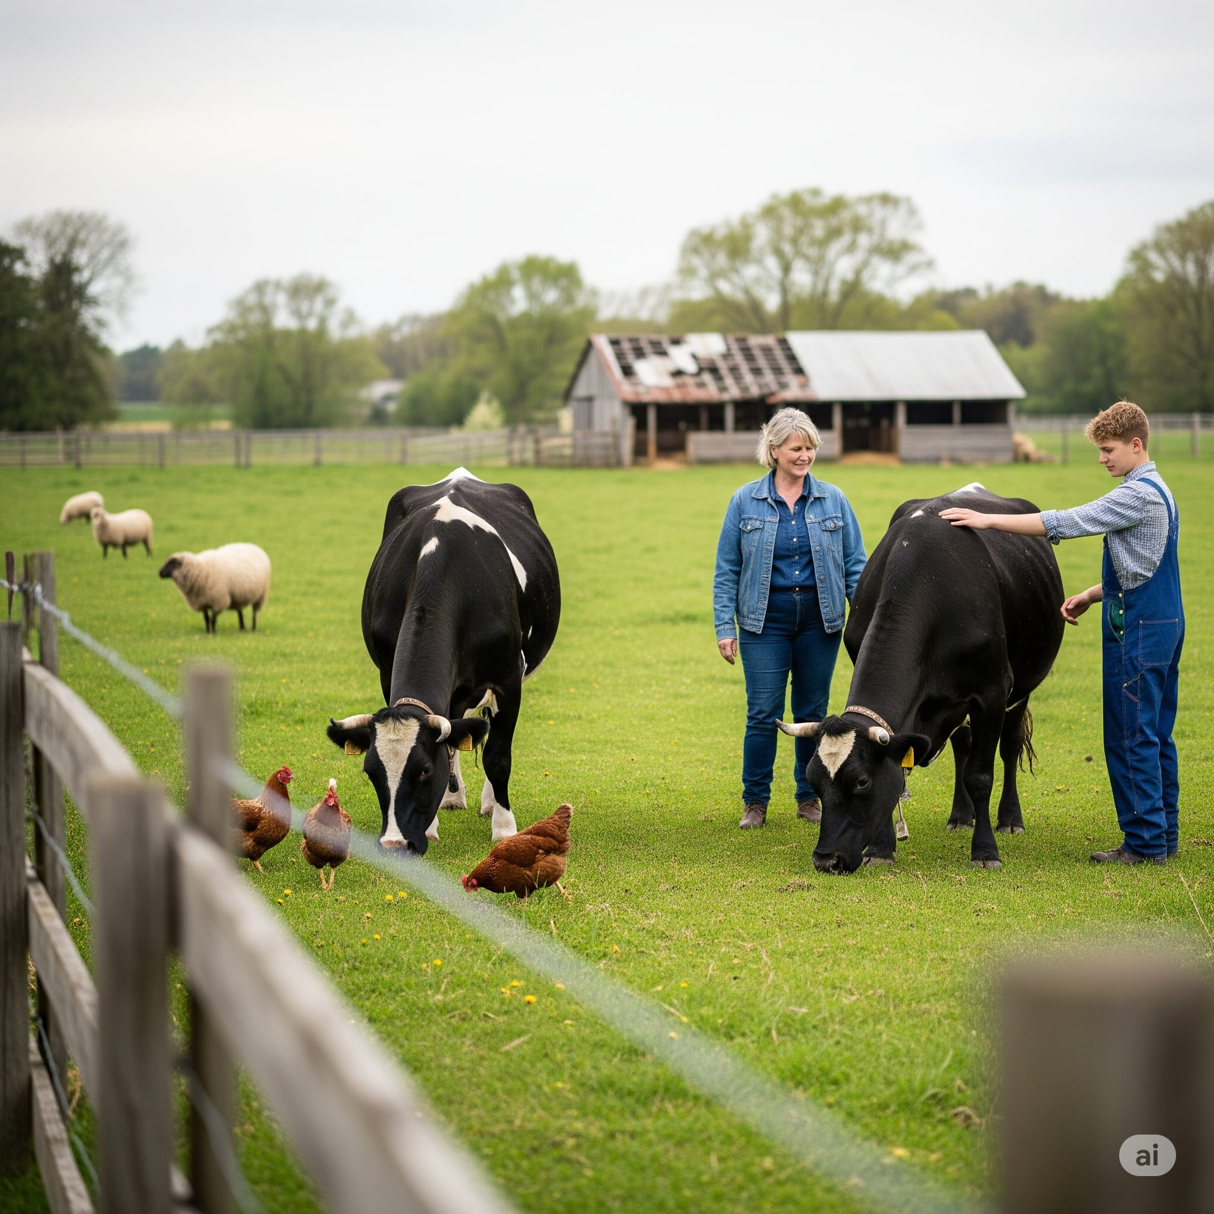

1. How many mammals are visible? 5 (taxonomic) (cows and sheep)

2. How many animals are in a flock? 5 (relational) (chickens)

3. If the barn roof was made of glass instead of metal, how many objects would be transparent? 1 (physical) (barn roof)

## Image 66 (library)



1. How many books are visible? 11 (taxonomic) (books)

2. How many people are seated at the table? 2 (relational) (people)

3. If the globe were replaced with a stack of three books, how many books would be on the table? 14 (taxonomic) (books)

## Image 67 (library)

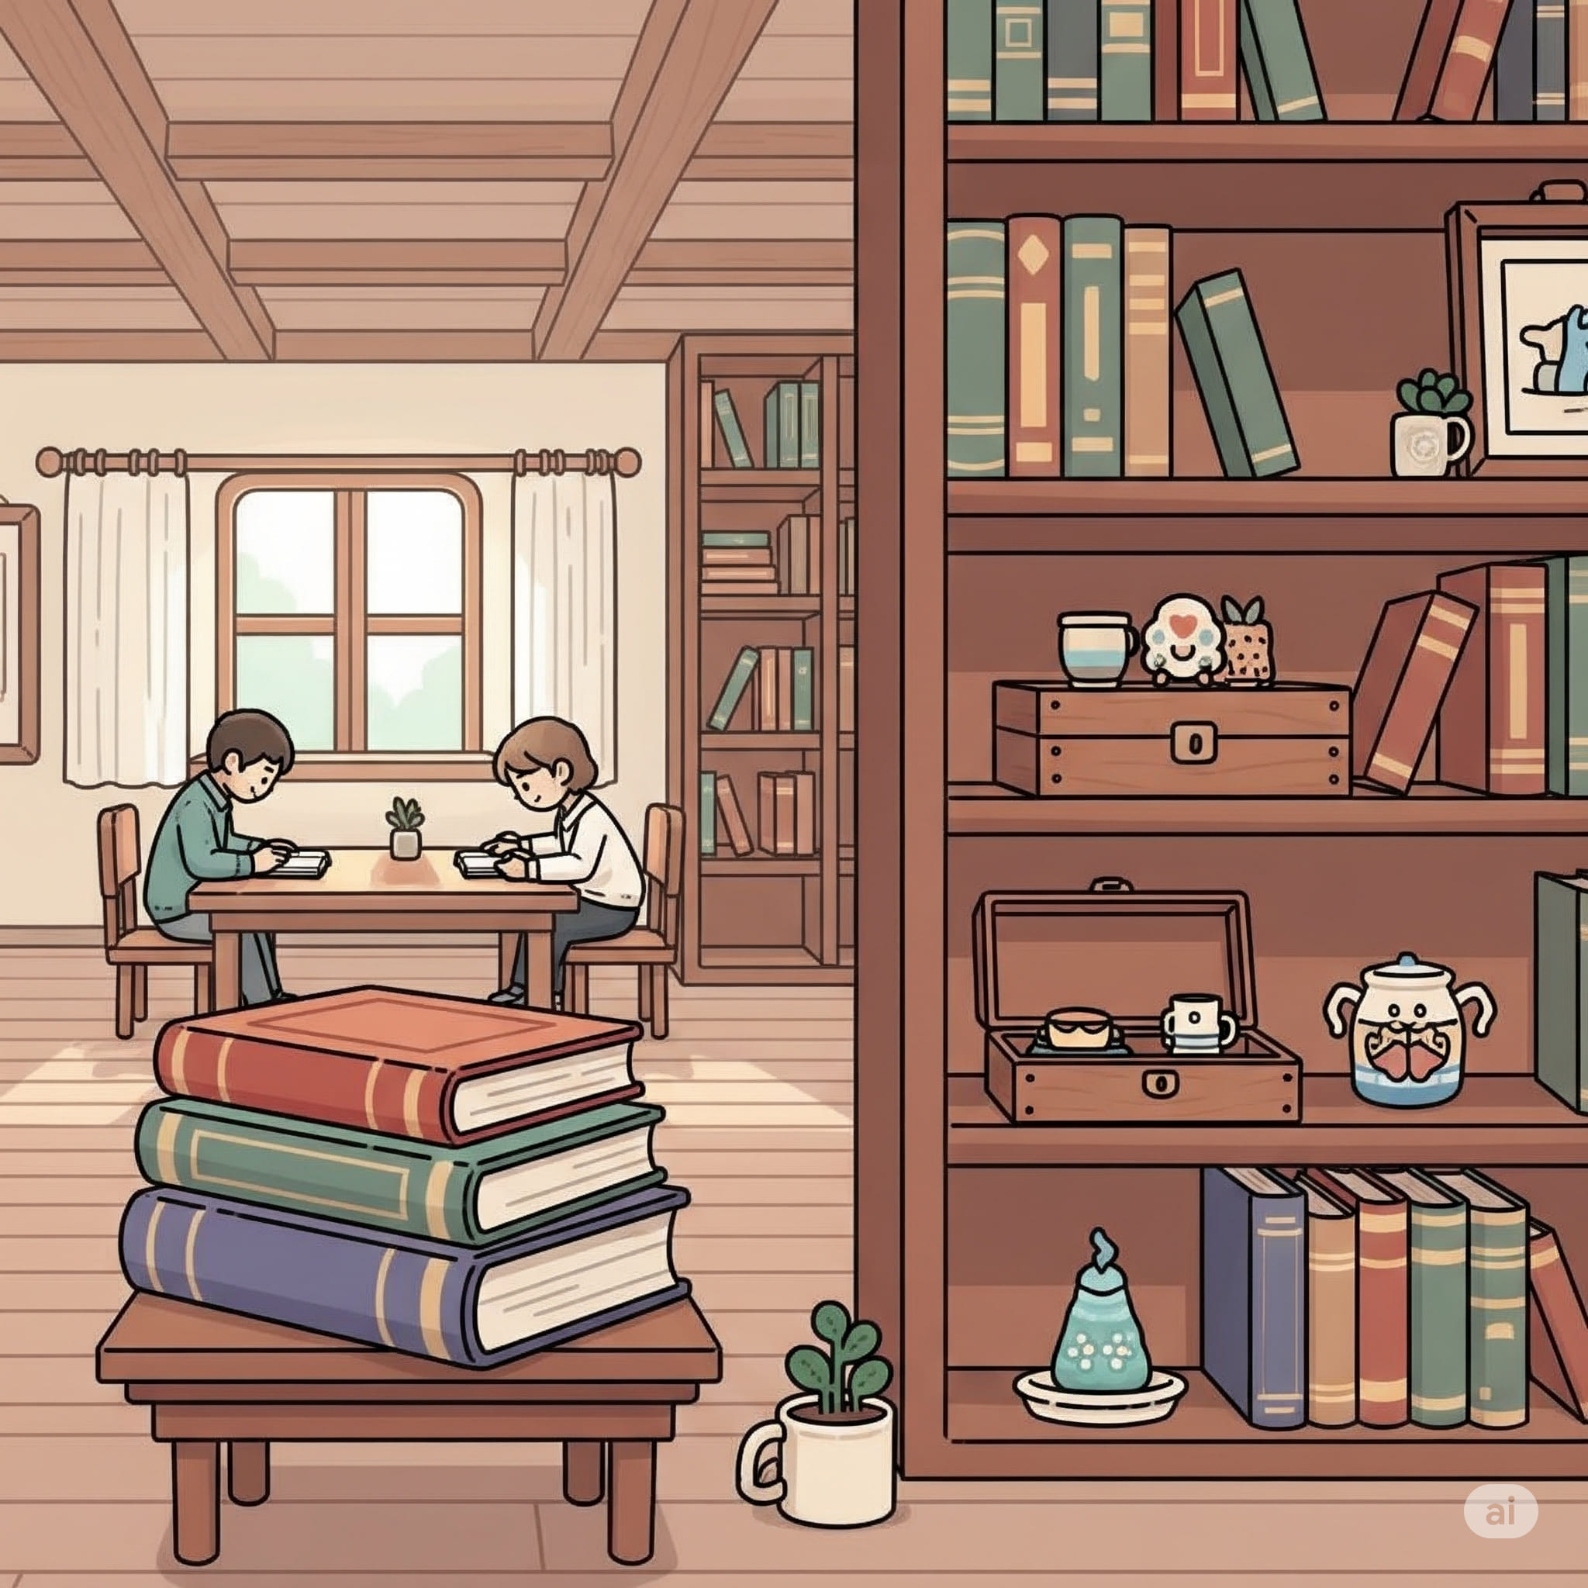

1. How many books are visible? 21 (taxonomic) (books)

2. How many items are on top of other items? 2 (relational) (stack of books)

3. If all the plants were fruits, how many fruits would there be? 3 (taxonomic) (plants)

## Image 68 (picnic)

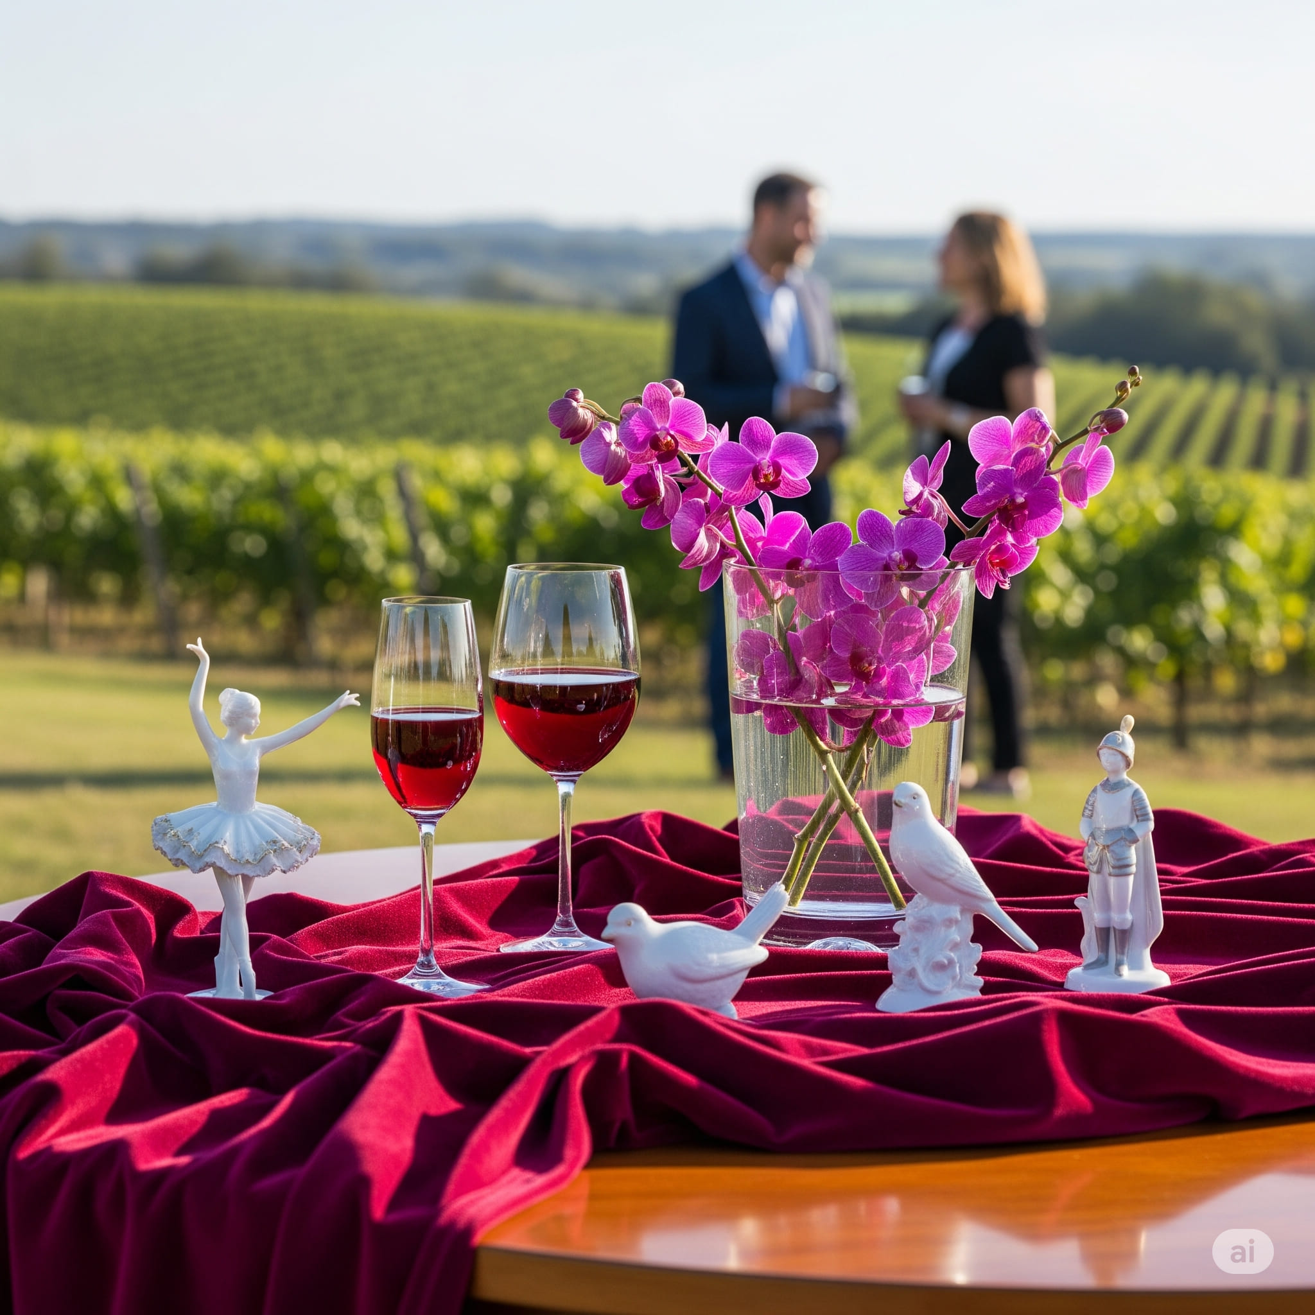

1. How many objects depicting birds are present? 3 (taxonomic) (bird figurines)

2. How many objects that can hold liquid are visible? 2 (functional) (wine glasses)

3. If the orchids were replaced with sunflowers, how many flower arrangements would be visible? 1 (taxonomic) (flower arrangement)

## Image 69 (picnic)



1. How many objects made of glass are present? 3 (physical) (wine glasses)

2. How many figures are standing on the table? 3 (relational) (figurines)

3. If the roses were replaced with sunflowers, how many flowers would there be? 15 (taxonomic) (flowers)

## Image 70 (construction)

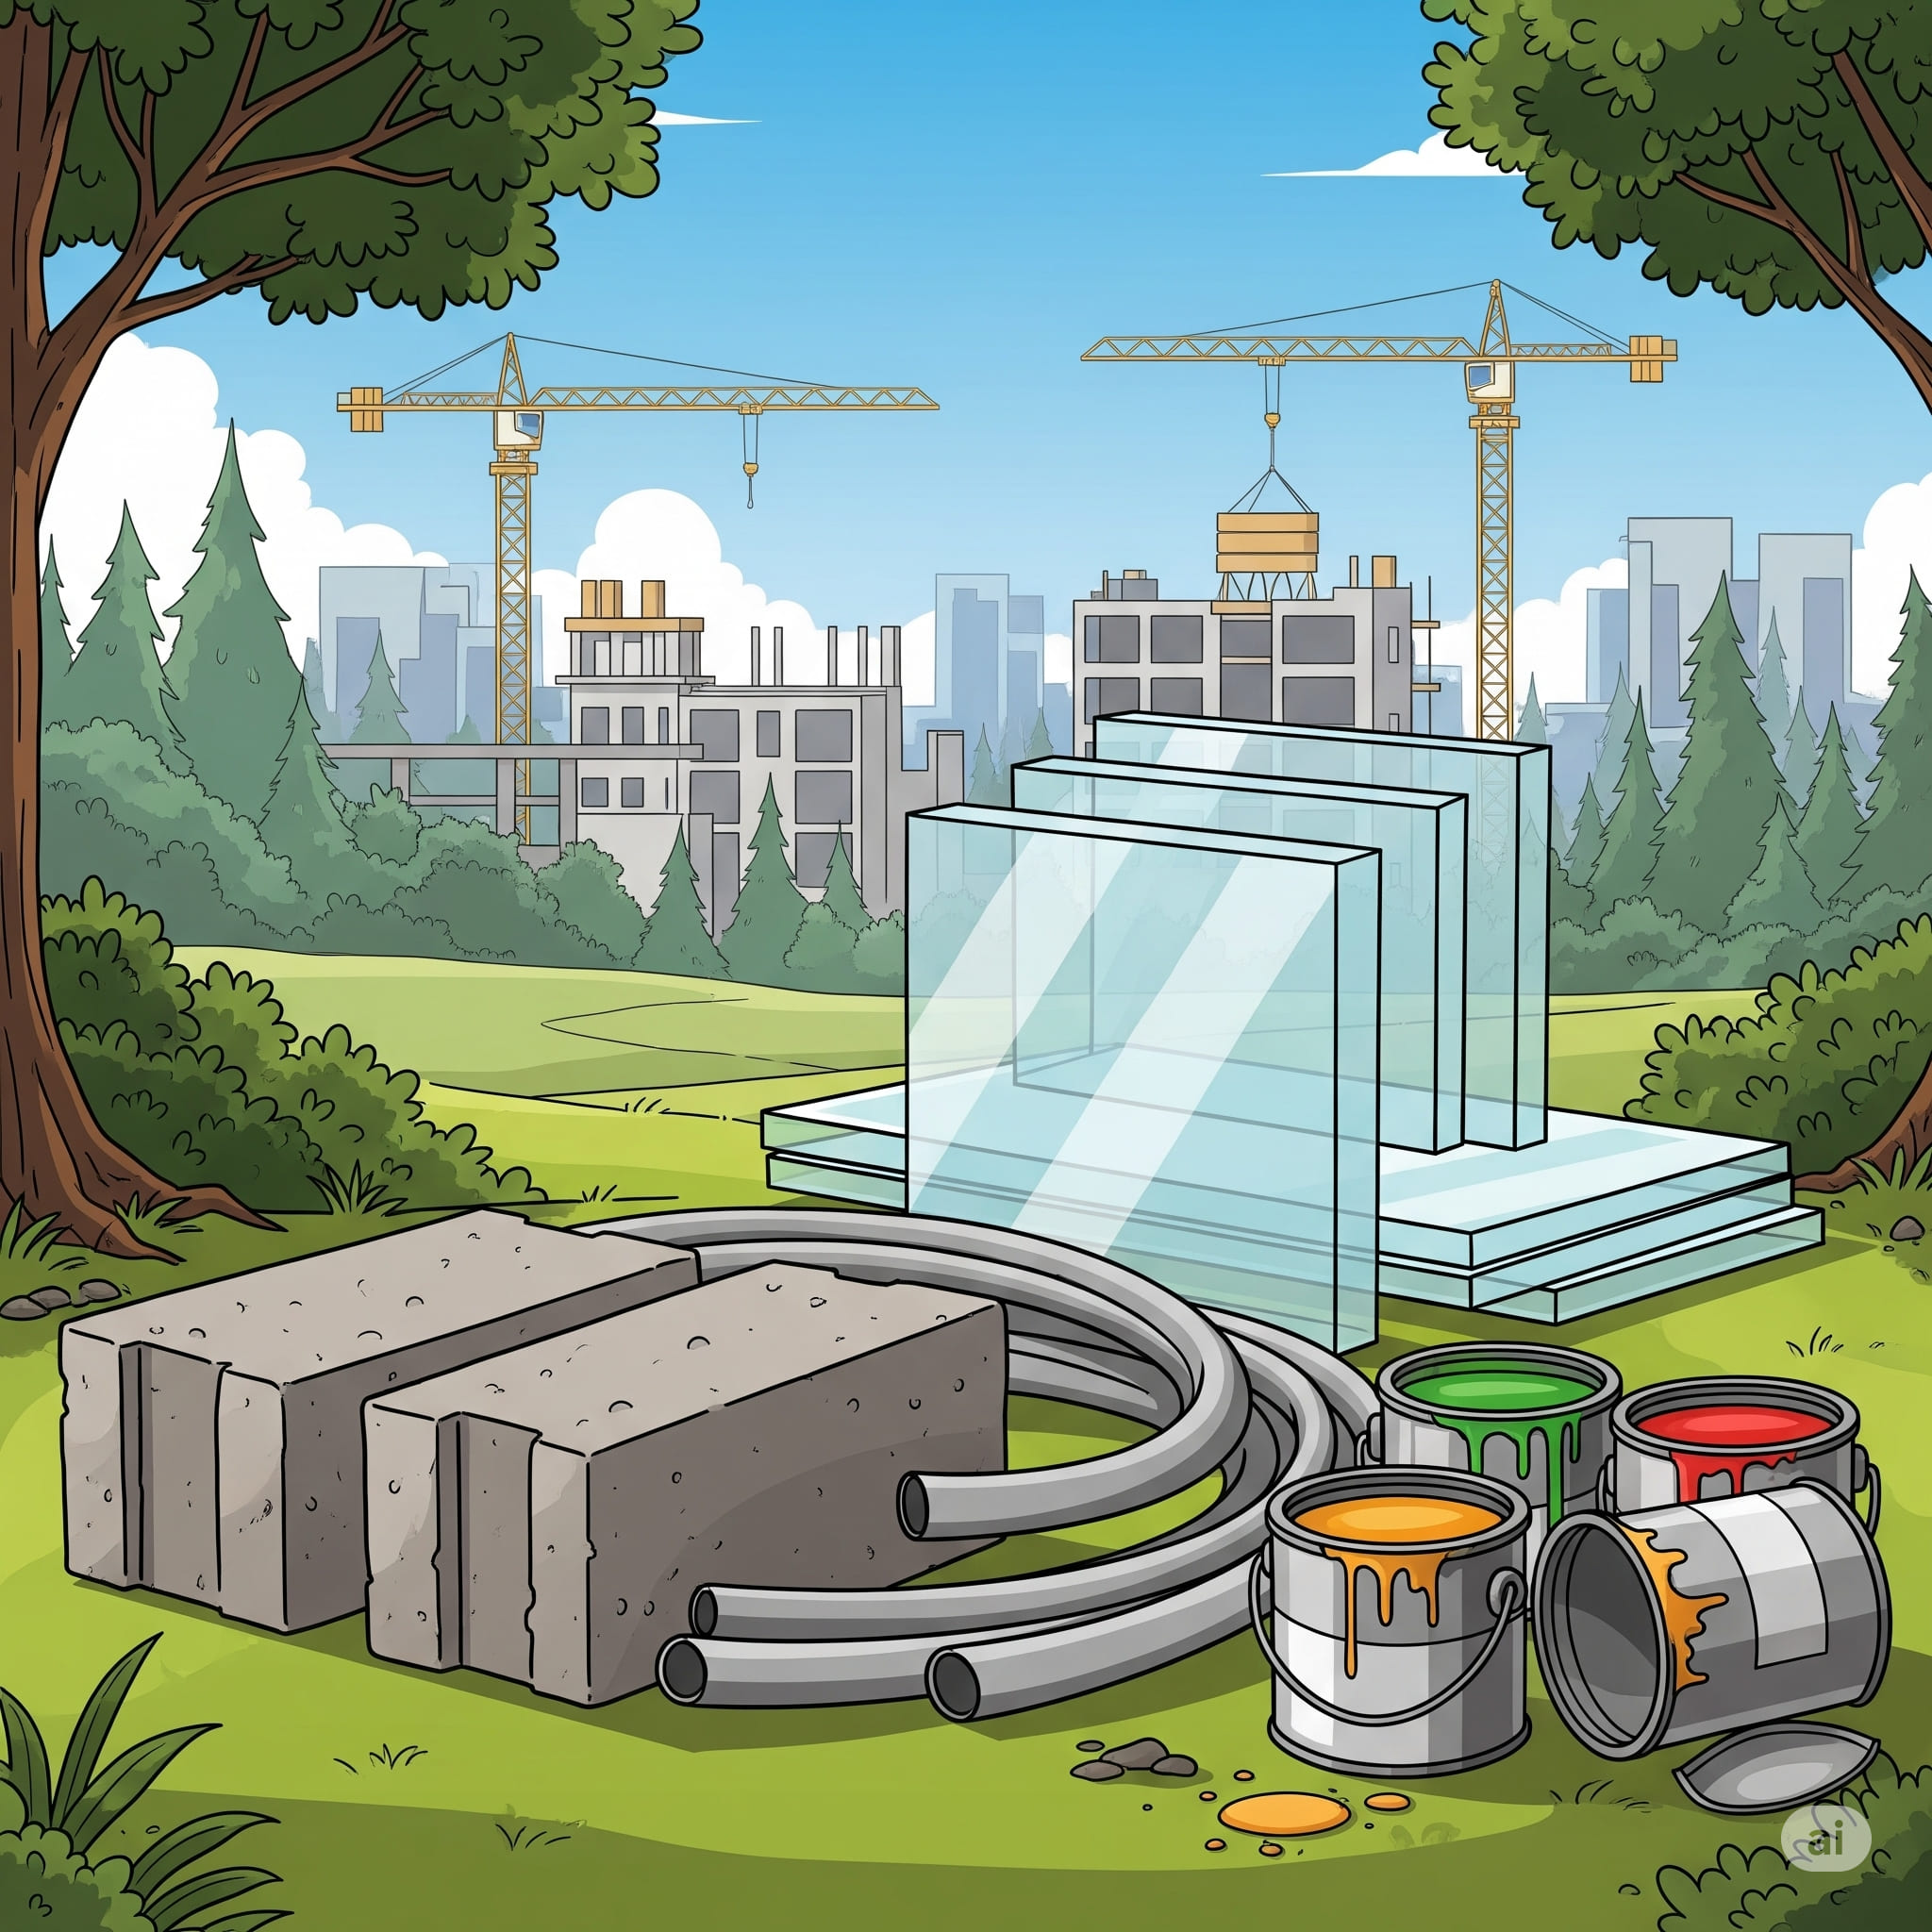

1. How many objects made of metal are present? 6 (physical) (cranes, pipes)

2. How many containers that can hold liquid are visible? 3 (functional) (paint cans)

3. If all the bricks were painted red, how many red objects would there be? 7 (taxonomic) (paint cans, bricks)

## Image 71 (farm)

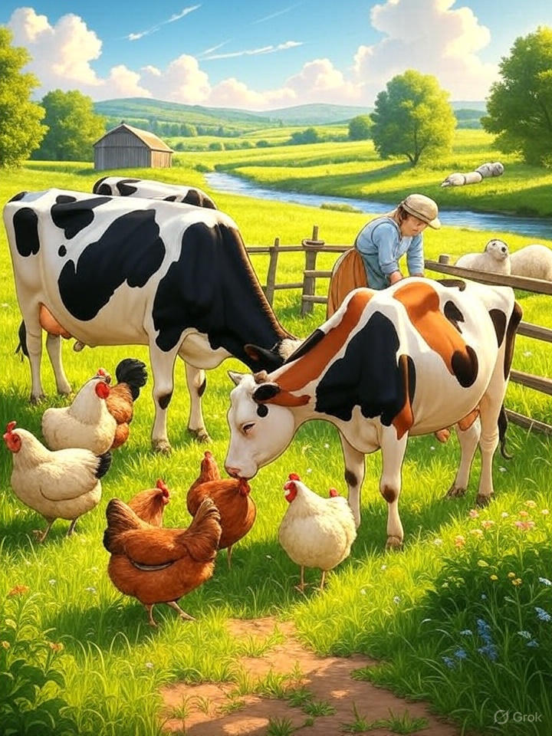

1. How many mammals are visible? 3 (taxonomic) (cows)

2. How many animals are in a flock? 5 (relational) (chickens)

3. If the sheep were the same color as the cows, how many black and white animals would there be? 5 (taxonomic) (cows and sheep)

## Image 72 (farm)

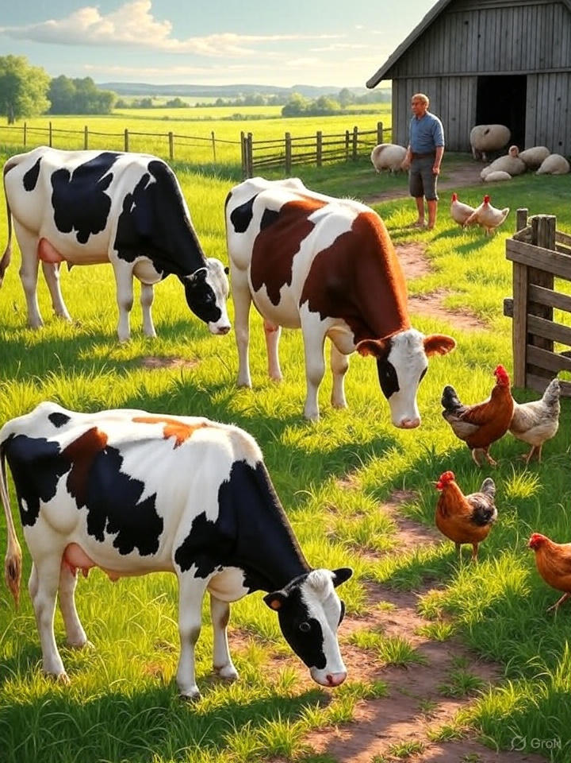

1. How many mammals are visible? 4 (taxonomic) (cows)

2. How many animals are in a flock? 7 (relational) (sheep and chickens)

3. If the cows were replaced with pigs, how many pigs would there be? 4 (taxonomic) (pigs)

## Image 73 (library)

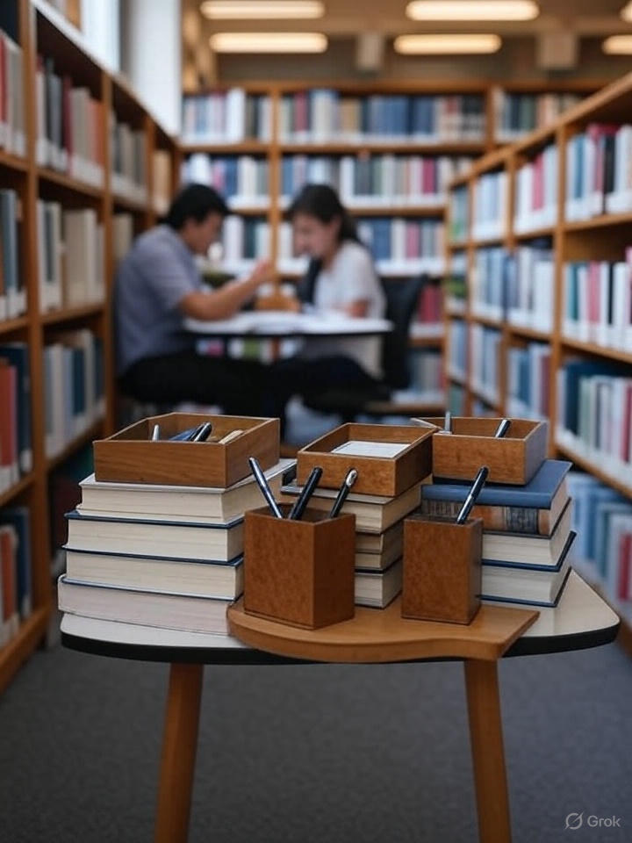

1. How many objects made of wood are present? 4 (physical) (boxes and pencil holder)

2. How many items are stacked on top of other items? 6 (relational) (books and boxes)

3. If all the books were removed from the shelves, how many people would be visible? 2 (taxonomic) (people)

## Image 74 (farm)

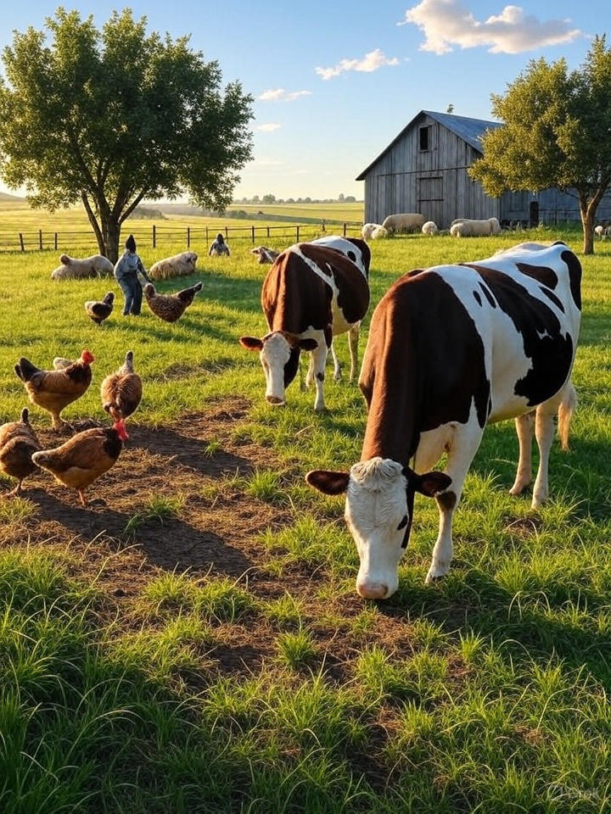

1. How many mammals are visible? 5 (taxonomic) (cows and sheep)

2. How many animals are in a flock? 7 (relational) (chickens)

3. If all the sheep were brown instead of white, how many white animals would be visible? 2 (taxonomic) (cows)

## Image 75 (library)

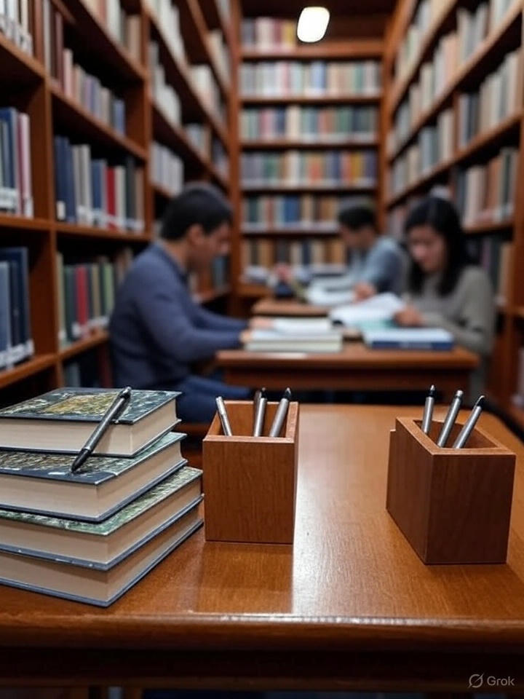

1. How many books are visible? 12 (taxonomic) (books)

2. How many pen holders are present? 2 (functional) (pen holders)

3. If all the books were removed from the shelves, how many people would be visible? 2 (relational) (people)

## Image 76 (library)

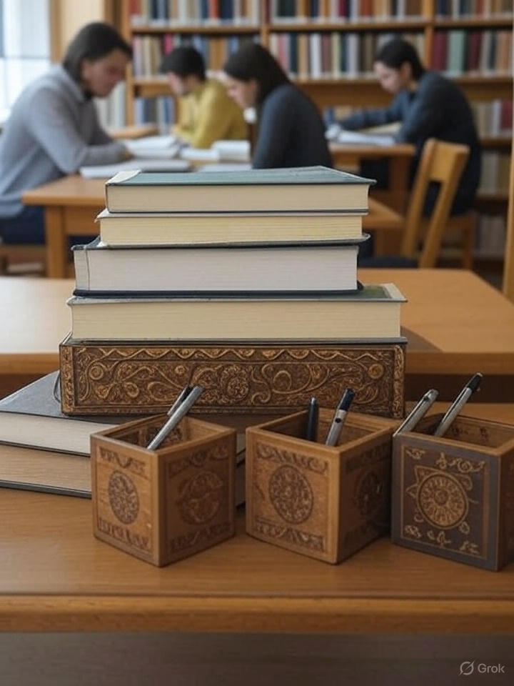

1. How many books are stacked on top of each other? 4 (taxonomic) (books)

2. How many pen holders are visible in the foreground? 3 (relational) (pen holders)

3. If the students were replaced with statues, how many people would be visible? 4 (taxonomic) (people)

## Image 77 (picnic)

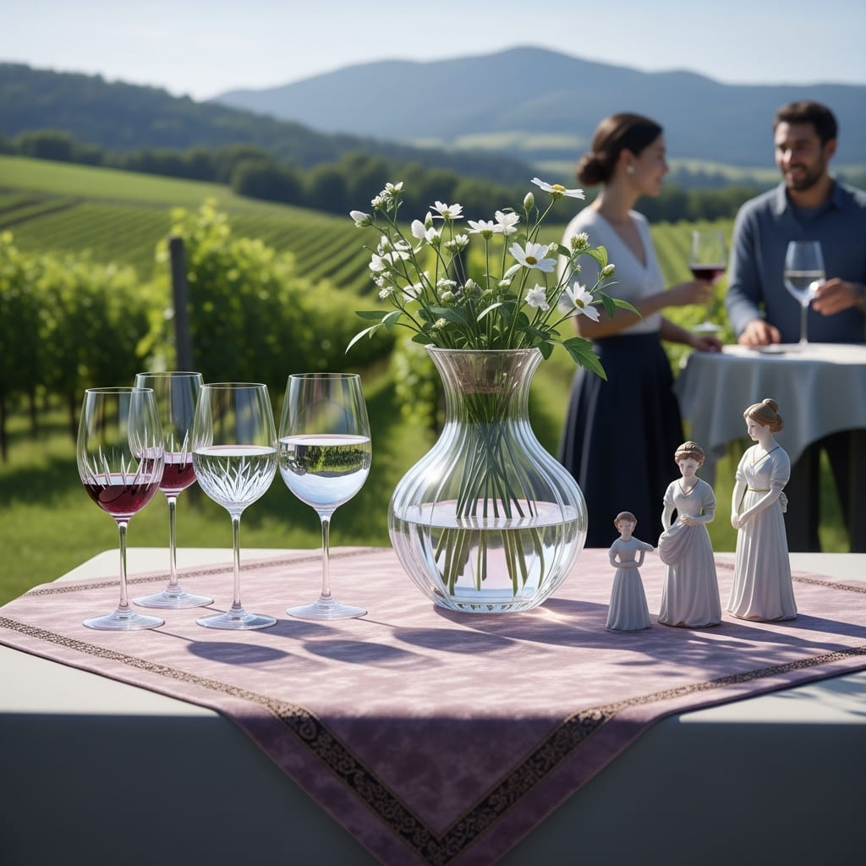

1. How many objects made of glass are present? 4 (physical) (wine glasses)

2. How many objects are on top of the table cloth? 7 (relational) (glasses, vase, figurines)

3. If the flowers were replaced with fruit, how many edible objects would be visible? 3 (taxonomic) (fruit)

## Image 78 (construction)

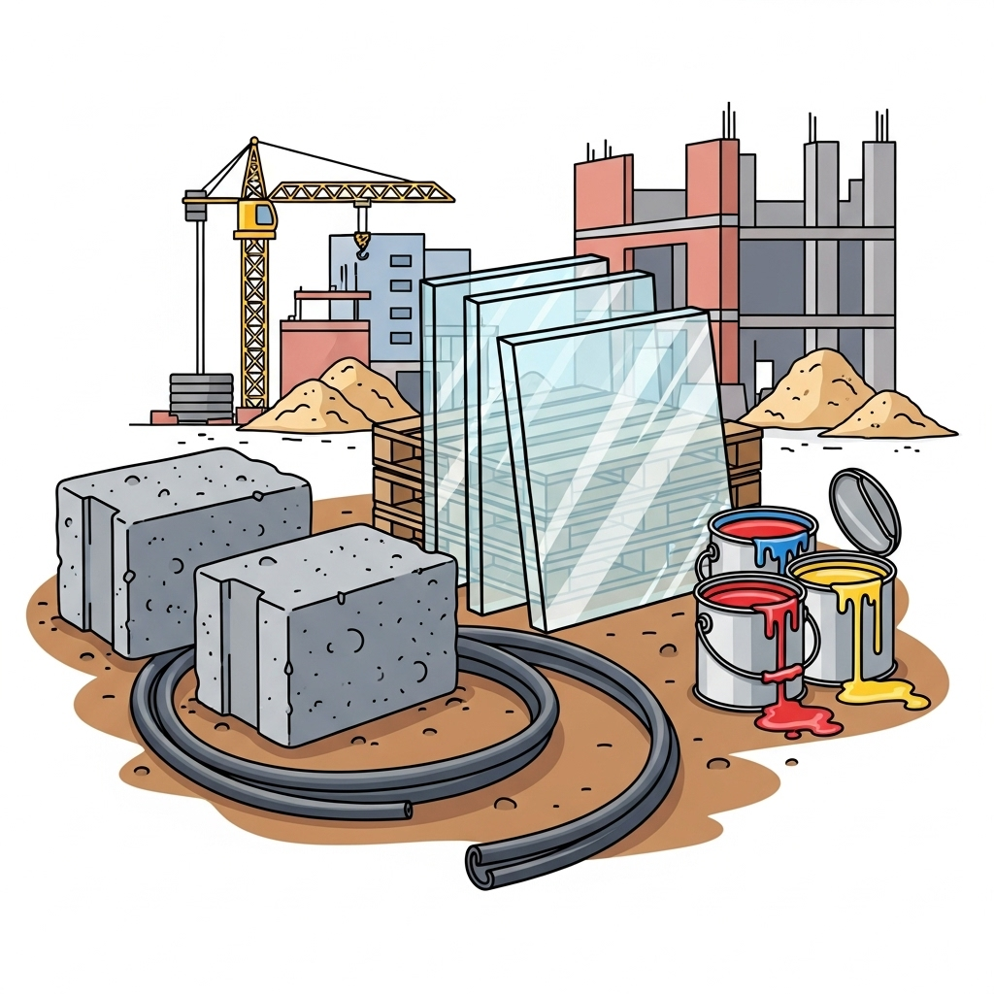

1. How many objects made of glass are present? 1 (physical) (window pane)

2. How many containers that can hold liquid are visible? 3 (functional) (paint cans)

3. If the piles of sand were replaced with piles of bricks, how many piles would there be? 3 (taxonomic) (piles)

## Image 79 (library)



1. How many books are visible? 21 (taxonomic) (books)

2. How many objects are on top of other objects? 1 (relational) (stack of books)

3. If all the lamps were removed, how many light sources would be visible? 0 (functional) (lamps)

## Image 80 (farm)

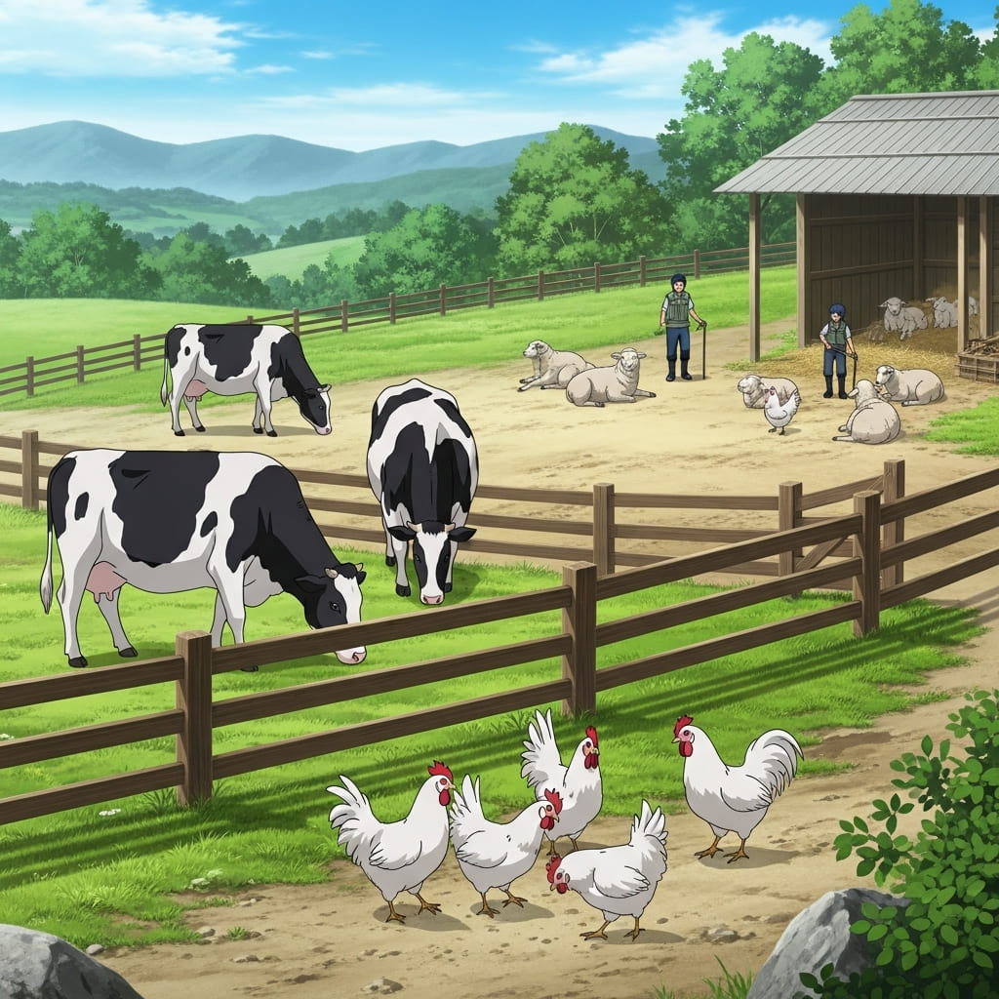

1. How many mammals are visible? 7 (taxonomic) (cows and sheep)

2. How many animals are in a flock? 6 (relational) (chickens)

3. If all the sheep were black instead of white, how many white animals would be visible? 3 (taxonomic) (cows)

## Image 81 (camping)

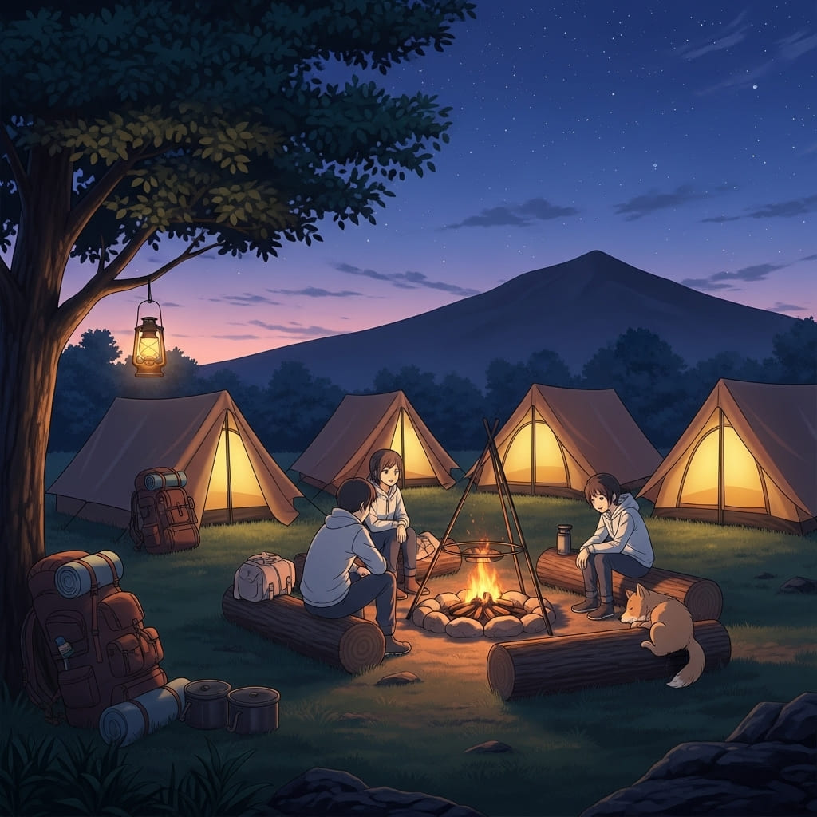

1. How many tents are visible? 4 (taxonomic) (tents)

2. How many people are sitting around the campfire? 4 (relational) (people)

3. If the dog was replaced with a cat, how many mammals would be present? 4 (taxonomic) (mammals)

## Image 82 (home setup)



1. How many objects made of metal are present? 2 (physical) (speaker, pen holder)

2. How many items are on top of the desk? 6 (relational) (laptop, cup, pen holder, notepad, speaker, sticky notes)

3. If the coffee cup was empty, how many liquid-holding objects would be visible? 0 (functional) (cups)

## Image 83 (home setup)



1. How many objects made of metal are present? 2 (physical) (speakers, pen holder)

2. How many items are on top of the desk? 5 (relational) (laptop, mug, notebook, sticky notes, speakers)

3. If the laptop were replaced with a tablet, how many flat screen devices would be visible? 1 (taxonomic) (monitor)

## Image 84 (home setup)



1. How many objects made of wood are present? 4 (physical) (desk, chair, drawer fronts)

2. How many items are on top of the desk? 6 (relational) (laptop, headphones, notebook, pens, sticky note, coffee cup)

3. If the drawer handles were all red, how many handles would be red? 3 (physical) (handles)

## Image 85 (kitchen)

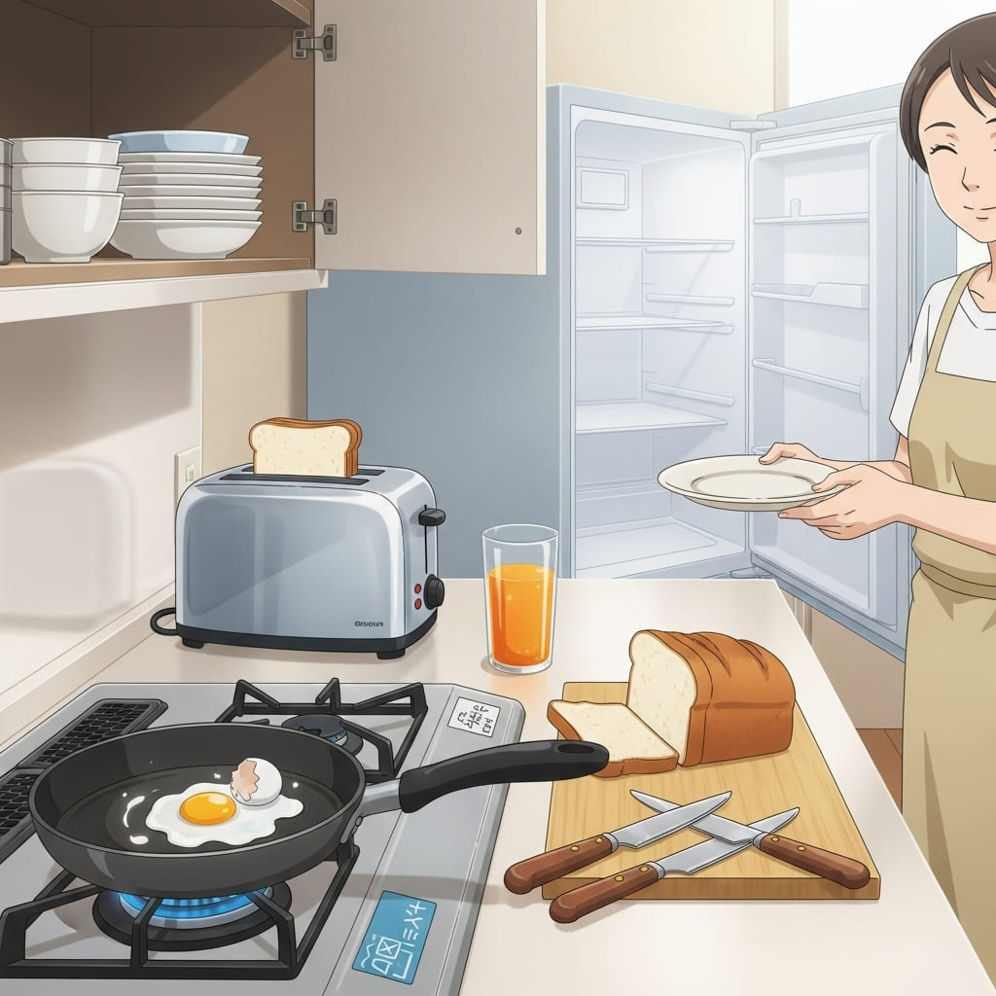

1. How many objects made of metal are present? 6 (physical) (pots, pan, toaster, knives)

2. How many items are on top of other items? 3 (relational) (toast on toaster, egg in pan, bread on cutting board)

3. If the refrigerator was empty, how many plates would be visible inside? 5 (relational) (plates)

## Image 86 (zoo)

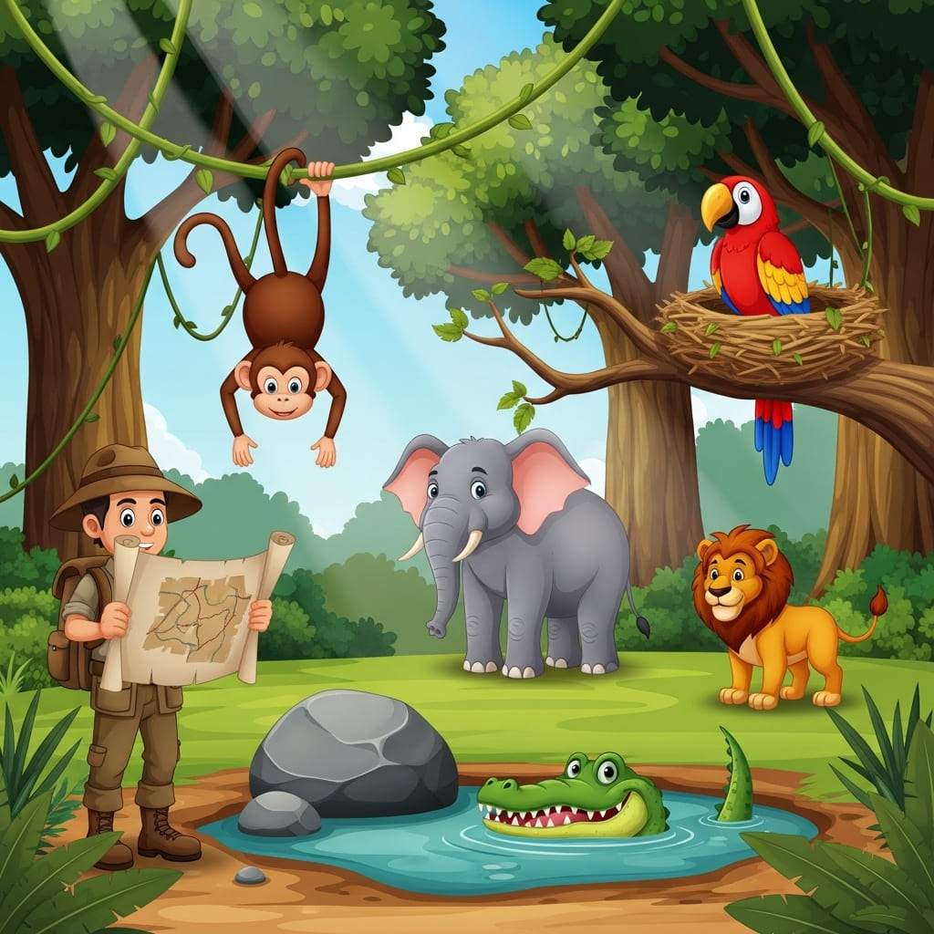

1. How many mammals are visible? 4 (taxonomic) (monkey, elephant, lion, explorer)

2. How many animals are shown interacting with trees? 3 (relational) (monkey, parrot, explorer)

3. If the crocodile had wings, how many flying creatures would be present? 2 (taxonomic) (parrot, crocodile)

## Image 87 (zoo)

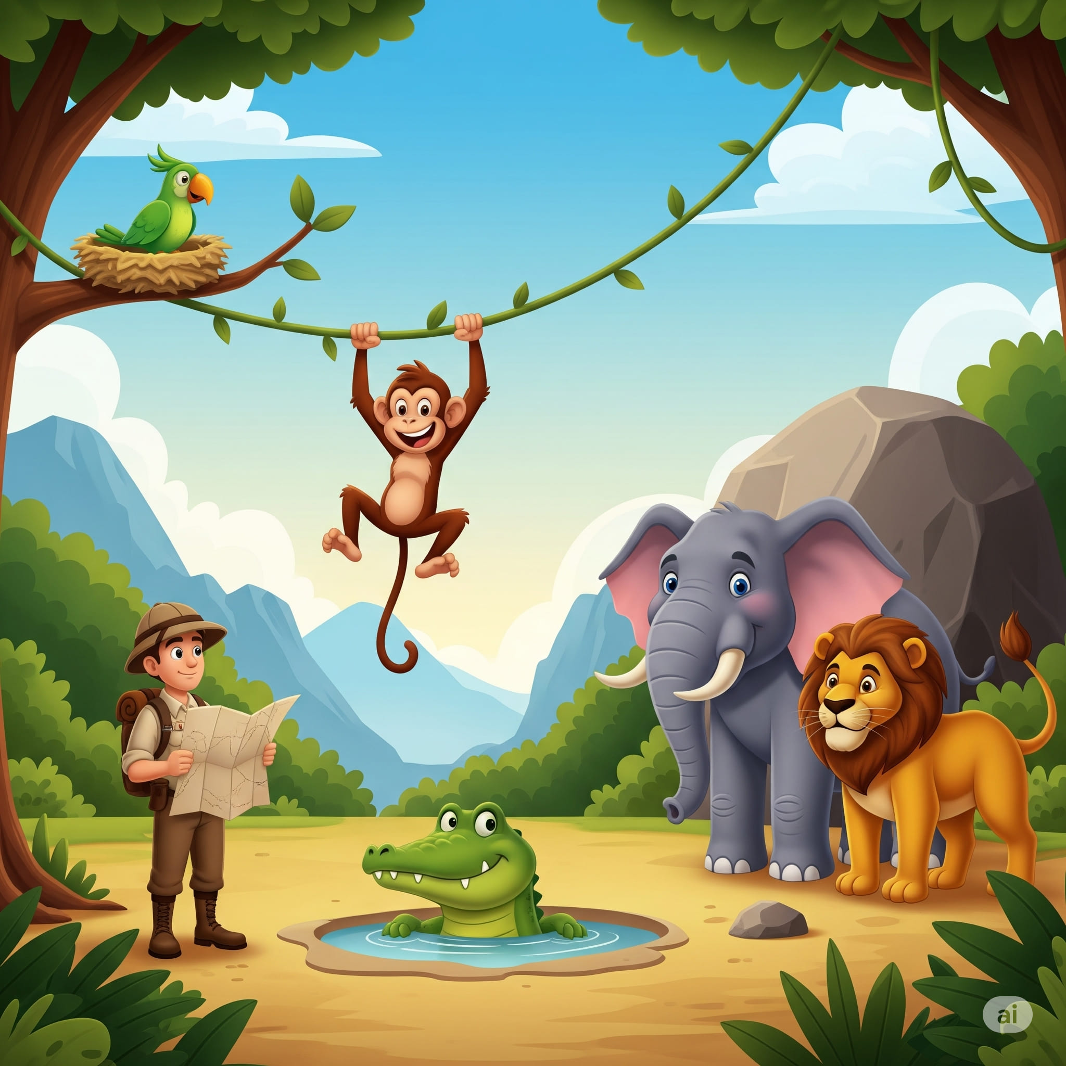

1. How many mammals are present? 3 (taxonomic) (elephant, lion, monkey)

2. How many animals are looking directly at the viewer? 3 (relational) (elephant, lion, crocodile)

3. If the parrot flew away from its nest, how many birds would be visible? 0 (taxonomic) (birds)

## Image 88 (bustop)

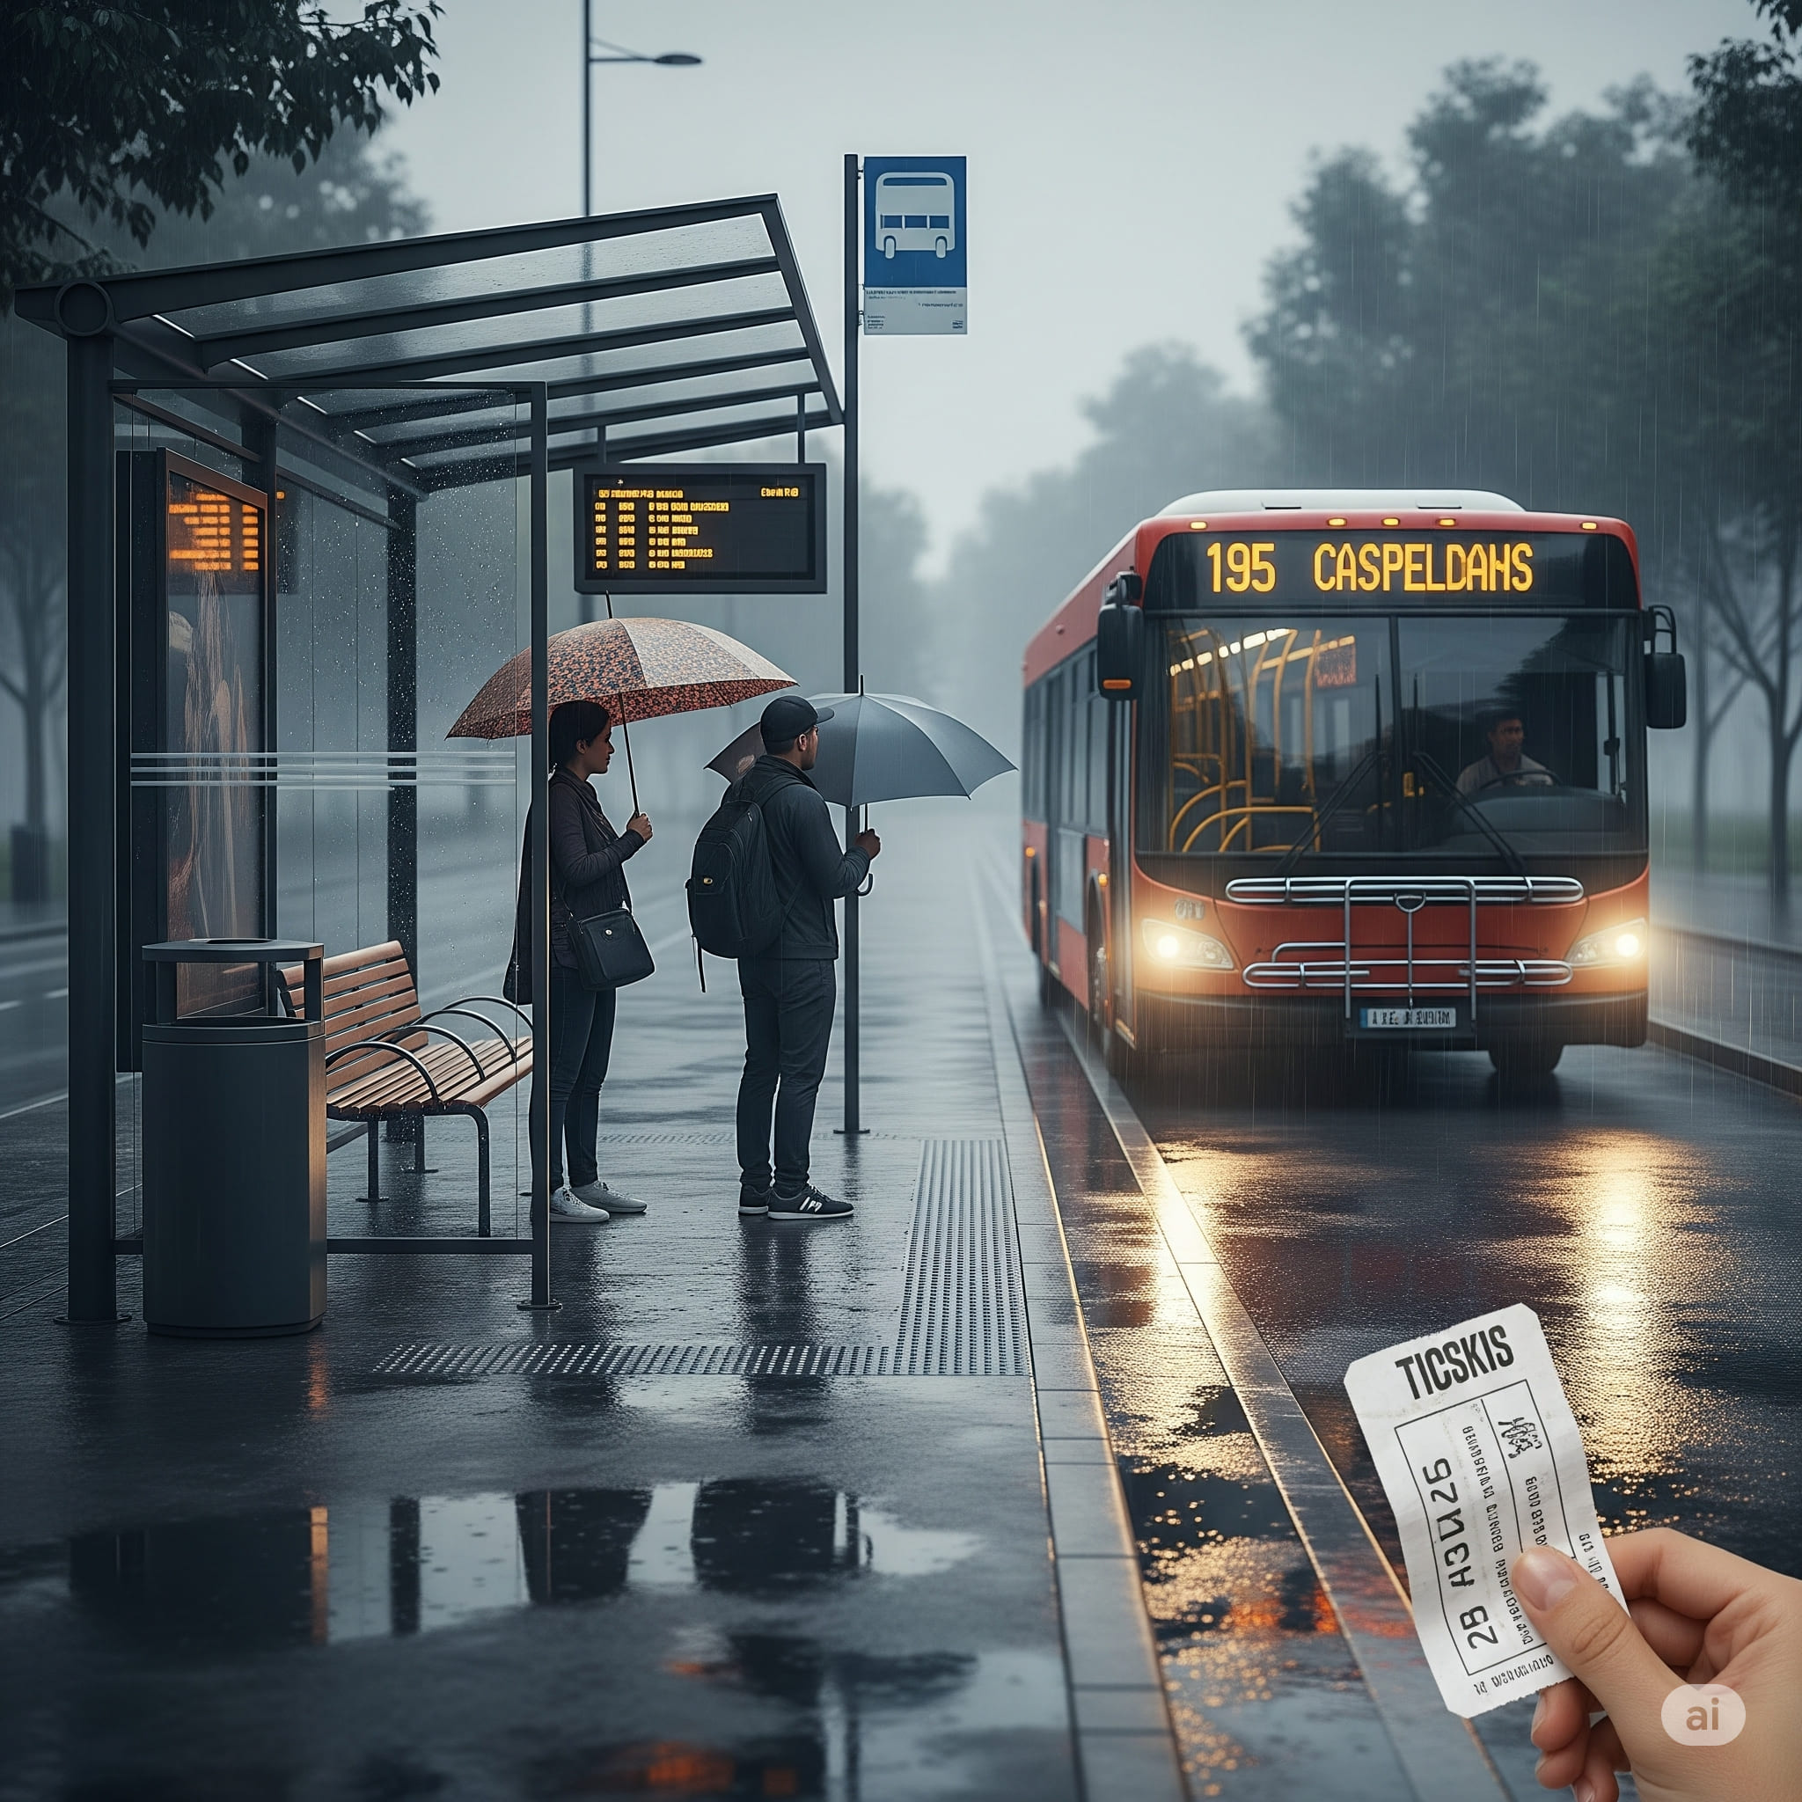

1. How many vehicles are present? 1 (taxonomic) (bus)

2. How many people are holding umbrellas? 2 (relational) (people and umbrellas)

3. If the bus had no wheels, how many wheels would be visible? 0 (physical) (wheels)

## Image 89 (bustop)

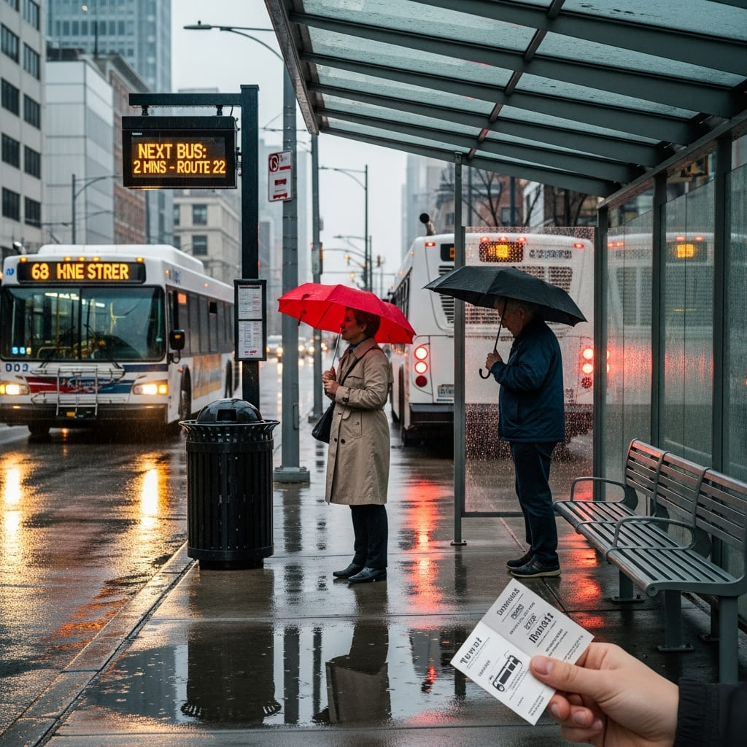

1. How many vehicles are present? 2 (taxonomic) (buses)

2. How many people are holding umbrellas? 2 (relational) (people)

3. If the bus stop shelter wasn't present, how many benches would be visible? 1 (physical) (bench)

## Image 90 (bustop)

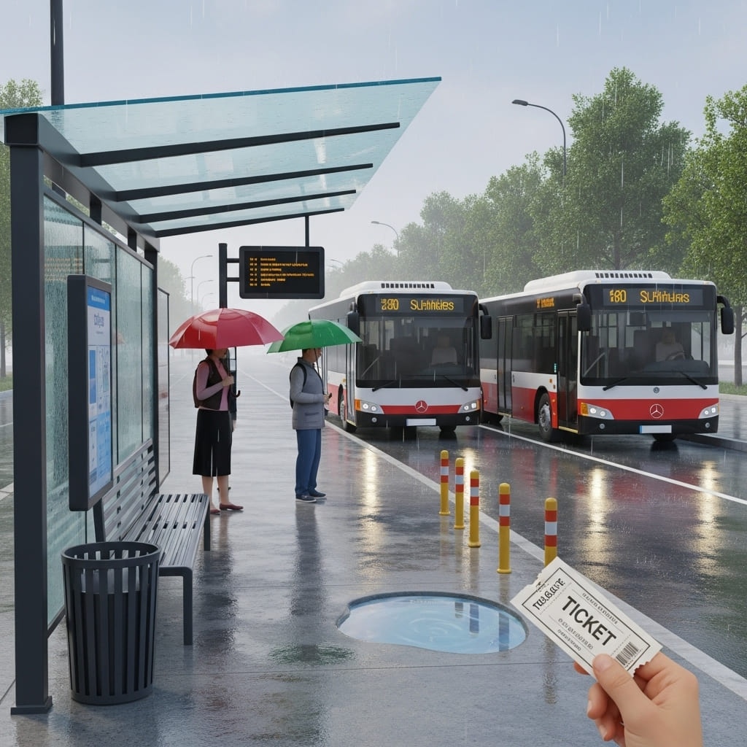

1. How many vehicles are present? 2 (taxonomic) (buses)

2. How many people are holding umbrellas? 2 (relational) (people and umbrellas)

3. If the trash can was full of paper, how many paper objects would be present? 5 (physical) (paper objects)

## Image 91 (driveway)

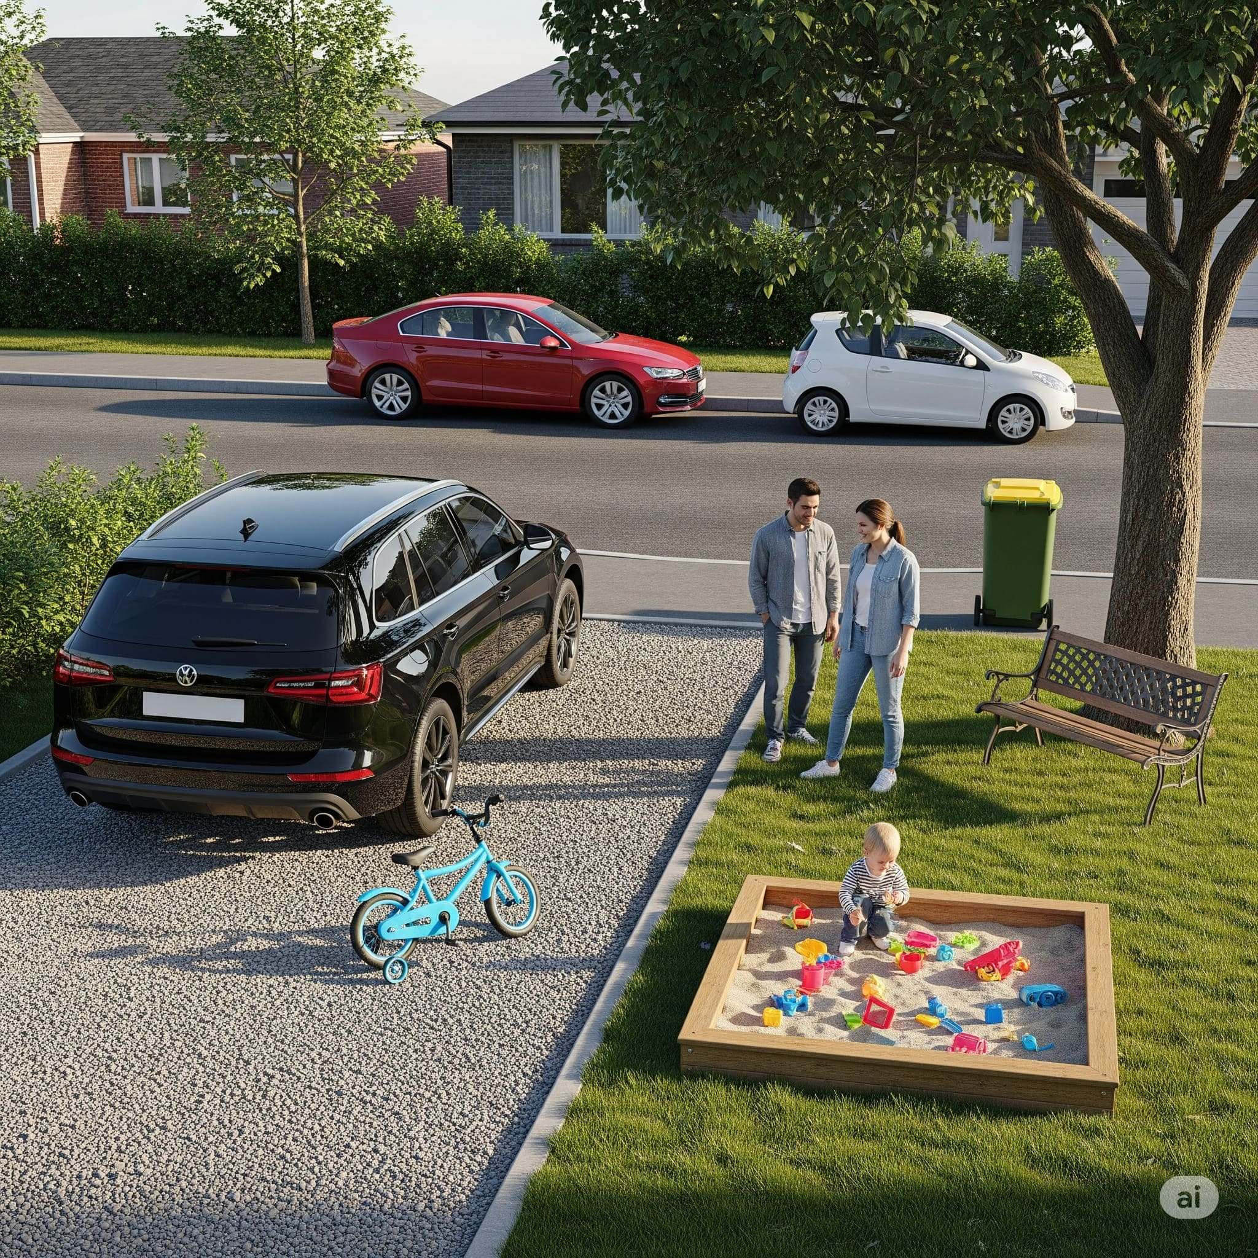

1. How many vehicles are present? 4 (taxonomic) (cars)

2. How many people are standing next to each other? 2 (relational) (adults)

3. If the sandbox was filled with water instead of sand, how many containers would be needed to hold all the toys? 10 (functional) (toys)

## Image 92 (driveway)

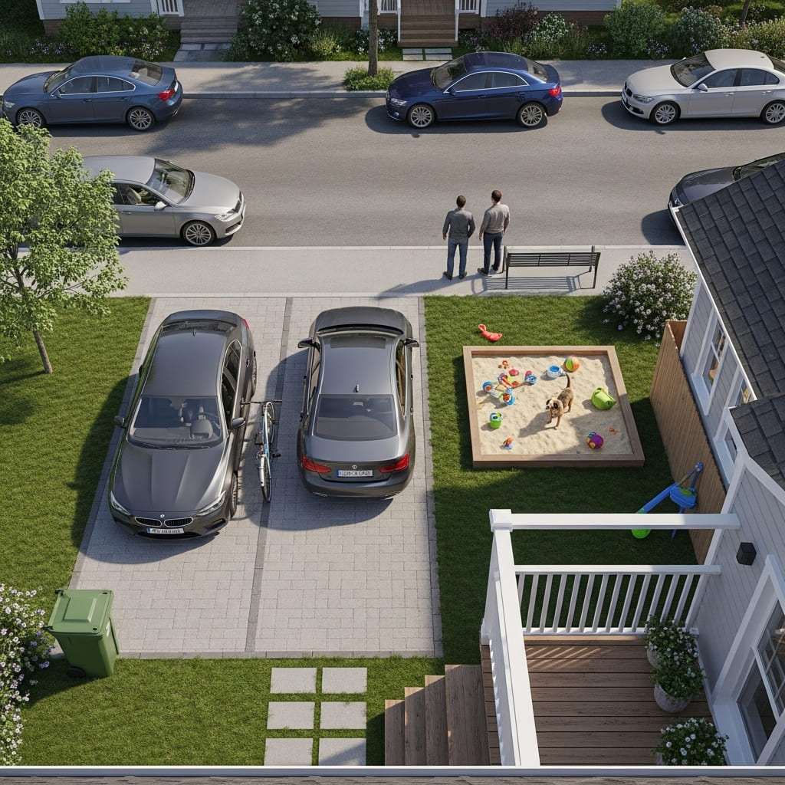

1. How many vehicles are present? 5 (taxonomic) (cars)

2. How many objects are located inside the sandbox? 4 (relational) (toys and dogs)

3. If the green trash bin was replaced with a blue one, how many green objects would be visible? 3 (physical) (trees and bushes)

## Image 93 (driveway)

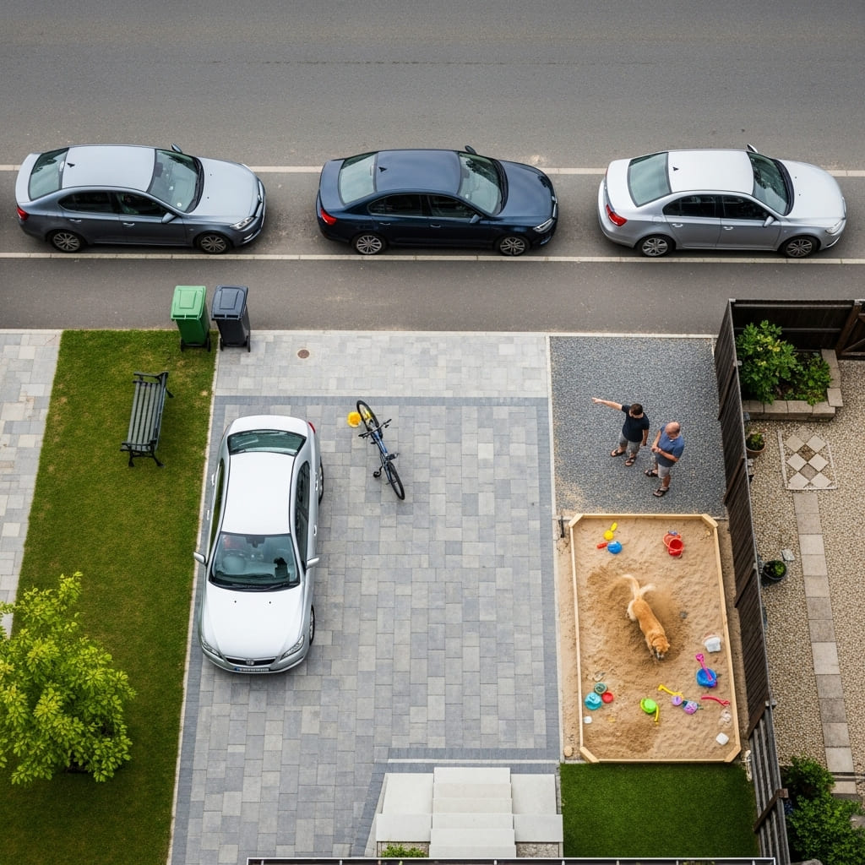

1. How many vehicles are present? 4 (taxonomic) (cars)

2. How many people are interacting with each other? 2 (relational) (people)

3. If the sandbox was filled with water instead of sand, how many liquid-holding objects would be present? 3 (functional) (buckets)

## Image 94 (library)

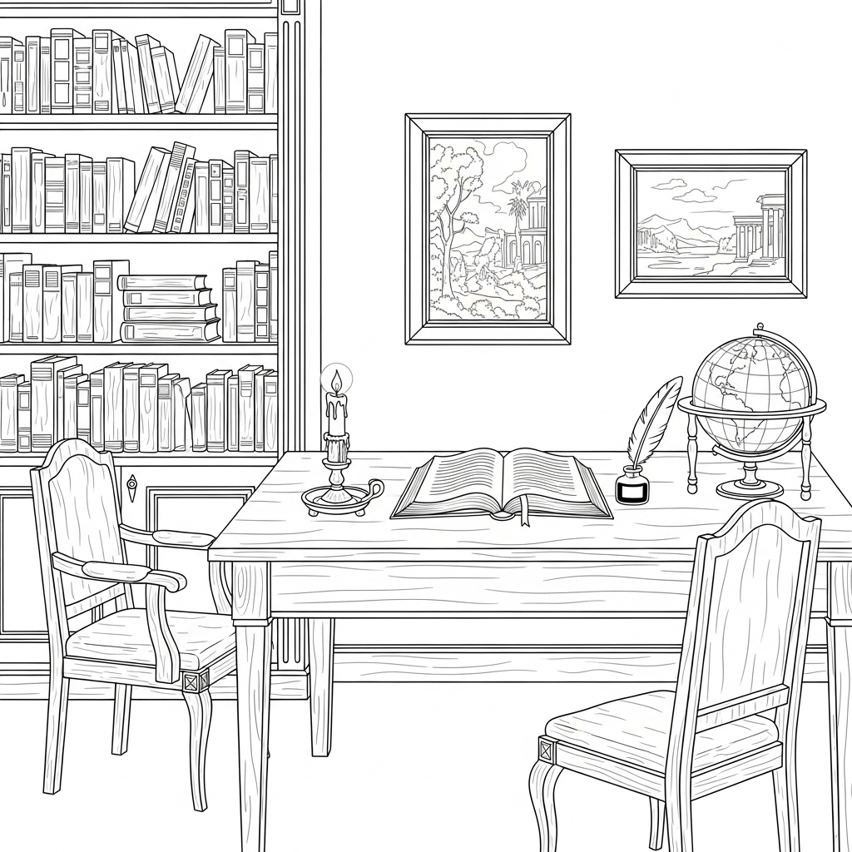

1. How many objects made of wood are present? 7 (physical) (chairs, table, bookshelf)

2. How many objects are on top of the table? 4 (relational) (book, candle, inkwell, quill)

3. If the bookshelf was empty, how many books would be missing? 21 (taxonomic) (books)

## Image 95 (library)

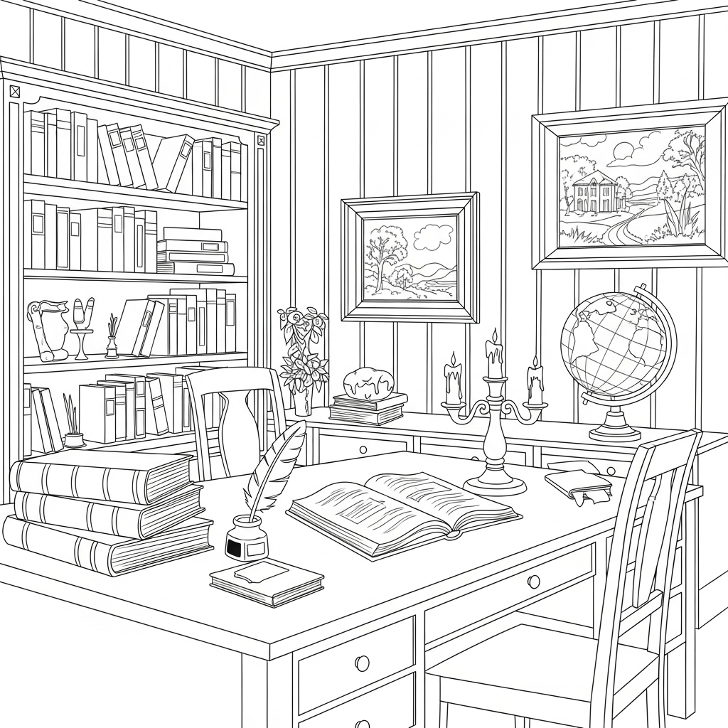

1. How many books are visible? 22 (taxonomic) (books)

2. How many items are on top of the desk? 8 (relational) (items)

3. If the globe were replaced with a lamp, how many lamps would be visible? 3 (taxonomic) (lamps)

## Image 96 (picnic)

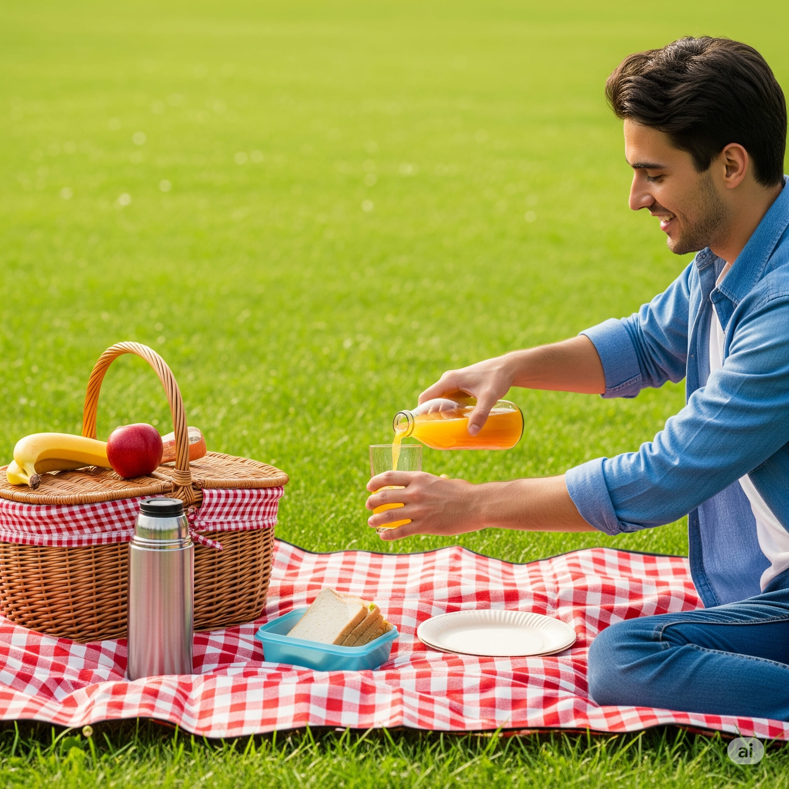

1. How many fruits are visible? 3 (taxonomic) (apple, banana, orange)

2. How many items are on top of the picnic blanket? 5 (relational) (basket, thermos, juice bottle, glass, sandwich container)

3. If the sandwich was replaced with two cookies, how many baked goods would be visible? 3 (taxonomic) (cookies, banana, apple)

## Image 97 (picnic)

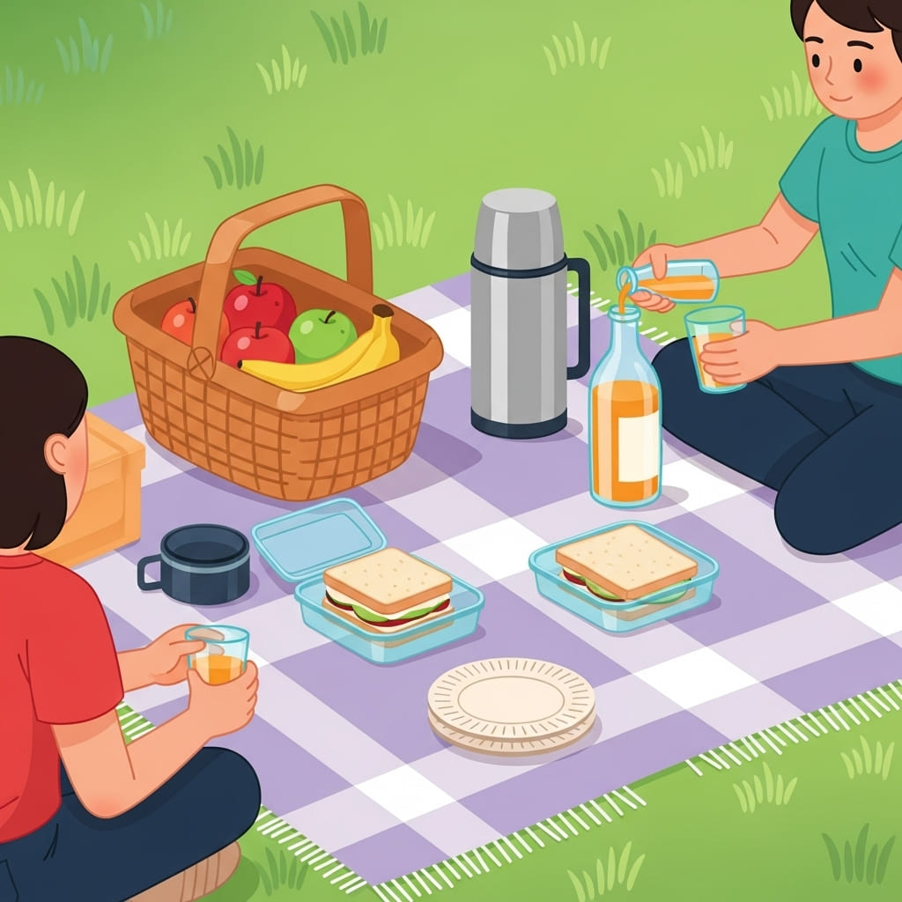

1. How many fruits are in the picnic basket? 3 (taxonomic) (apples and bananas)

2. How many containers are used to hold food or drink? 5 (functional) (basket, thermos, bottle, two food containers)

3. If the picnic blanket was a solid color instead of checkered, how many checkered patterns would be visible? 0 (relational) (checkered patterns)

## Image 98 (picnic)

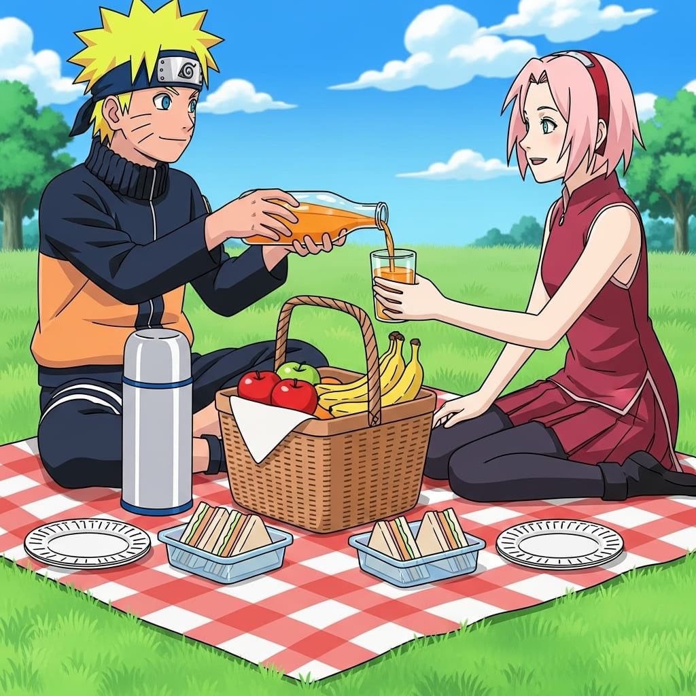

1. How many fruits are visible? 3 (taxonomic) (apples and bananas)

2. How many containers are used to hold food or drink? 4 (functional) (picnic basket, thermos, juice bottle, sandwich containers)

3. If the picnic blanket was blue instead of red, how many red items would be visible? 1 (physical) (Sakura’s top)

## Image 99 (park)

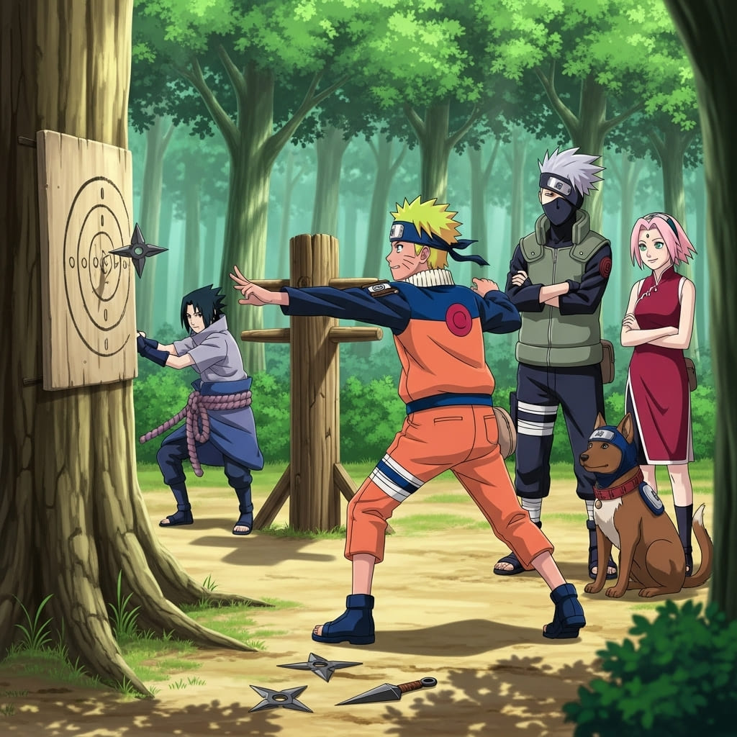

1. How many characters are mammals? 2 (taxonomic) (dog, Pakkun)

2. How many characters are standing with arms crossed? 2 (relational) (Kakashi, Sakura)

3. If all the shurikens were removed from the ground and the target, how many shurikens would be missing? 4 (physical) (shurikens)

## Image 100 (park)

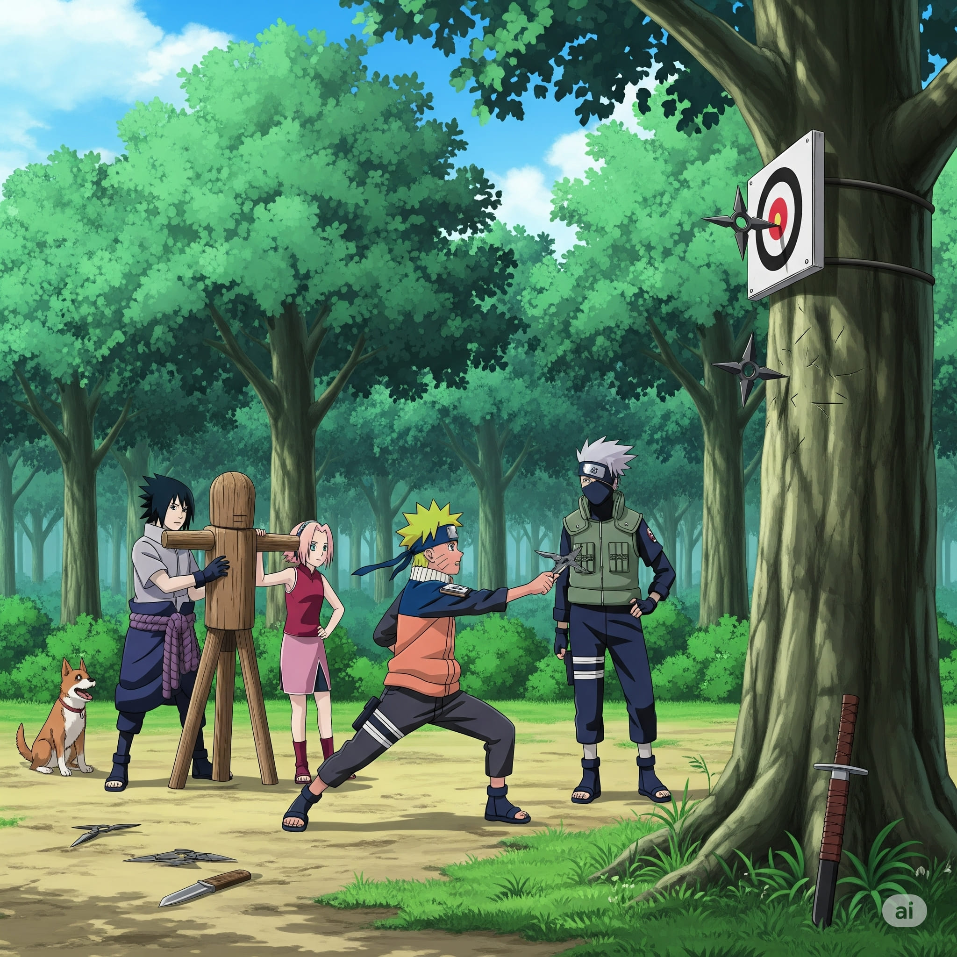

1. How many characters are present? 5 (taxonomic) (people)

2. How many weapons lying on the ground are visible? 2 (functional) (knives)

3. If the target practice board was not present, how many shurikens would be visible? 1 (physical) (shurikens)

## Image 101 (home setup)

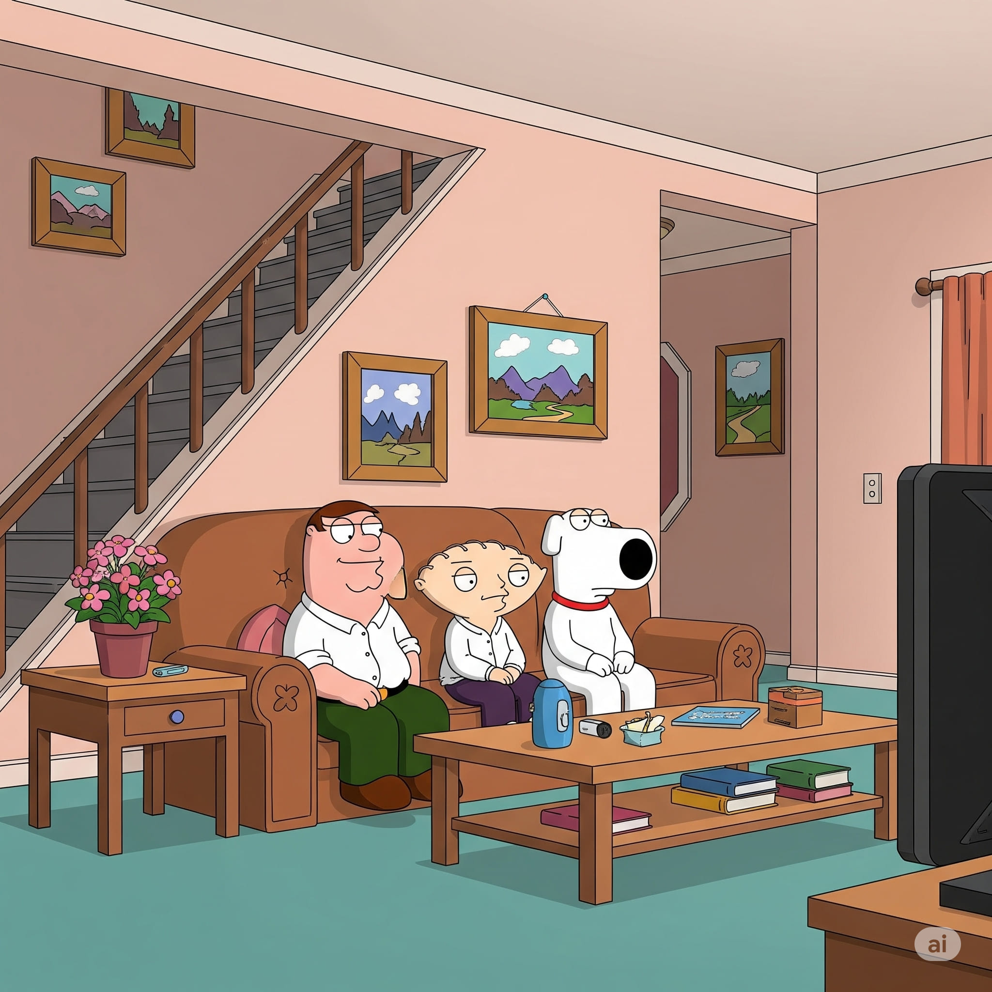

1. How many characters are present? 3 (taxonomic) (humans and dog)

2. How many items are on top of the coffee table? 6 (relational) (objects)

3. If the sofa was replaced with two chairs, how many seating objects would be visible? 2 (functional) (chairs)

## Image 102 (kitchen)

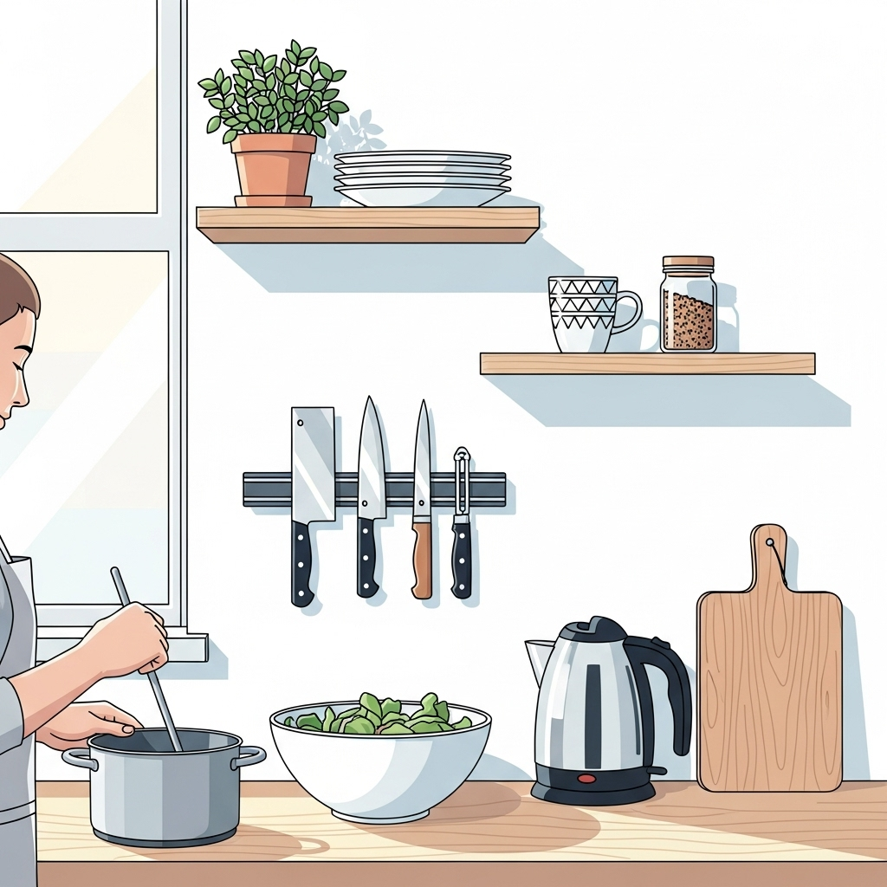

1. How many items are made of metal? 5 (physical) (knives, kettle, pot)

2. How many items are on the shelves? 4 (relational) (plant, plates, mug, jar)

3. If the leaves in the bowl were carrots, how many vegetables would be visible? 1 (taxonomic) (carrots)

## Image 103 (kitchen)

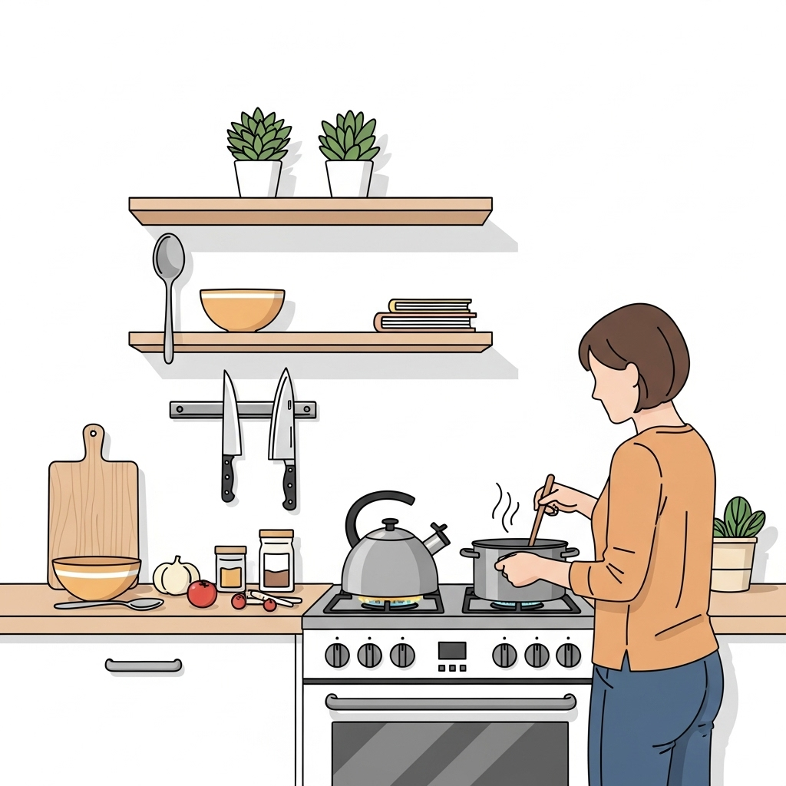

1. How many items are made of metal? 4 (physical) (kettle, pot, knives, stove knobs)

2. How many items are on top of the kitchen counter? 6 (relational) (bowl, onion, tomatoes, jars, salt/pepper shakers, cutting board)

3. If the plants were all fruits, how many fruits would there be? 4 (taxonomic) (plants/fruits)

## Image 104 (market)

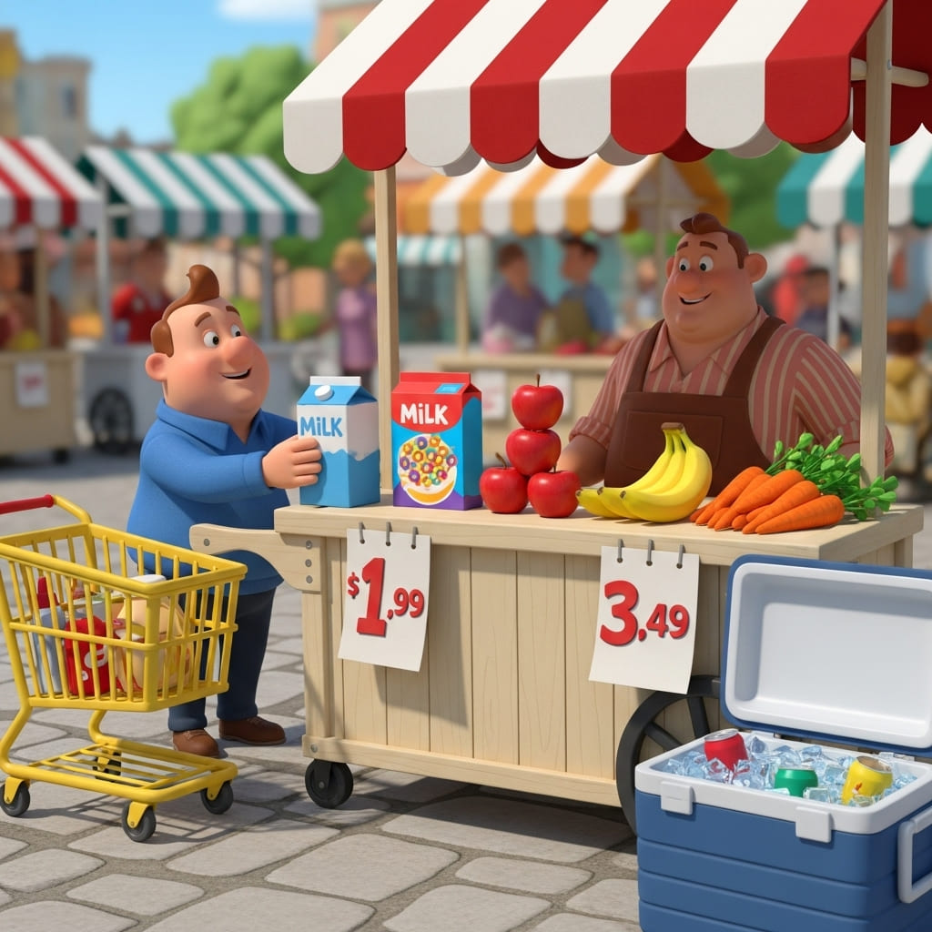

1. How many fruits are visible? 7 (taxonomic) (apples and bananas)

2. How many containers can hold items? 4 (functional) (cart, cooler, milk cartons)

3. If the awning was removed from the stall, how many striped objects would be visible? 4 (physical) (awnings)

## Image 105 (market)

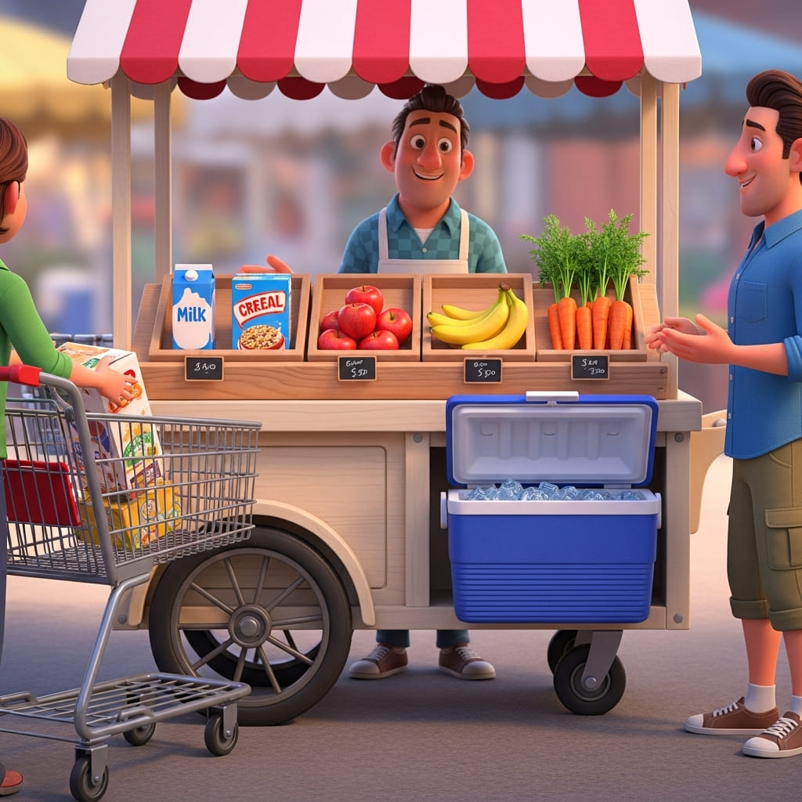

1. How many items of fruit are visible? 3 (taxonomic) (apples, bananas)

2. How many containers are holding items? 3 (functional) (cooler, shopping cart, crate)

3. If the vendor removed all the produce, how many items would be on the top shelf? 3 (taxonomic) (milk, cereal, apples)

## Image 106 (market)

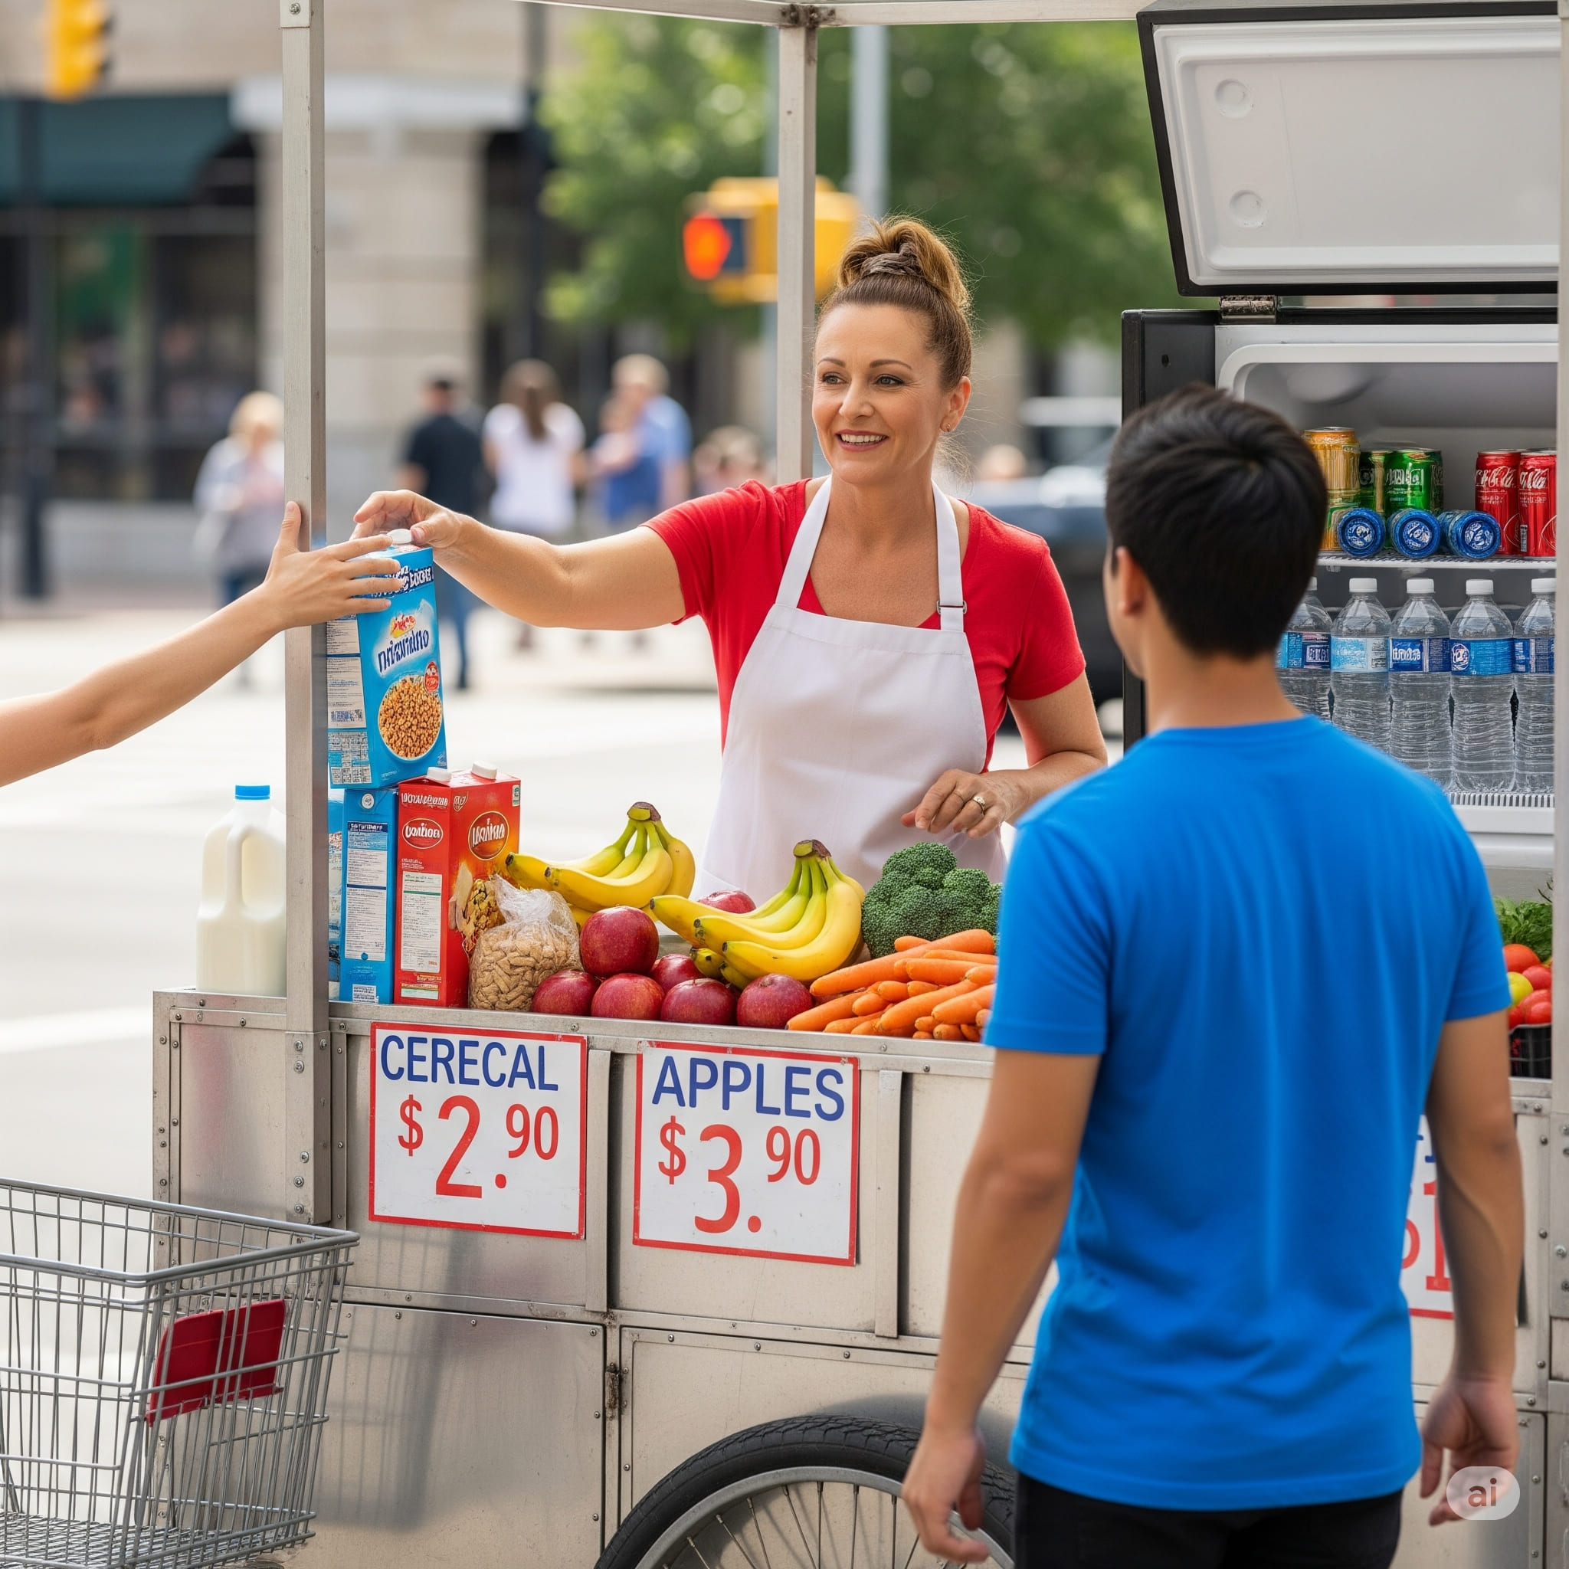

1. How many items are fruits or vegetables? 7 (taxonomic) (apples, bananas, broccoli, carrots)

2. How many containers can hold liquids? 3 (functional) (milk jugs, water bottles)

3. If the cereal boxes were removed from the cart, how many boxes would remain? 1 (physical) (bread)

## Image 107 (home setup)

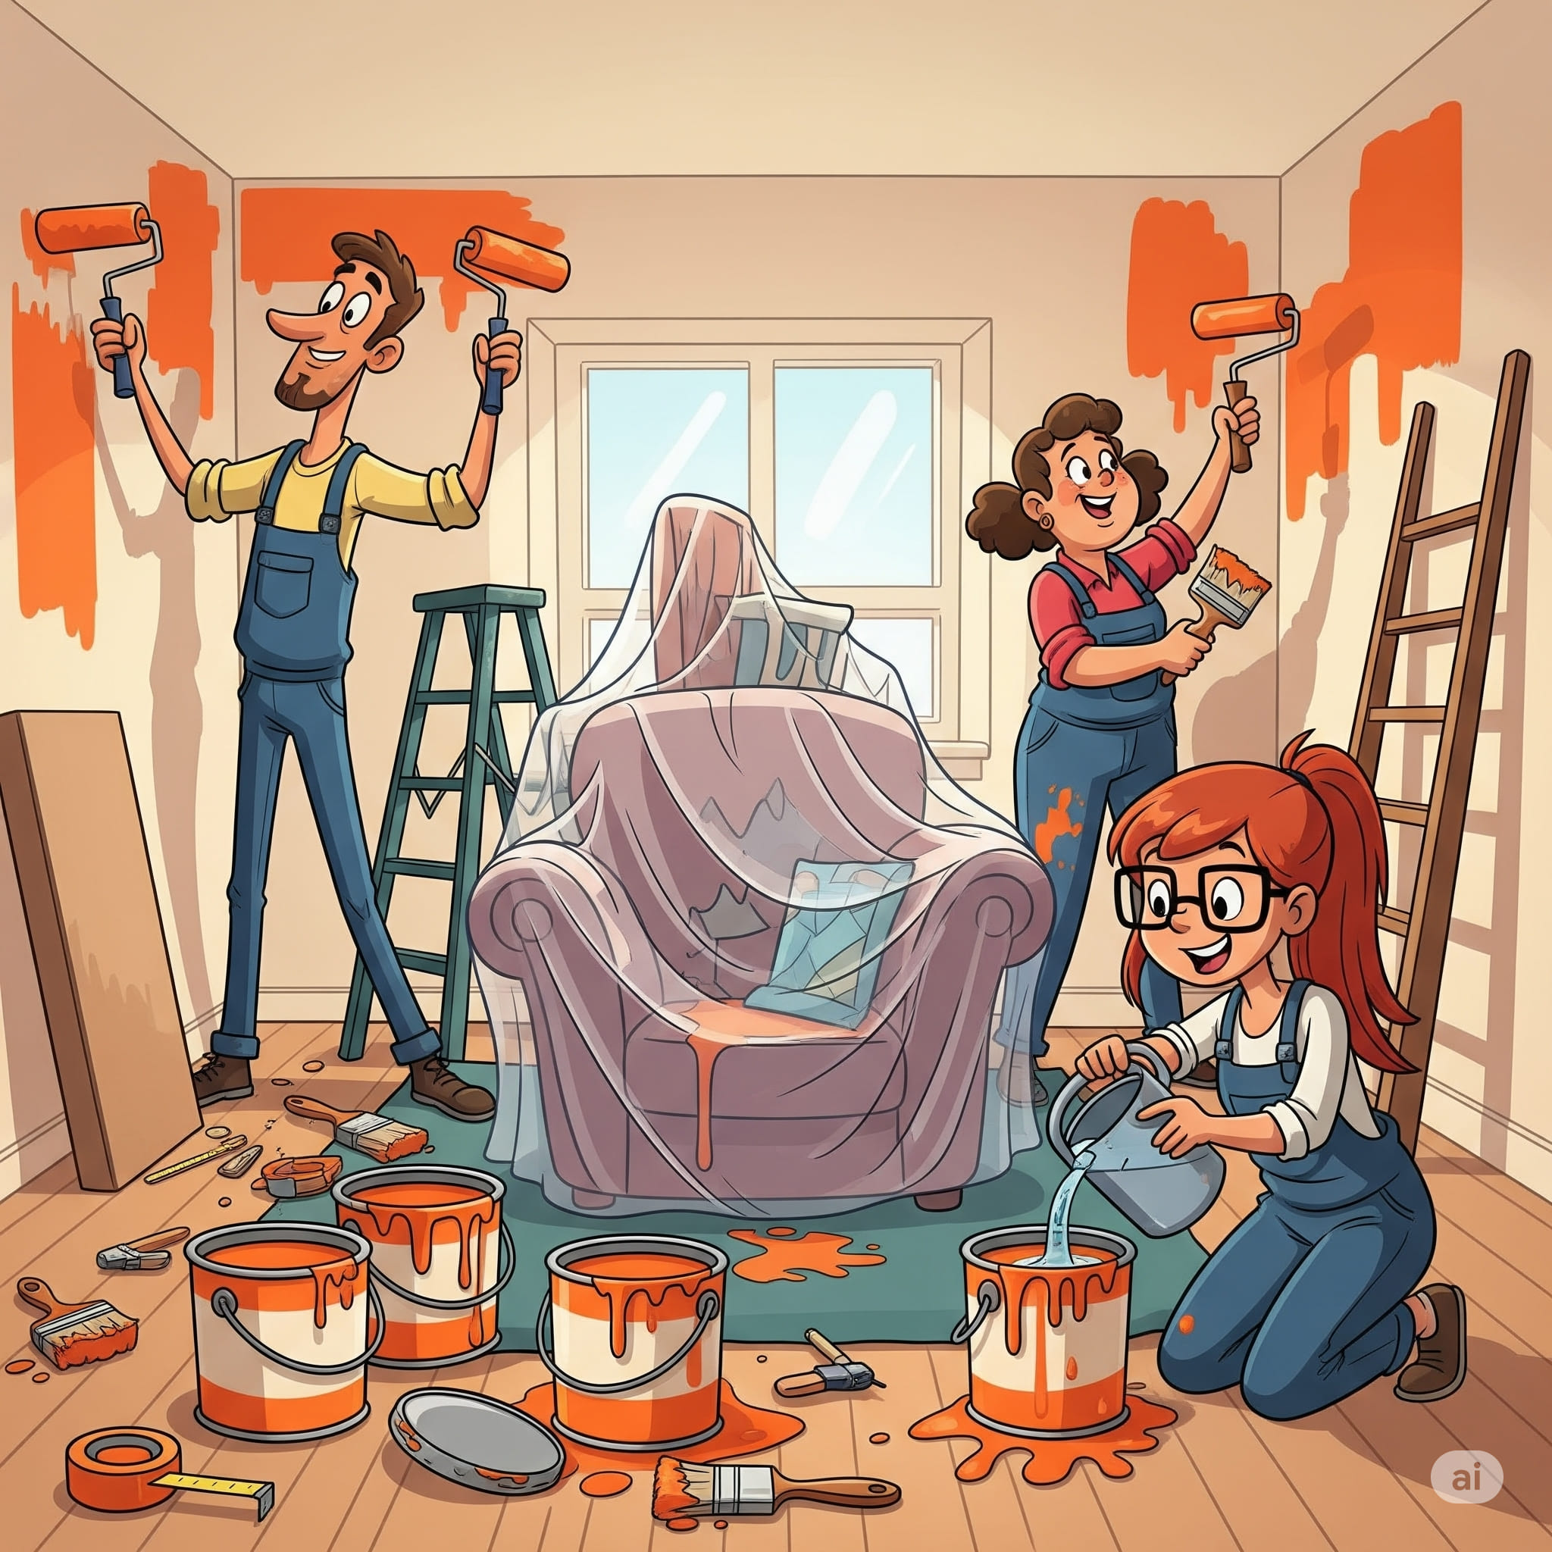

1. How many paint cans are present? 4 (taxonomic) (paint cans)

2. How many people are holding painting tools? 3 (functional) (people)

3. If the couch wasn't covered in plastic, how many pieces of furniture would be visible? 1 (taxonomic) (furniture)

## Image 108 (construction)

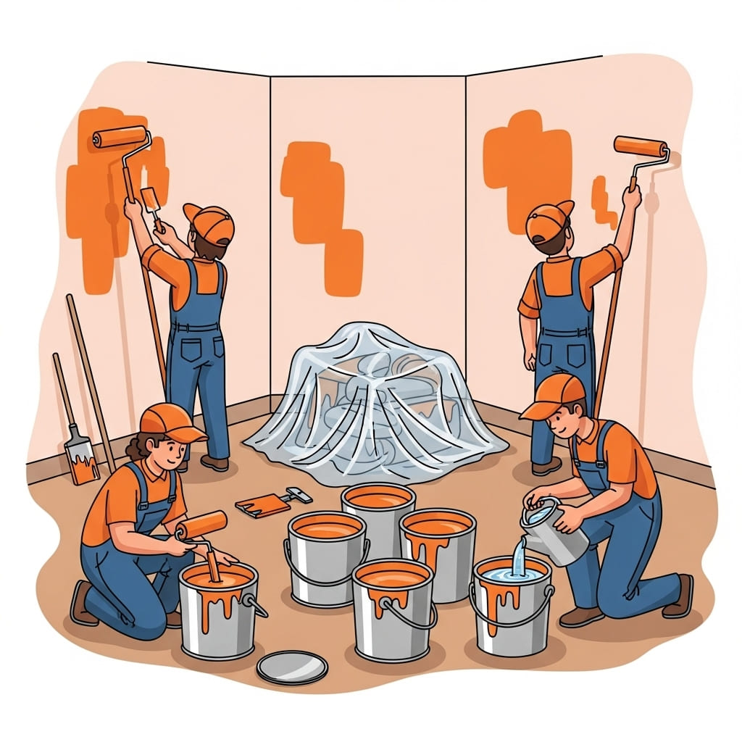

1. How many people wearing hats are present? 4 (taxonomic) (people)

2. How many paint cans appear to be holding liquid? 5 (functional) (paint cans)

3. If all the furniture was removed from the room, how many people would still be visible? 4 (relational) (people)

## Image 109 (home setup)

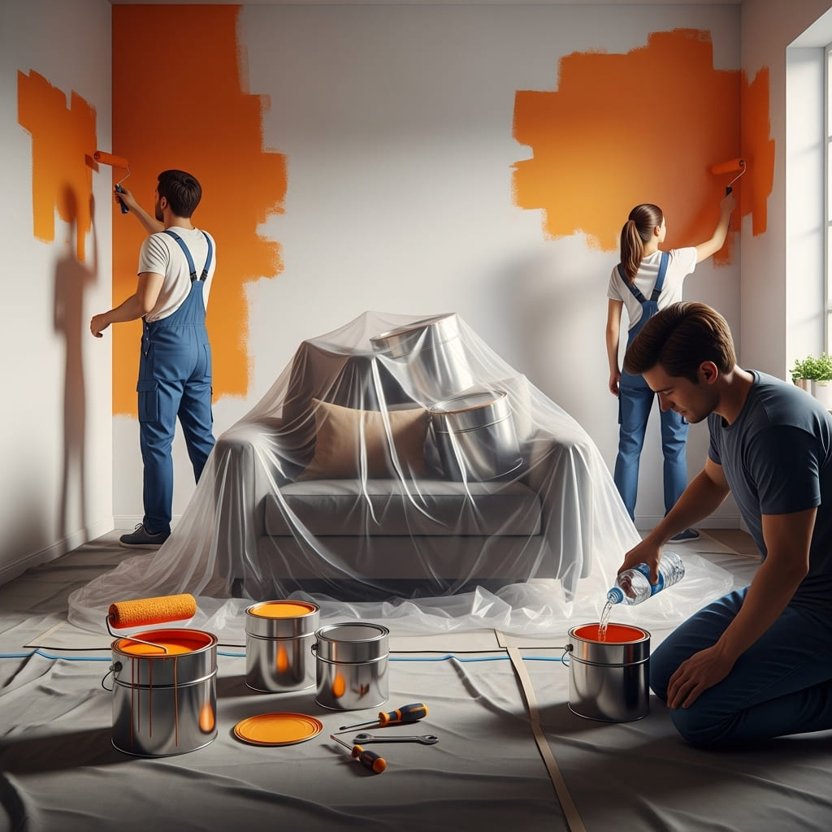

1. How many metal paint cans are visible? 5 (physical) (paint cans)

2. How many items are covering the furniture? 1 (relational) (plastic sheet)

3. If the people were not painting, how many paint rollers would be visible? 1 (functional) (paint rollers)

## Image 110 (biking)

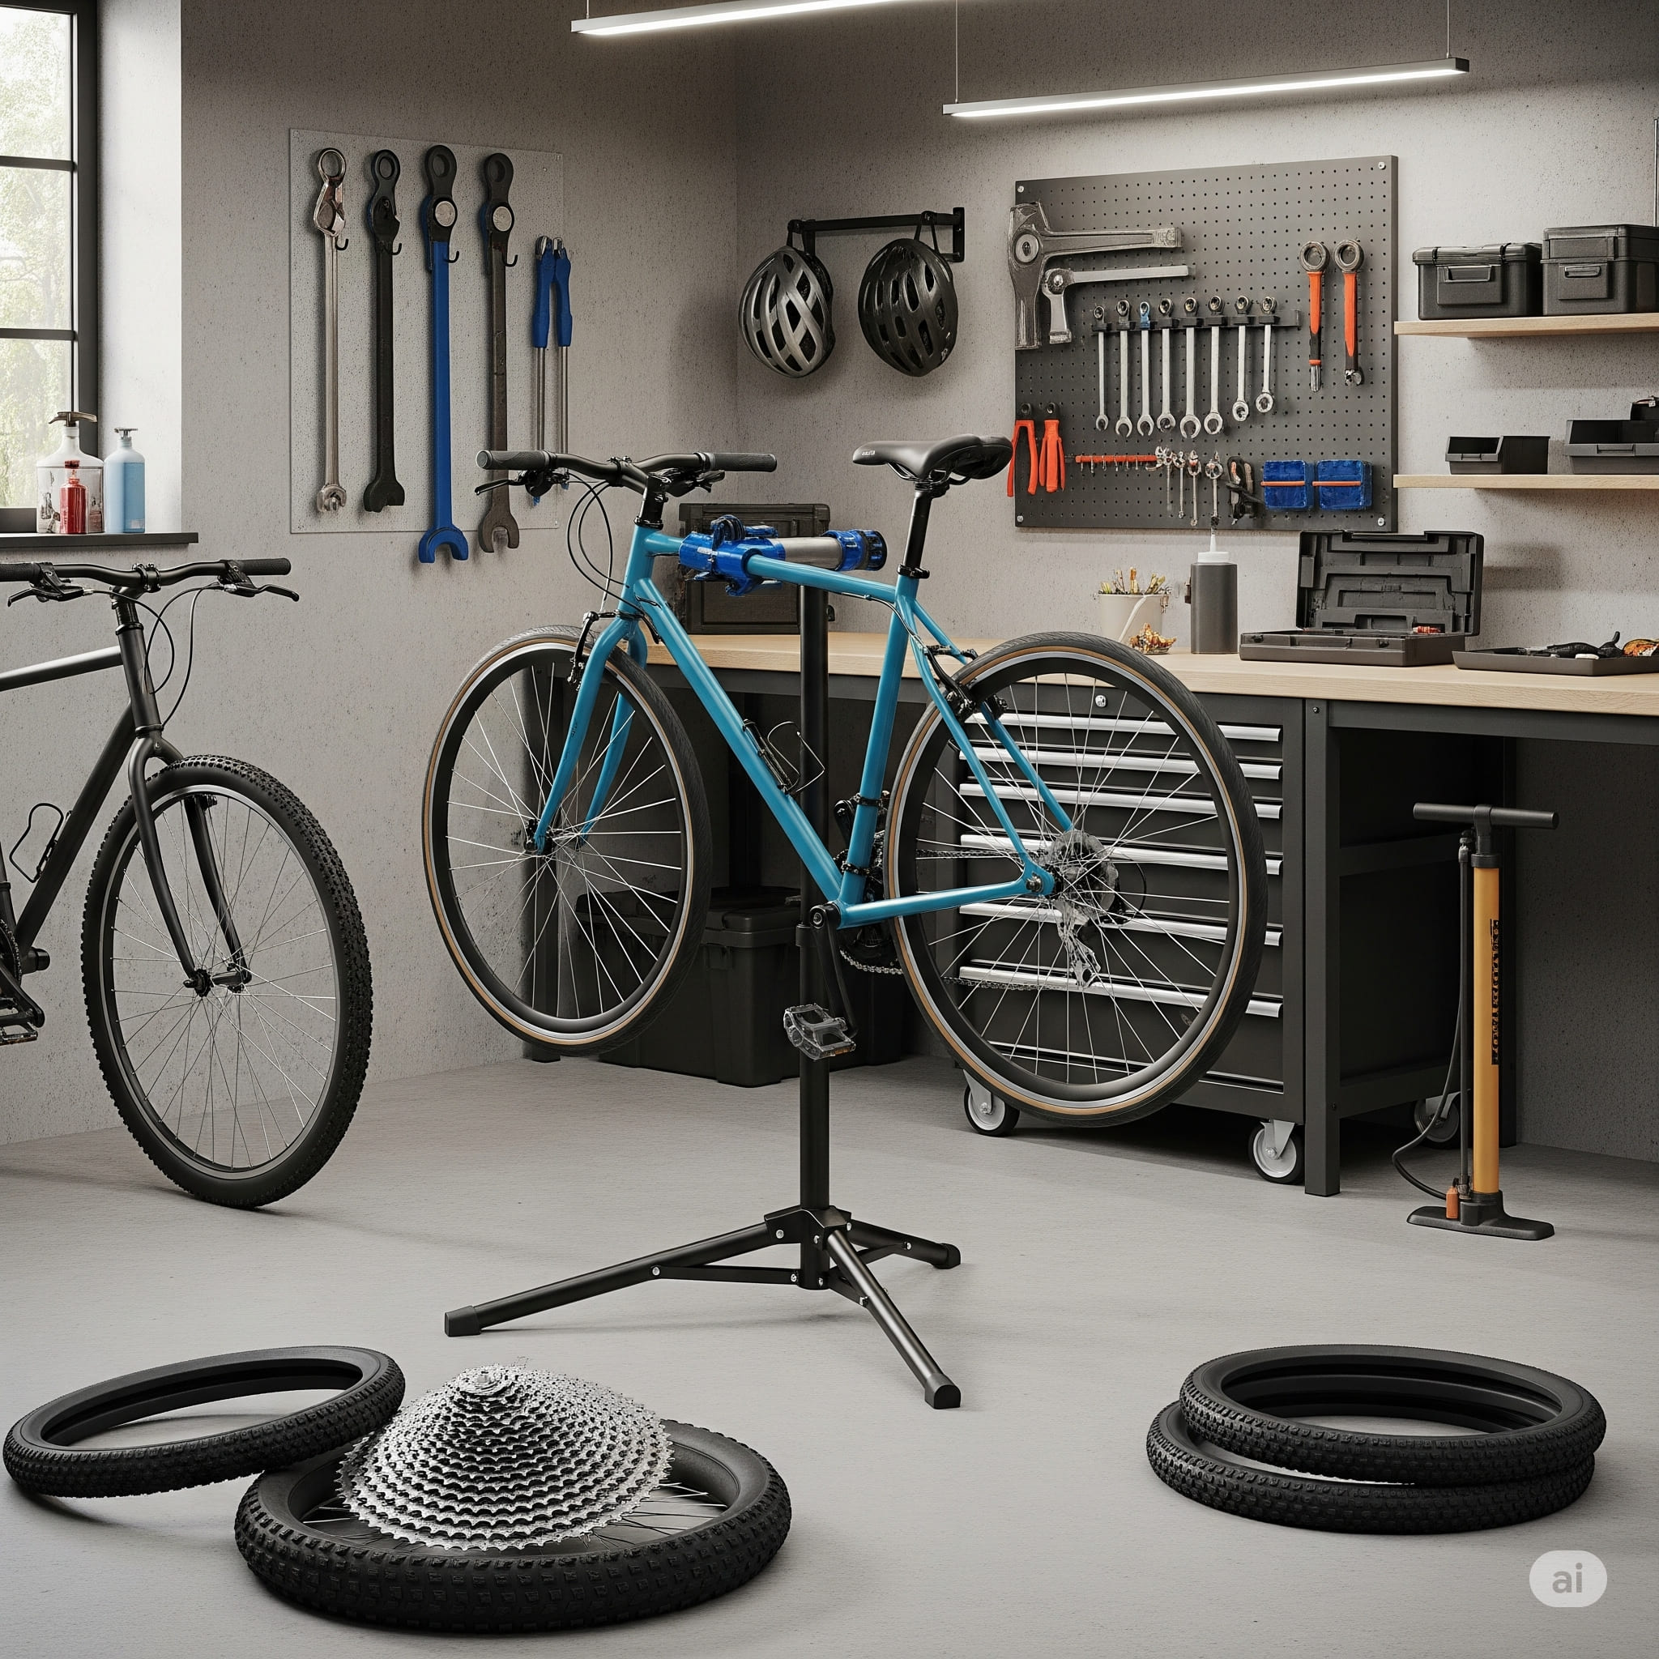

1. How many bicycles are present? 2 (taxonomic) (vehicles)

2. How many tools are hanging on the wall? 13 (functional) (tools)

3. If the tires on the floor were attached to bicycles, how many bicycles would be complete? 4 (relational) (bicycles)

## Image 111 (garage)

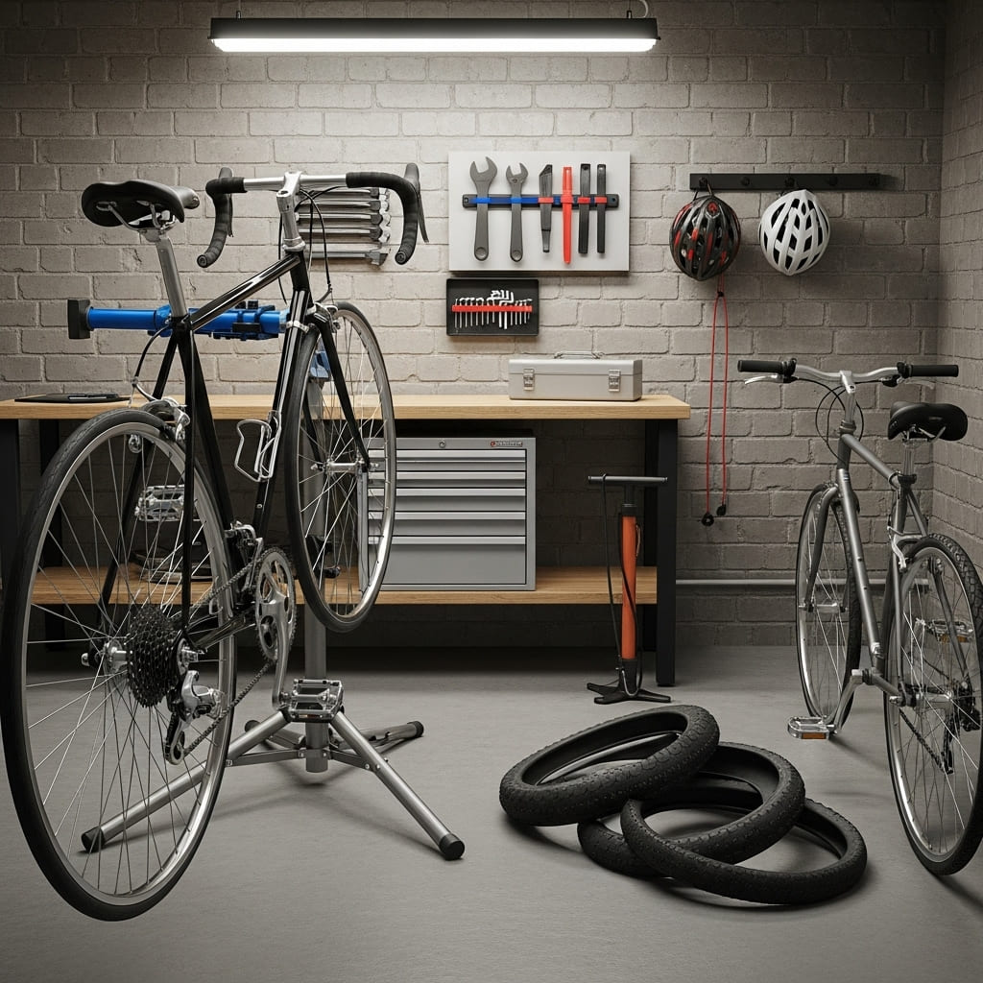

1. How many vehicles are present? 2 (taxonomic) (bicycles)

2. How many items are hanging on the wall? 3 (relational) (helmets and tools)

3. If the tires were stacked neatly in a single pile, how many tires would there be? 4 (physical) (tires)

## Image 112 (garage)

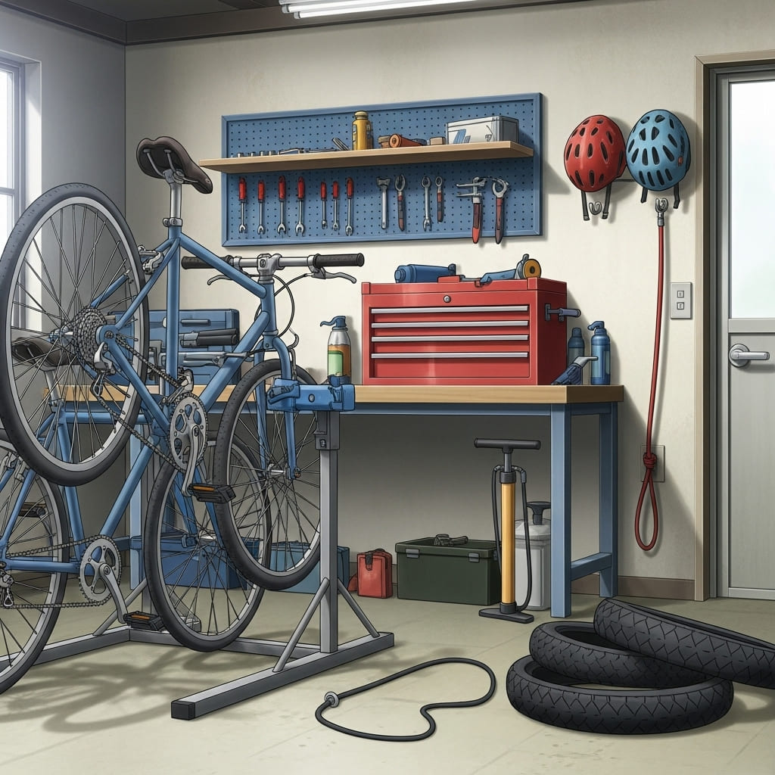

1. How many tools are hanging on the wall? 7 (taxonomic) (wrenches)

2. How many items are on top of the workbench? 4 (relational) (objects)

3. If the bicycle tires were all inflated, how many tires would there be? 3 (physical) (tires)

## Image 113 (home setup)



1. How many pieces of furniture are present? 4 (taxonomic) (chair, armchair, table, side table)

2. How many items are on top of other items? 2 (relational) (books on side table, blanket on armchair)

3. If the plant was a different color, how many green objects would be visible? 0 (taxonomic) (green objects)

## Image 114 (home setup)



1. How many items are made of wood? 5 (physical) (chair, table, legs of table, side table, frame of plant pot)

2. How many items are on top of other items? 3 (relational) (tea on book, book on book, book on table)

3. If the plant was a different species, how many plants would be visible? 1 (taxonomic) (plant)

## Image 115 (kitchen)

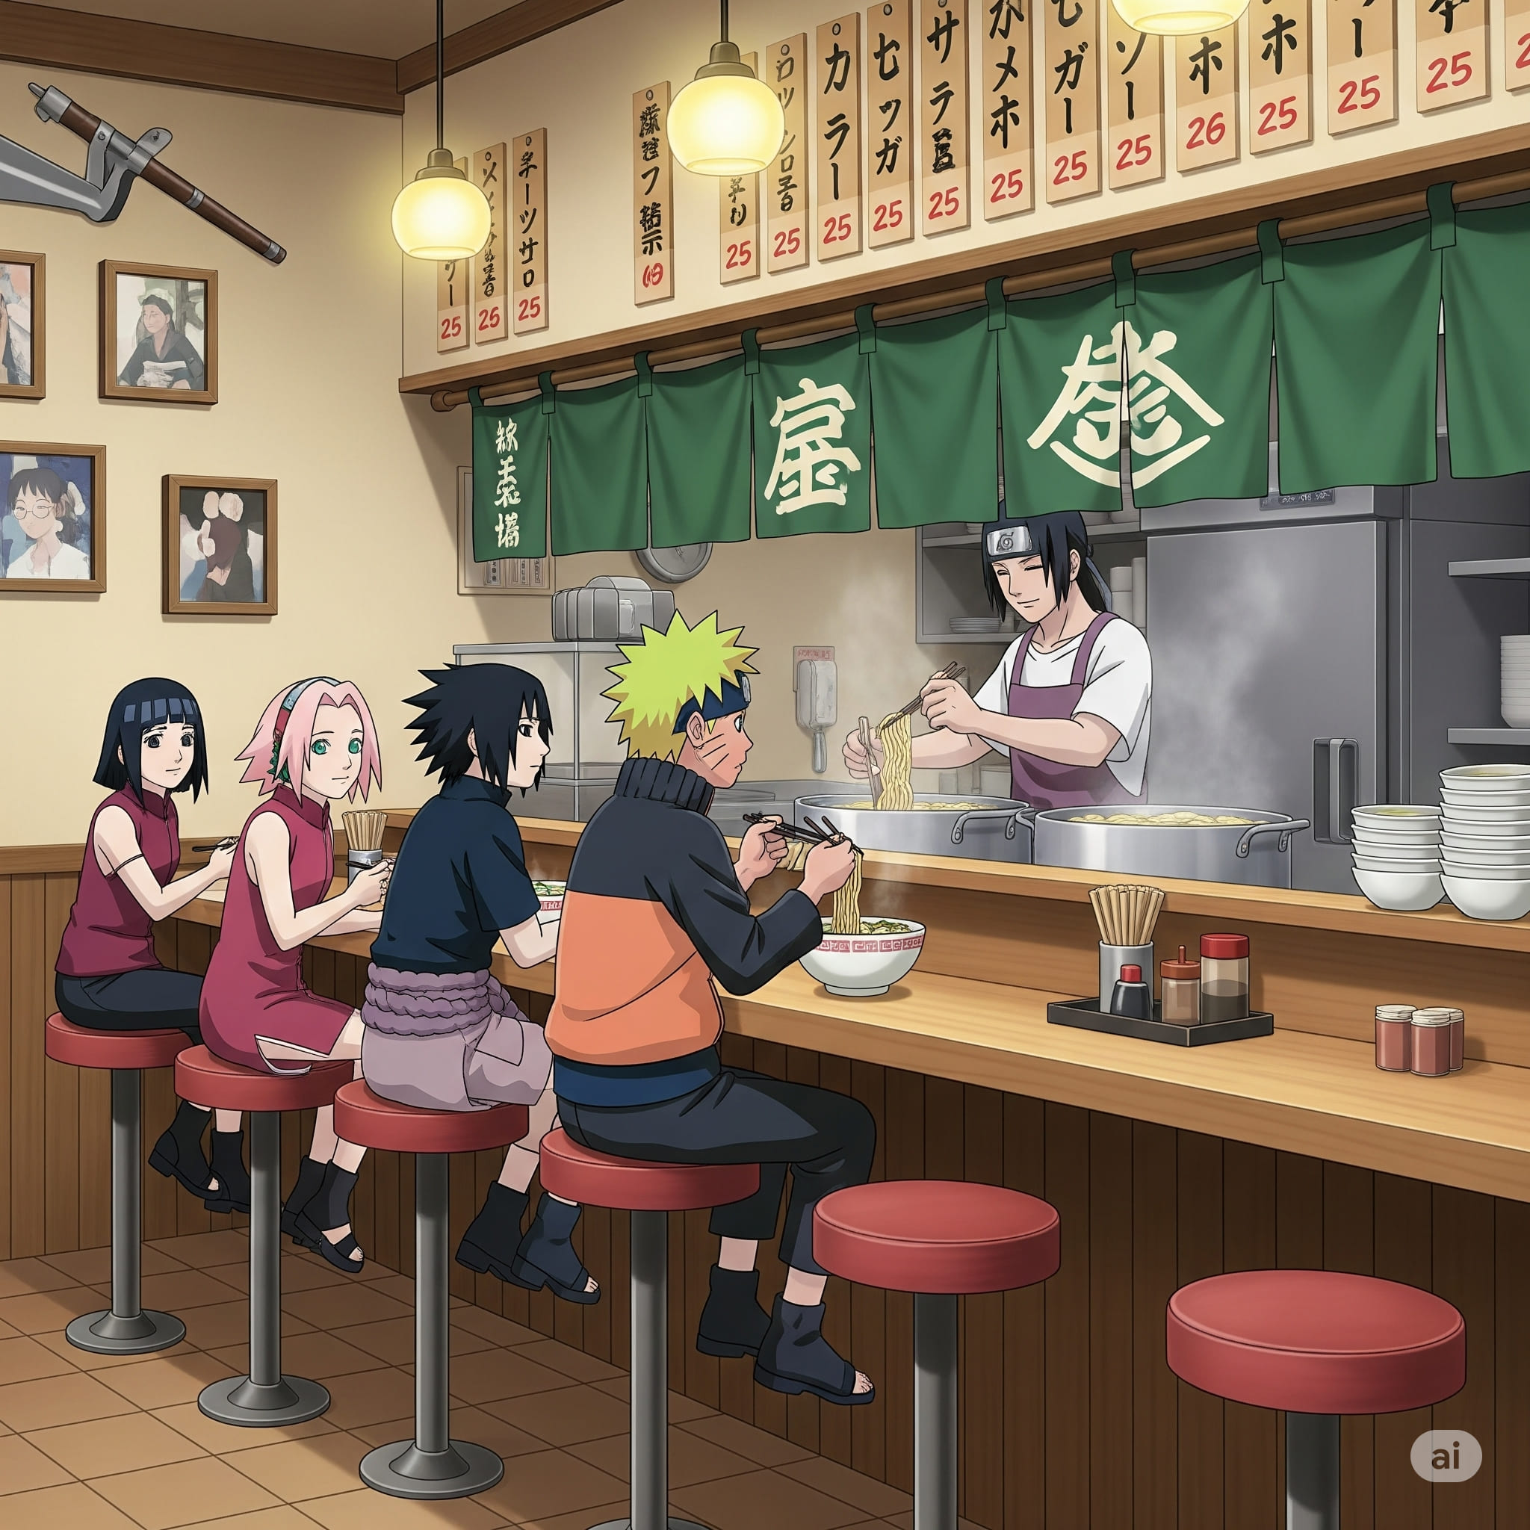

1. How many characters are present? 5 (taxonomic) (people)

2. How many stools are being sat on? 4 (relational) (stools)

3. If all the bowls of ramen were empty, how many bowls would be visible? 4 (functional) (bowls)

## Image 116 (home setup)



1. How many monitors are visible? 3 (taxonomic) (computer monitors)

2. How many items are on top of the desk? 7 (relational) (objects)

3. If the laptop was replaced with a tablet, how many computers would be visible? 3 (taxonomic) (computers)

## Image 117 (home setup)



1. How many objects made of wood are present? 1 (physical) (desk)

2. How many items are on top of the desk? 8 (relational) (items)

3. If the computer monitors were replaced with books, how many monitors would be visible? 0 (taxonomic) (monitors)

## Image 118 (park)

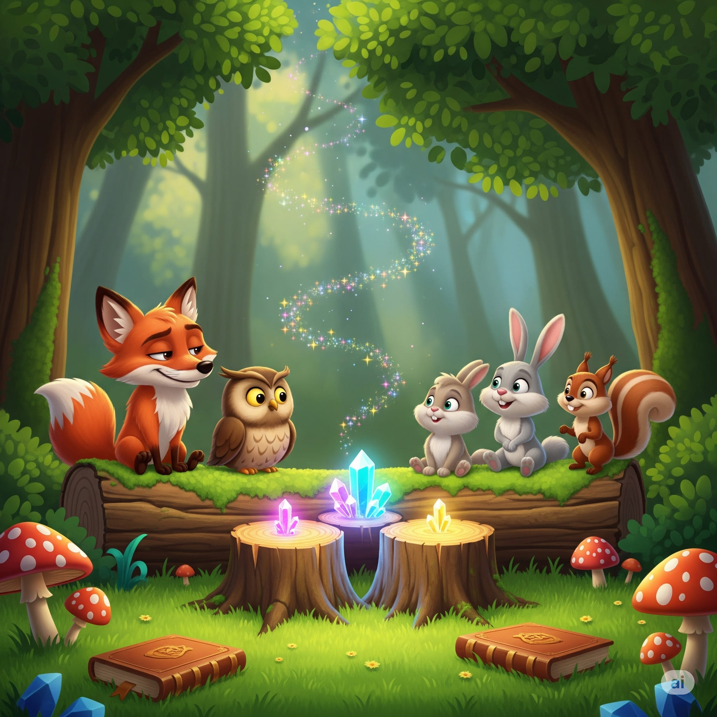

1. How many mammals are present? 5 (taxonomic) (animals)

2. How many objects are on top of the tree stumps? 2 (relational) (crystals)

3. If the mushrooms were all the same color as the rabbit, how many red mushrooms would there be? 0 (physical) (mushrooms)

## Image 119 (tech)

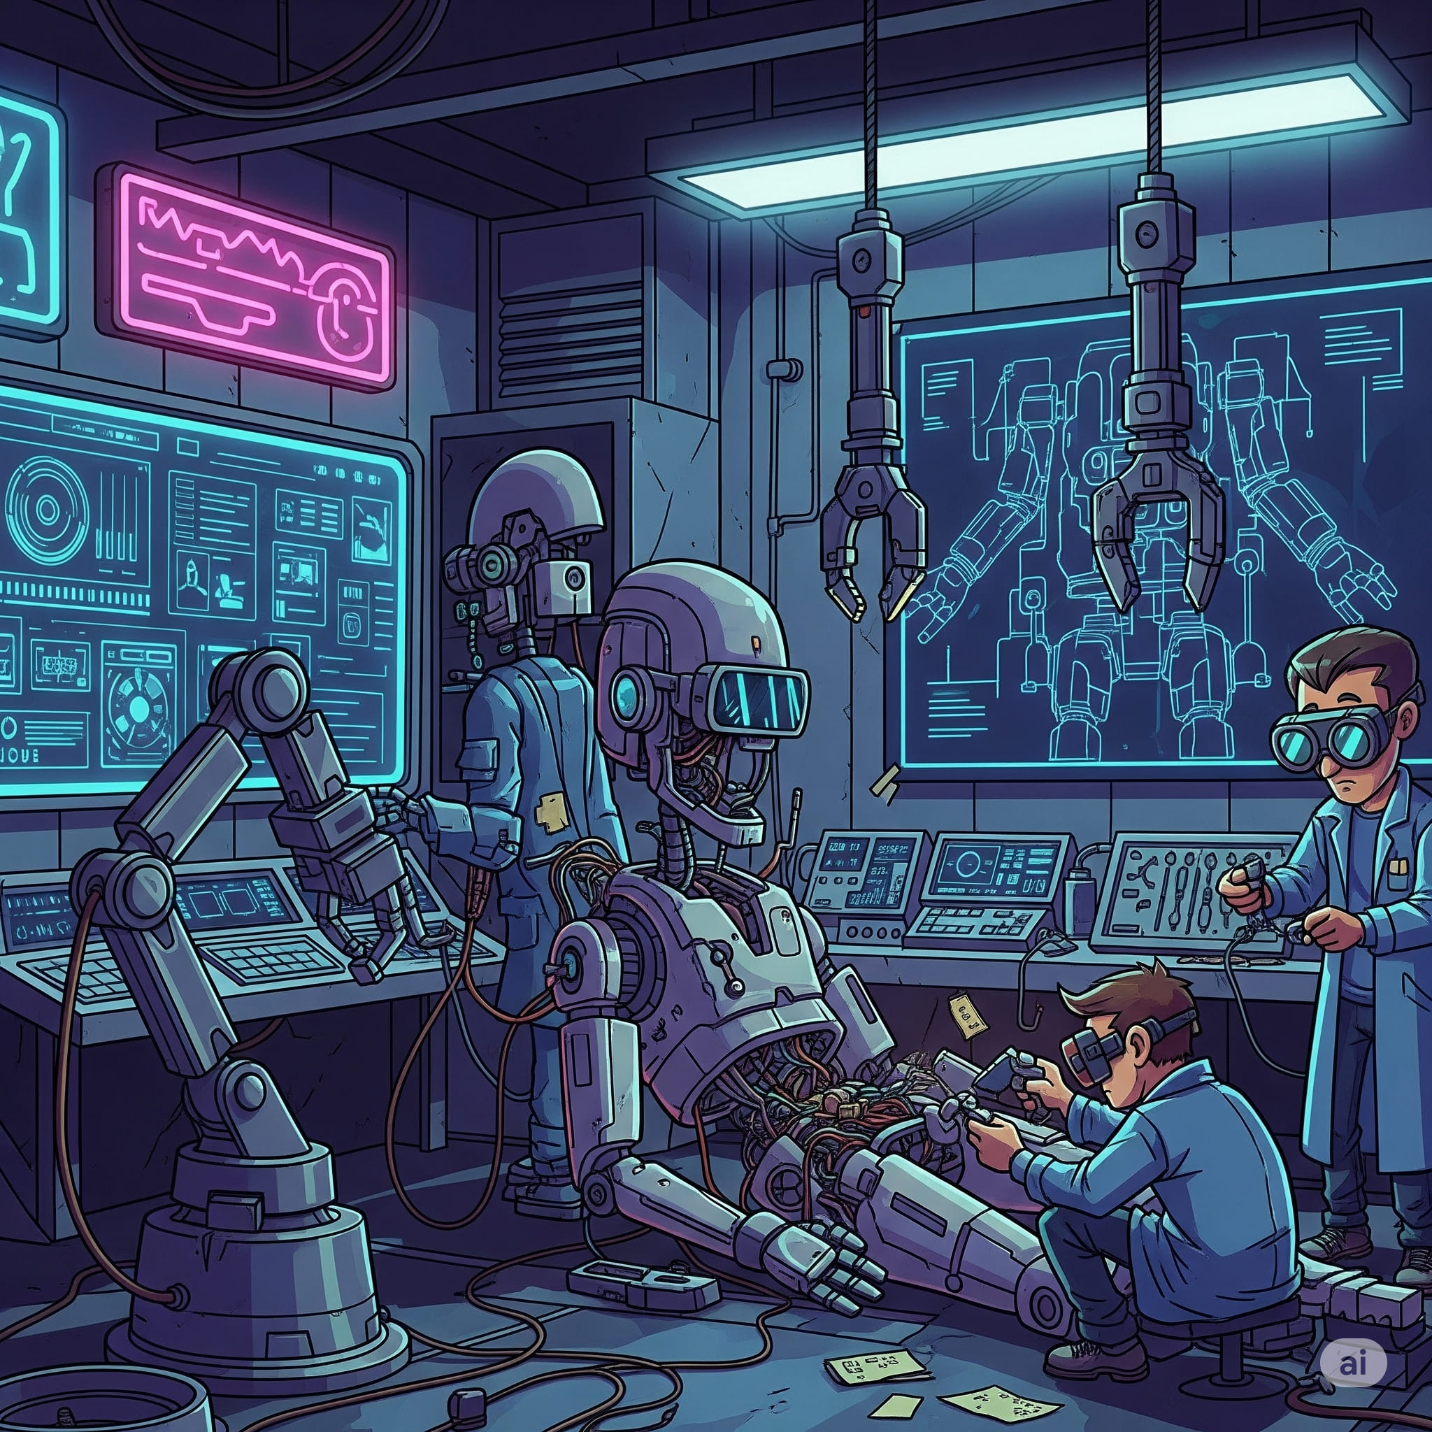

1. How many robots are present? 2 (taxonomic) (robots)

2. How many items that need electricity are visible? 8 (functional) (machines/screens)

3. If all the tools on the floor were removed, how many tools would remain visible? 2 (functional) (wrench/screwdriver)

## Image 120 (kitchen)

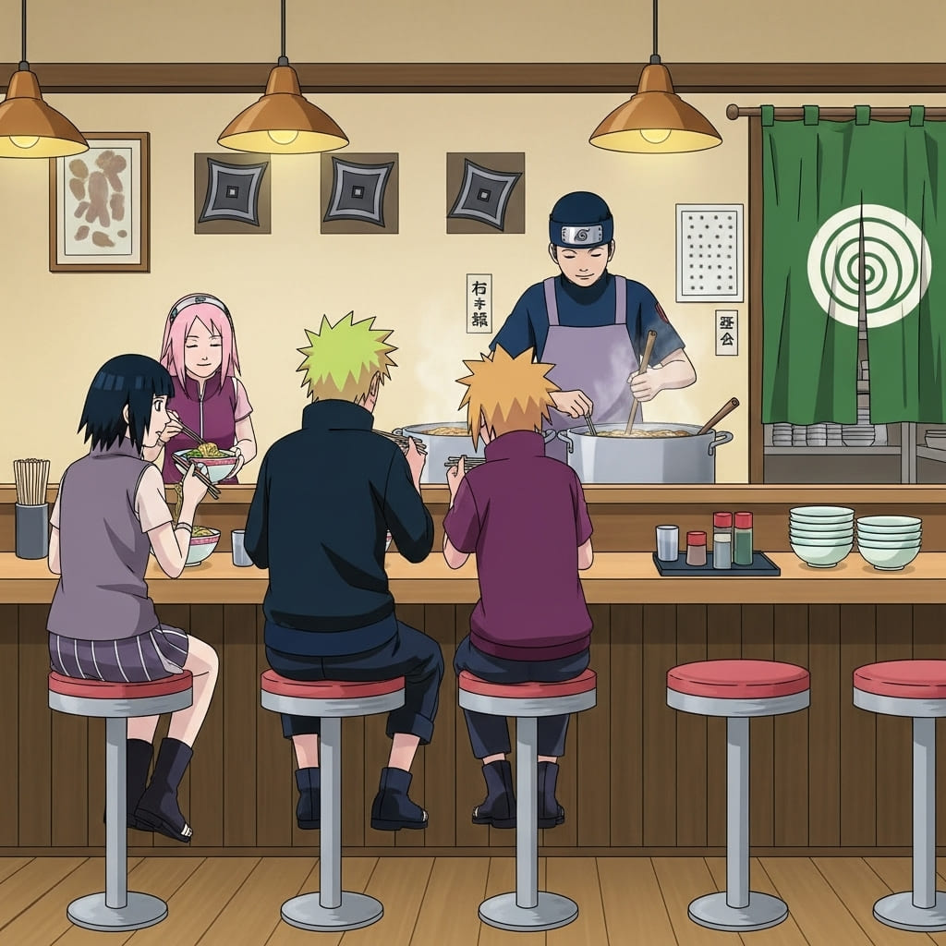

1. How many stools are present? 7 (physical) (stools)

2. How many people are eating ramen? 4 (relational) (people)

3. If the ramen bowls were empty, how many bowls would still be visible? 5 (physical) (bowls)